**ReClaim: AI-Based Lost and Found SaaS Platform**

**A project report submitted in partial fulfillment of the requirements for the award of the degree of**

**BACHELOR OF COMPUTER APPLICATION**

**BY**

**PARAS VINOD CHAUDHARI**

**Seat Number: 8112**

**Under the esteemed guidance of**

**PROF. Dipti Shardul Khiste**

**DEPARTMENT OF COMPUTER APPLICATION**

**MAHATMA EDUCATION SOCIETY’S**

**PILLAI COLLEGE OF ARTS COMMERCE & SCIENCE (AUTONOMUS)**

**(Affiliated to University of Mumbai)**

**NEW PANVEL - 410206, MAHARASHTRA**

**YEAR 2025-2026**

**Mahatma Education Society’s**

**PILLAI COLLEGE OF ARTS, COMMERCE & SCIENCE**

**(Autonomous), New Panvel**

**Re-accredited “A” Grade by NAAC (3rd Cycle)**



**CERTIFICATE**

**This is to certify that the project entitled “ReClaim: AI-Based Lost and Found SaaS Platform”, is Bonafide work of Mr. Paras Vinod Chaudhari bearing Seat No: 8112 submitted in partial fulfillment of the requirements for the award of degree of BACHELOR OF COMPUTER APPLICATION from University of Mumbai.**

Internal Guide   Coordinator

Prof. Dipti Shardul Khiste Prof. Sreevidya T.V

College Seal

Date: ExternalExaminer

**ACKNOWLEDGEMENT**

I would like to express my sincere gratitude to all those who supported me throughout the completion of this project. First and foremost, I extend my heartfelt thanks to my project guide, Prof. Dipti Shardul Khiste , for their invaluable guidance, encouragement, and constructive feedback, which greatly contributed to the success of this work.

I am also deeply thankful to our course coordinator, Prof. Sreevidya T.V, for their continuous support and timely assistance, and to our Head of Department, Prof. Dipika Sharma, for their encouragement and for providing the necessary direction that helped me stay focused on my goals.

I am grateful to Department of Computer Application for providing the necessary resources and a conducive environment to carry out this project. My appreciation goes to my classmates and friends for their constant support, insightful discussions, and motivation during challenging times.

Finally, I owe my deepest gratitude to my family for their unwavering encouragement, patience, and belief in me, which inspired me to persevere and complete this project successfully.

Yours faithfully,

**Paras Chaudhari**

(T.Y. B.C.A)

**DECLARATION**

I hereby declare that this project report entitled ***"ReClaim: AI-Based Lost and Found SaaS Platform”*** submitted by me to University of Mumbai is a record of my original work carried out under the guidance of Prof. Dipti Shardul Khiste. This project has not been submitted to any other institution or university for the award of any degree, diploma, or certificate.

I further declare that all sources of information and assistance have been duly acknowledged in the report.

**Date:** **Signature of Student**

**Place:** **Name of Student**

**TABLE OF CONTENTS**

|  |  |  |
| --- | --- | --- |
|  | **INDEX** |  |
| **Sr.no** | **Chapter 1** | **Page Number** |
| **1** | **Introduction** | **7-9** |
| 1.1 | Background | **7** |
| 1.2 | Objective | **7** |
| 1.3 | Purpose | **8** |
| 1.4 | Scope | **8-9** |
|  |  |  |
|  | **Chapter 2** |  |
| **2** | **System Planning** | **10-13** |
| 2.1 | Survey of technologies | **10** |
| 2.1 | Fact finding technique | **11** |
| 2.3 | Feasibility Study | **12** |
| 2.4 | Stakeholders | **13** |
|  |  |  |
|  | **Chapter 3** |  |
| **3** | **Requirement and Analysis** | **14-26** |
| 3.1 | Problem Definition | **14** |
| 3.2 | Requirement Specification | **14-16** |
| 3.3 | Planning and Scheduling | **17-18** |
| 3.4 | Software and Hardware Requirement | **19** |
| 3.5 | Conceptual Models | **20** |
| 3.5.1 | ER Diagram | **20** |
| 3.5.2 | DFD Diagram | **21** |
| 3.5.3 | Use case Diagram | **22** |
| 3.5.4 | Sequence Diagram | **23-26** |
|  |  |  |
|  | **Chapter 4** |  |
| **4** | **System Design** | **27-55** |
| 4.1 | Basic Modules | **27-28** |
| 4.2 | Data Design and Data integrity and Constraints | **29-37** |
| 4.3 | User Interface and Design | **38-53** |
| 4.4 | Security Issues | **54-55** |
| 4.5 | Test Cases | **55** |
|  |  |  |
|  | **Chapter 5** |  |
| **5** | System Coding, Implementation and Testing | **56-135** |
| 5.1 | Coding Details | **56-134** |
| 5.2 | Testing Approach | **135** |
| 5.2.1 | Unit Testing | **135** |
| 5.2.2 | Integrated Testing | **135** |
| 5.3 | Modification and Improvements | **135** |
|  |  |  |
|  |  |  |
|  | **Chapter 6** |  |
| **6** | Conclusion and Future Work | **136** |
|  |  |  |
|  | **Chapter 7** |  |
| **7** | References | **137** |
|  |  |  |

**CHAPTER 1-INTRODUCTION**

**1.1 Background**

Traditional methods for managing lost and found items in large organizations such as malls, hotels, and airports are often manual, decentralized, and inefficient. These systems typically rely on paper logs or uncoordinated spreadsheets, leading to slow matching times, poor recovery rates, and a high administrative workload.

The **ReClaim** project addresses these systemic challenges by developing a modern Software as a Service (SaaS) platform. ReClaim leverages Artificial Intelligence (AI) to automate the critical function of item matching, transforming the process from a manual administrative task into an efficient, digitized service. The system provides a centralized, secure portal for businesses to manage their entire lost and found operations, significantly enhancing recovery rates and staff productivity.

**1.2 Objectives**

The primary objectives of the **ReClaim** project are to deliver a reliable, secure, and intelligent Lost & Found management solution:

* **Centralize Management:** Provide a secure, single platform for businesses to log and manage all lost and found activities.
* **Automate Matching:** Implement an AI-Based Item Matching system to automatically link lost item reports with found item entries, significantly reducing manual effort.
* **Enhance User Experience:** Offer clear, easy-to-use forms for staff to log items quickly and an intuitive admin dashboard for oversight.
* **Improve Communication:** Develop an automated Notifications System to alert owners when a potential match is found.
* **Enable Reporting:** Generate detailed Reports & Analytics for tracking item recovery rates, log history, and overall system performance.

**1.3 Purpose**

The purpose of **ReClaim** is to overcome the inherent weaknesses of conventional lost and found systems, which are prone to errors, lack of transparency, and slow turnaround times. ReClaim achieves this by:

* **Providing Real-Time Logging:** Staff can instantly log items with details and photos, eliminating paperwork.
* **Ensuring Efficiency:** The AI core performs matches instantly, dramatically reducing the time required to link a lost item to a found item.
* **Saving Time and Reducing Workload:** Automation minimizes manual tracking and cross-referencing for business staff.
* **Improving Security and Transparency:** Every item entry is stored securely with timestamps, and access is managed through robust Staff User Management.

In essence, the system ensures accurate, reliable, and secure Lost & Found management using modern AI technologies and a centralized SaaS architecture.

**1.4 Scope**

**Included in Scope (Initial Development)**

* **Business Registration:** Setup, authentication, and unique CODE generation for client businesses and the primary admin account.
* **Staff User Management:** Registration, role/permission setup, and modification functions for staff users.
* **Lost/Found Item Logging:** Dedicated forms, photo upload system, data validation, and database storage for both lost and found items.
* **AI Matching Core:** Model training, matching logic, and result UI for automated item comparison.
* **Notifications System:** Email/SMS template setup and logic for auto-triggering match notifications.
* **Reporting & Analytics:** Access logs, filtering system (date/category), graphs.

**Not Included (Future Work)**

* Advanced biometric authentication or 3D anti-spoofing detection.
* Integration with RFID, IoT hardware, or client ERP systems.
* Mobile application development.
* Integration with third-party payment systems.

**CHAPTER 2- SYSTEM PLANNING**

**2.1 Survey of Technologies**

To build ReClaim as a modern, scalable SaaS (Software as a Service) platform, a detailed survey of currently relevant web and AI development technologies was conducted. The primary goal was to identify tools that can support the complex requirements of AI-Based Item Matching, secure User Management, and a scalable architecture.

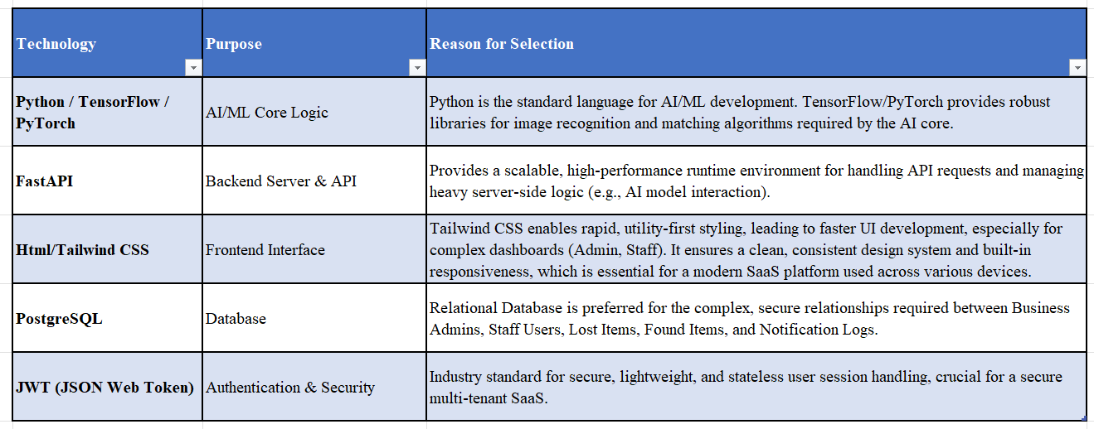

**2.2 Fact Finding Techniques**

To solidify the requirements and functional needs of **ReClaim**, various fact-finding methods were utilized. These techniques focused on validating user processes and guiding the system design, particularly around item logging and staff workflows.

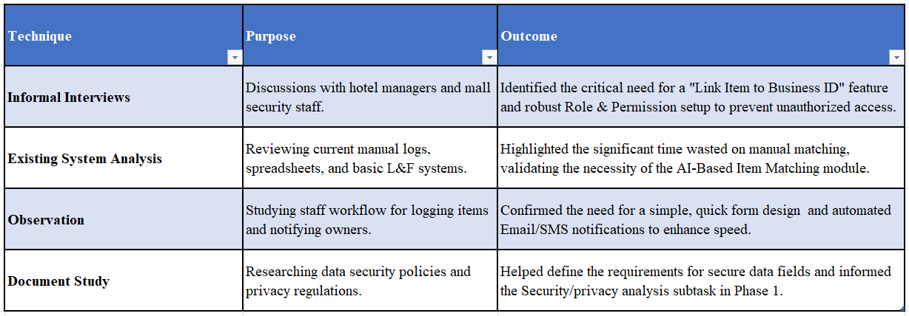

**2.3 Feasibility Study**

A feasibility evaluation was performed to determine if the ReClaim system can be realistically developed within the allocated project timeline, skills, and resources.

**A. Technical Feasibility**

The project relies on established, well-documented technologies (e.g., Python, FastAPI, PostgreSQL) that are widely supported by the developer community. The integration of the AI core requires specialized skills but utilizes standard, accessible frameworks (TensorFlow/PyTorch). The technical execution is feasible with the necessary expertise.

**B. Economic Feasibility**

No external hosting, paid APIs, or hardware costs are required. Development runs locally on the student’s laptop. Hence, total cost is zero, making the system highly cost-effective.

**C. Operational Feasibility**

The system provides intuitive, role-based dashboards for administrators and staff, secure login, and clear logging procedures. Its primary function automated matching directly solves a major operational bottleneck. The system is therefore operationally viable and expected to be well-adopted by end-users.

**D. Time Feasibility**

* Available Development Period: The project timeline is set from December 18, 2025, to February 10, 2026.
* Total Duration: **54 days** (based on the provided schedule).

The features selected are prioritized to deliver the core AI and User Management functionality within this timeline, ensuring time feasibility. Complex features are placed outside the initial scope to ensure timely delivery of the core product.

**2.4 Stakeholders of the System**

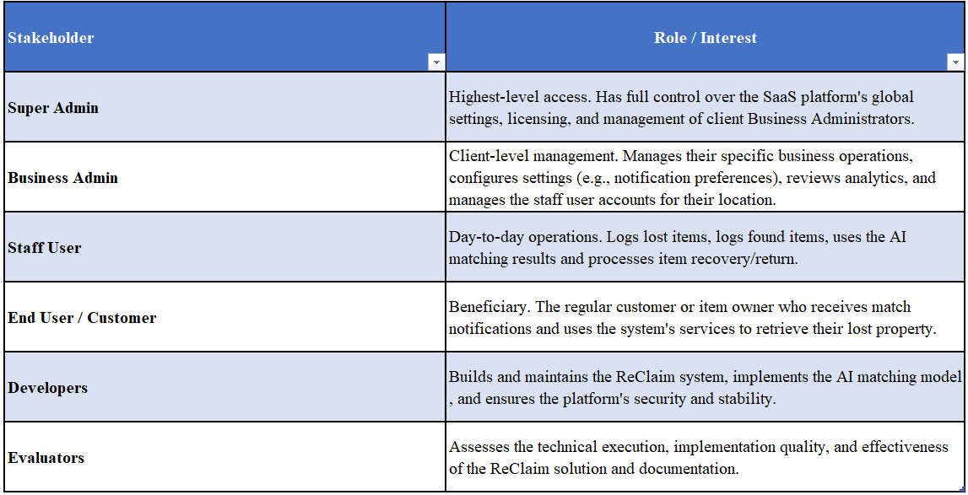

**CHAPTER 3-REQUIREMENTS AND ANALYSIS**

**3.1 Problem Defination**

Currently, the management of lost and found items in high-traffic venues such as airports, hotels, shopping malls, and universities is a predominantly manual and inefficient process. Most organizations rely on physical logbooks, decentralized spreadsheets, or disparate legacy systems, leading to significant fragmentation in data management. This approach creates critical operational challenges: staff members spend hours manually searching through logs to answer customer inquiries, while the lack of centralized databases and visual matching results in low recovery rates. Furthermore, the process suffers from a lack of transparency, forcing customers to make repeated physical visits or phone calls for updates. The administrative burden is equally significant, with staff overwhelmed by manual ownership verification and the complex logistics of disposing of unclaimed items. To address these inefficiencies, this project proposes a SaaS-based Lost & Found Platform that automates reporting, matching, and recovery. By utilizing Artificial Intelligence (AI) for image recognition and text matching, the system significantly reduces manual effort, while its multi-tenant architecture allows businesses to operate their own digital "Lost & Found" departments with integrated billing, role-based access control, and automated notifications.

**3.2 Requirement Specification**

**Functional Requirements (FR)**

**FR-1: User Authentication & Role-Based Access Control (RBAC)**

* The system must support three distinct roles: Super Admin, Business Admin, and Staff/User.
* Business Admin: Can manage subscriptions, view all items for their business, and invite staff.
* Staff: Can report found items and search for lost items.
* Super Admin: Has global oversight of all registered businesses and revenue analytics.
* Secure login using JWT (JSON Web Tokens) and password hashing (Bcrypt).

**FR-2: Item Management (Lost & Found)**

* Users must be able to upload details of items (Name, Category, Color, Brand, Description).
* The system must support image uploads for "Found" items.
* The system must generate a unique Item ID for tracking.
* Status tracking: Items must transition through statuses.

**FR-3: AI-Powered Matching Engine**

* The system must utilize Vector Embeddings to compare text descriptions and images.
* When a "Lost" item is reported, the system must automatically scan the "Found" database for potential matches.
* The system must return a "Similarity Score" (0-100%) to help staff prioritize potential matches.

**FR-4: Multi-Tenant Business Onboarding**

* Businesses must be able to self-register via a landing page.
* The system must generate a unique Business Code upon registration.
* Subscriptions must be managed via tiers (Starter, Professional, Enterprise) with feature gating (e.g., report limits).

**FR-5: Billing & Subscription Management**

* Integration with Razorpay payment gateway for handling subscription payments.
* Automatic handling of upgrades (e.g., moving from Starter to Professional).
* Automated Invoice Generation: Users must be able to download PDF invoices for their payment history.

**FR-6: Notification System**

* The system must alert users when a high-confidence match is found.
* In-app notifications for status updates (e.g., "Item Returned").

**Non-Functional Requirements (NFR)**

**NFR-1: Security & Data Privacy**

* All sensitive user data (passwords) must be hashed.
* API endpoints must be protected via Dependency Injection (get_current_user) to ensure unauthorized users cannot access business data.
* Cross-Origin Resource Sharing (CORS) must be configured to prevent unauthorized domain access.

**NFR-2: Scalability**

* The database schema must use Foreign Keys and Indexing to handle thousands of items across multiple businesses without performance degradation.
* The architecture should support horizontal scaling (SaaS model).

**NFR-3: Performance**

* The dashboard must load critical statistics (KPIs) in under 2 seconds.
* AI Matching queries should return results in under 3 seconds using optimized database queries.

**NFR-4: Usability**

* The interface must be responsive (Mobile-friendly via Tailwind CSS).
* Workflows (reporting an item) should require no more than 3 steps.

**3.3 Planning And Scheduling**

For the development of the Reclaimed platform, the Waterfall Model was selected as the Software Development Life Cycle (SDLC) methodology. This linear, sequential approach was chosen because the project requirements such as the specific SaaS roles (Super Admin vs. Business Admin) and the AI matching logi were well-defined and fixed before development began. The strict project deadline (February 10th) necessitated a structured schedule where each phase was completed and verified before moving to the next, minimizing the risk of scope creep.

**Project Phases**

The project execution was divided into five distinct phases, ensuring a logical flow from concept to deployment:

1. **Requirement Analysis (Dec 18 - Dec 31):** The foundation of the project. We conducted a market survey to understand the inefficiencies in current "Lost & Found" systems. We defined the functional requirements (e.g., Image Recognition, Role-Based Access) and finalized the Software Requirement Specification (SRS) document.
2. **System Design (Jan 01 - Jan 14):** With requirements frozen, we designed the system architecture. Key activities included:
   * **Database Design:** Creating Entity-Relationship (ER) diagrams to handle multi-tenancy.
   * **UI/UX Design:** Drafting wireframes for the Admin Dashboard and Landing Page.
   * **AI Logic Design:** Defining how vector embeddings would be generated and stored.
3. **Implementation (Jan 15 - Feb 05):** This was the core development phase where designs were converted into code.
   * **Backend:** Built robust REST APIs using Python FastAPI.
   * **Frontend:** Developed responsive interfaces using HTML, Tailwind CSS, and JavaScript.
   * **Integration:** Connected the AI matching engine and Razorpay payment gateway to the application.
4. **Testing (Feb 06 - Feb 08):** The system underwent rigorous testing to ensure reliability. We performed **Unit Testing** on individual modules (like billing calculations) and **Integration Testing** to verify that the frontend correctly displayed AI search results.
5. **Deployment & Documentation (Feb 09 - Feb 10):** The final phase involved preparing the project for submission. This included code optimization, final bug fixes, and the generation of the final project report and user manual.

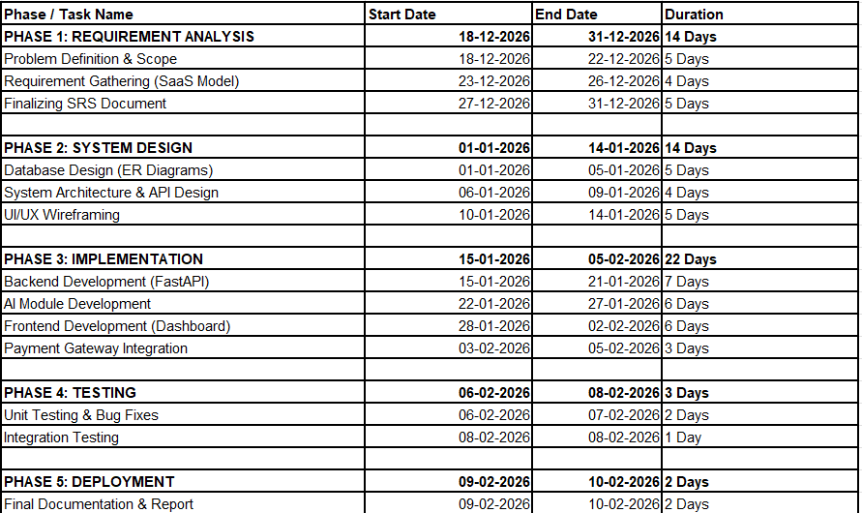

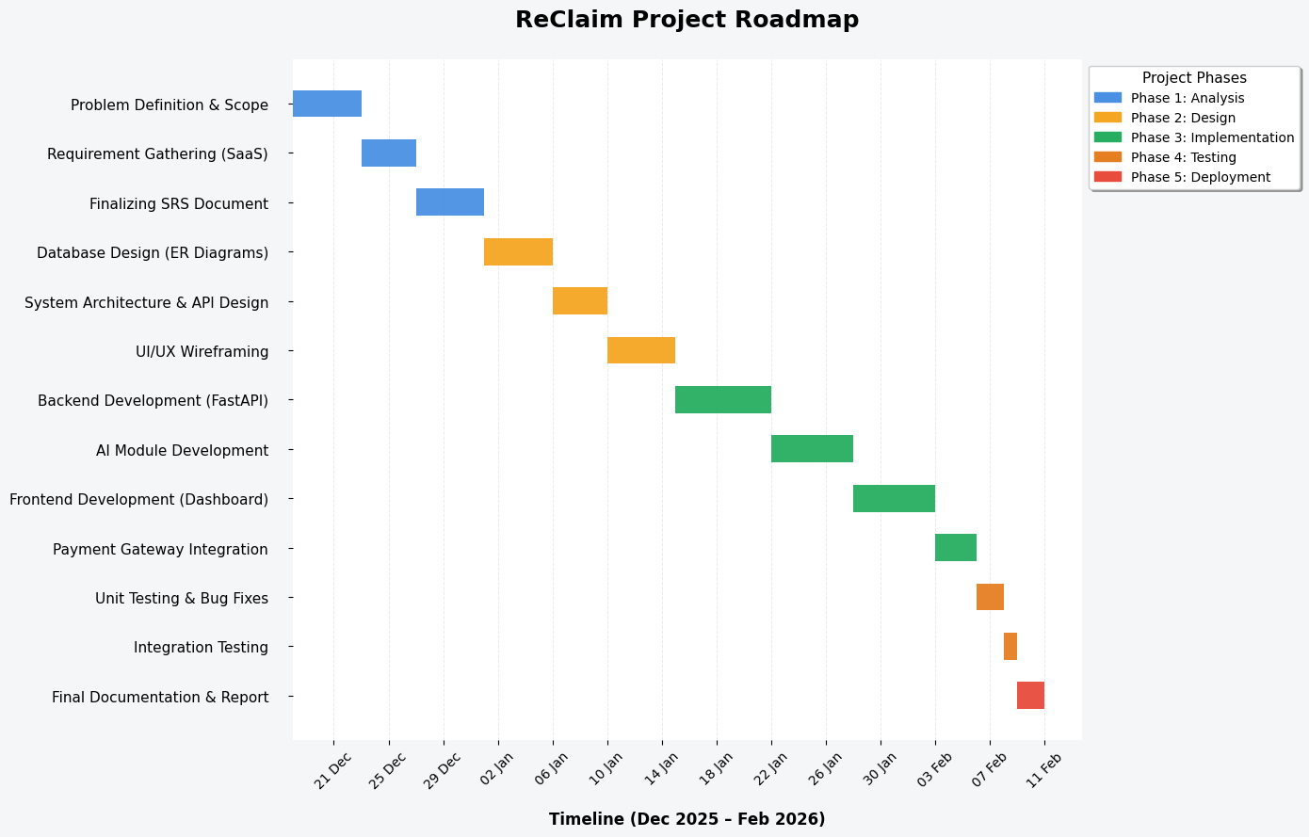

**3.4 Software and Hardware Requirements**

**Server / Development Environment** The development and hosting of the backend, especially the AI module, require significant computational power.

* Processor (CPU): Intel Core i5 (10th Gen or higher) or AMD Ryzen 5. A multi-core processor is essential for handling concurrent API requests and generating vector embeddings.
* RAM: Minimum 16 GB DDR4. The AI model (for image recognition) and the database service (PostgreSQL) are memory-intensive.
* Storage: 512 GB SSD (NVMe recommended). Fast read/write speeds are critical for retrieving images and database records instantly.
* Network: High-speed broadband connection (minimum 50 Mbps) for seamless cloud deployment and API testing.

**Client-Side (End User)** Since the application is accessed via a web browser, the client-side requirements are minimal.

* Device: Any modern laptop, desktop, tablet, or smartphone.
* Processor: Basic dual-core processor (e.g., Intel Core i3 or mobile equivalent).
* RAM: Minimum 4 GB.
* Web Browser: Latest versions of Google Chrome, Mozilla Firefox, Safari, or Microsoft Edge.

**3.5. Conceptual Models**

A conceptual model is a high-level representation of a system that uses abstract concepts to help stakeholders understand, simulate, and communicate the subject the model represents. For the Reclaimed project, conceptual modeling serves as a bridge between the software requirements and the actual technical implementation. It visualizes how the SaaS architecture handles multi-tenancy, how the AI matching engine processes data, and how different users (Super Admin, Business Admin, Staff) interact with the system.

These models provide a blueprint for the project's resources, rules, and data flows, ensuring that the development team and stakeholders share a unified vision of the platform before coding begins.

**3.5.1 ENTITY RELATIONSHIP DIAGRAM**

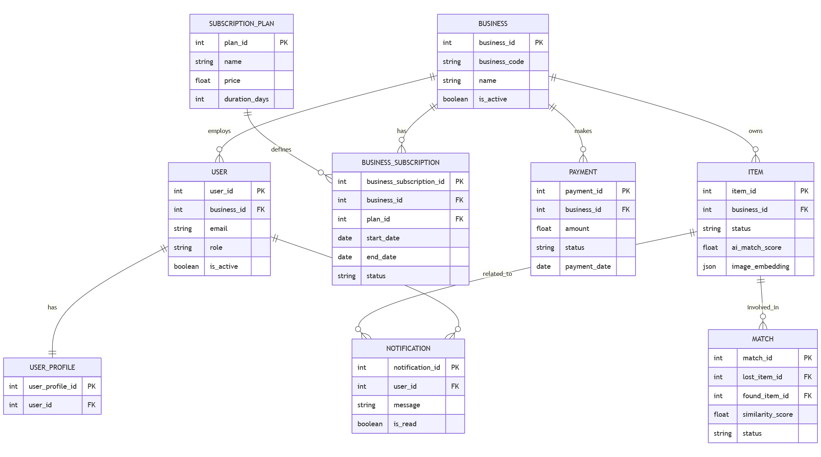

**3.5.2 DATA FLOW DIAGRAM**

**DFD(level-0):**

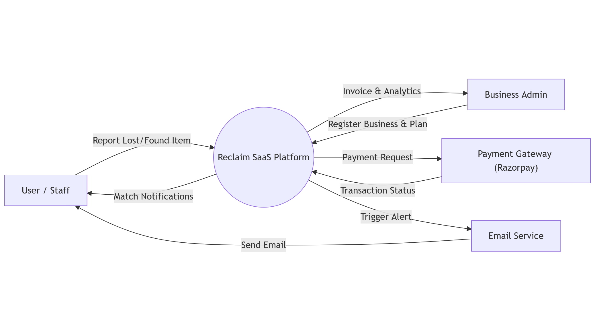

**DFD(level-1):**

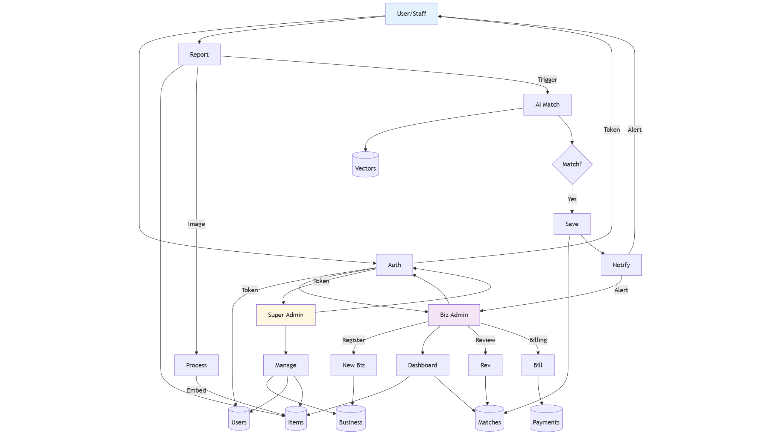

**3.5.3 USE CASE DIAGRAM**

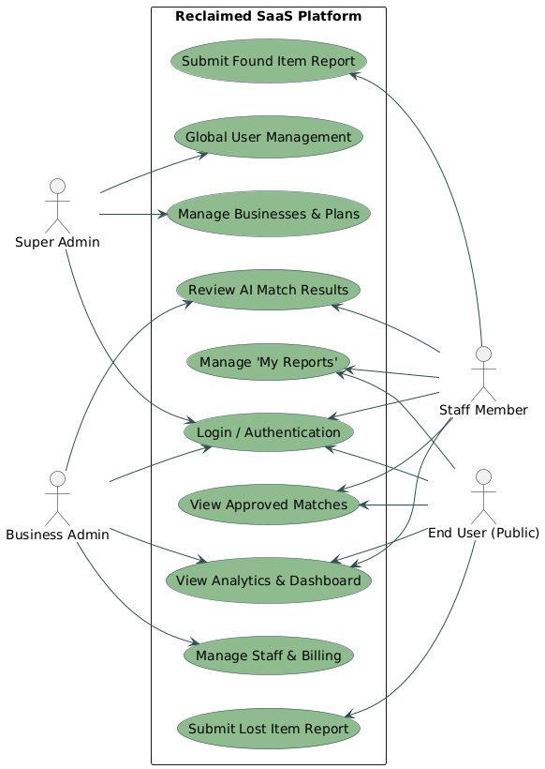

**3.5.4 SEQUENCE DIAGRAM**

**Super_admin**

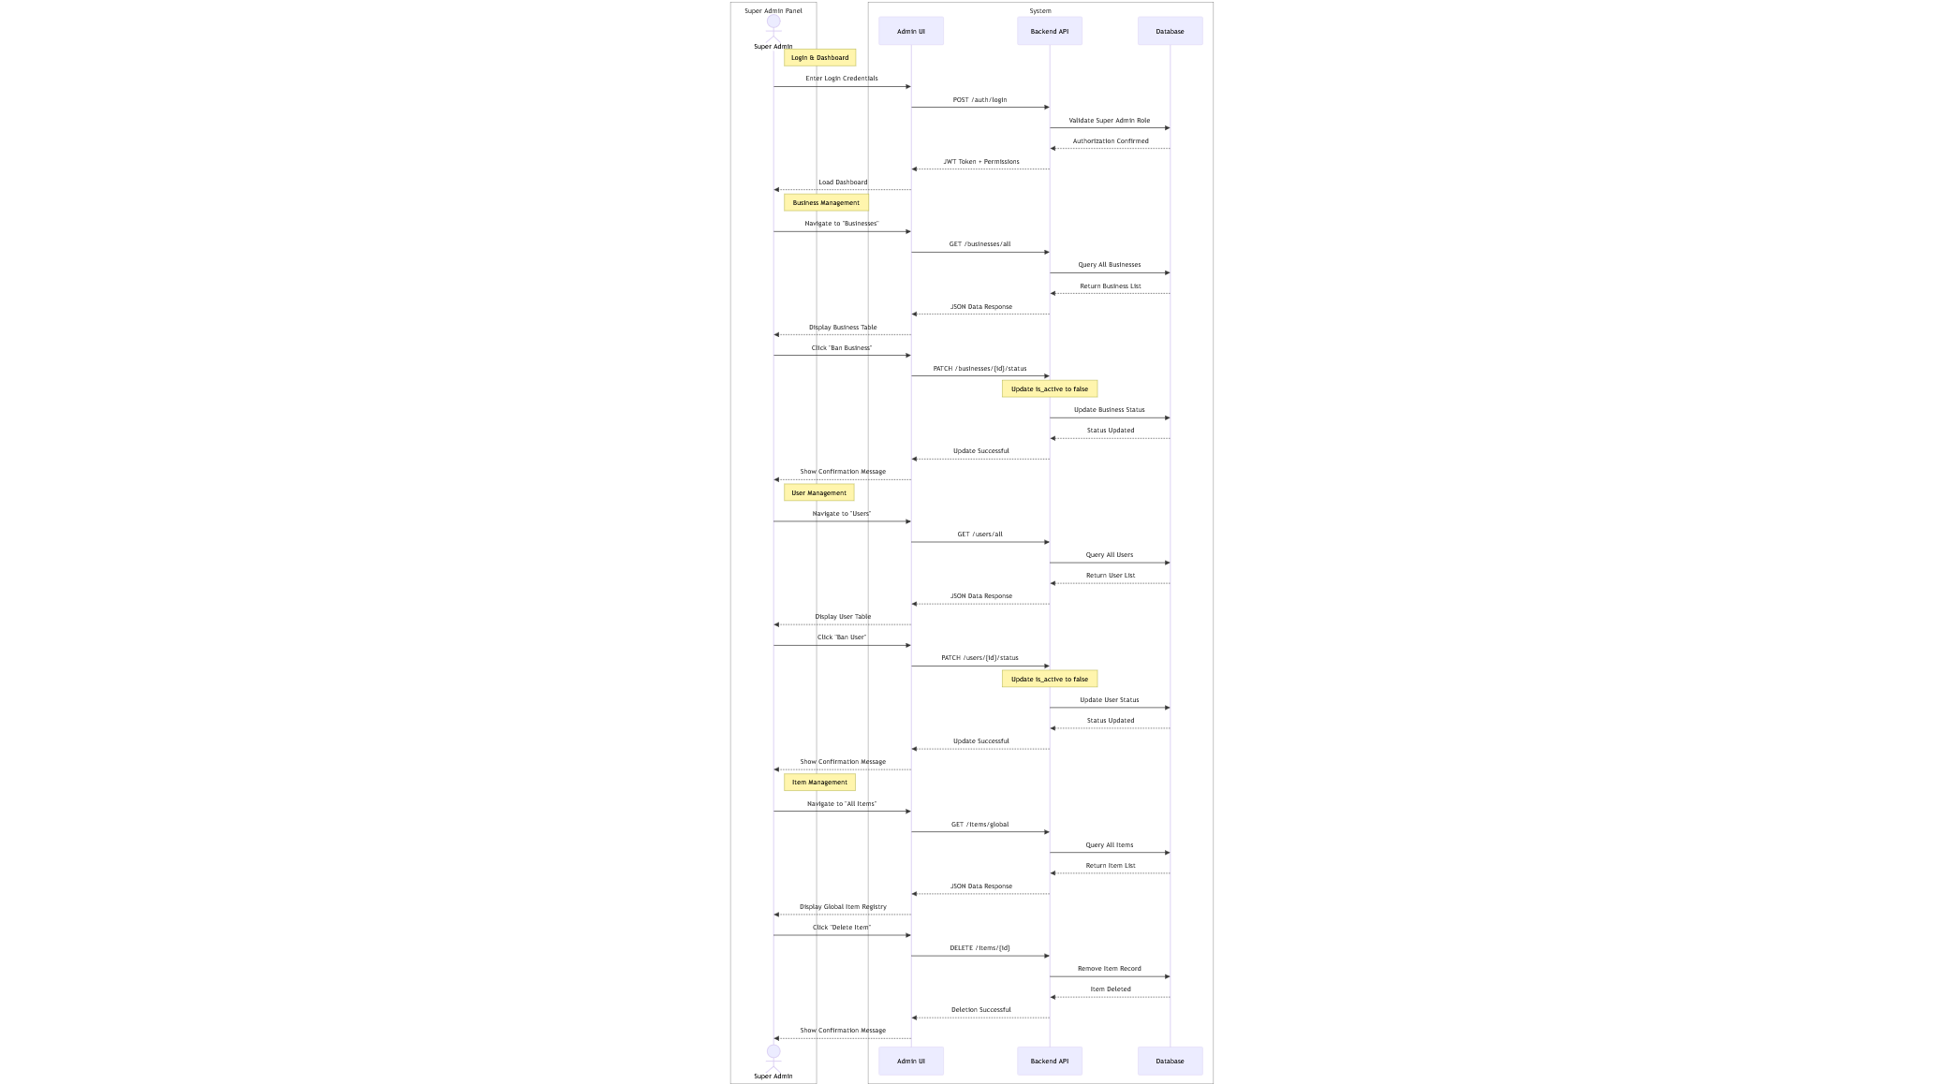

**Admin**

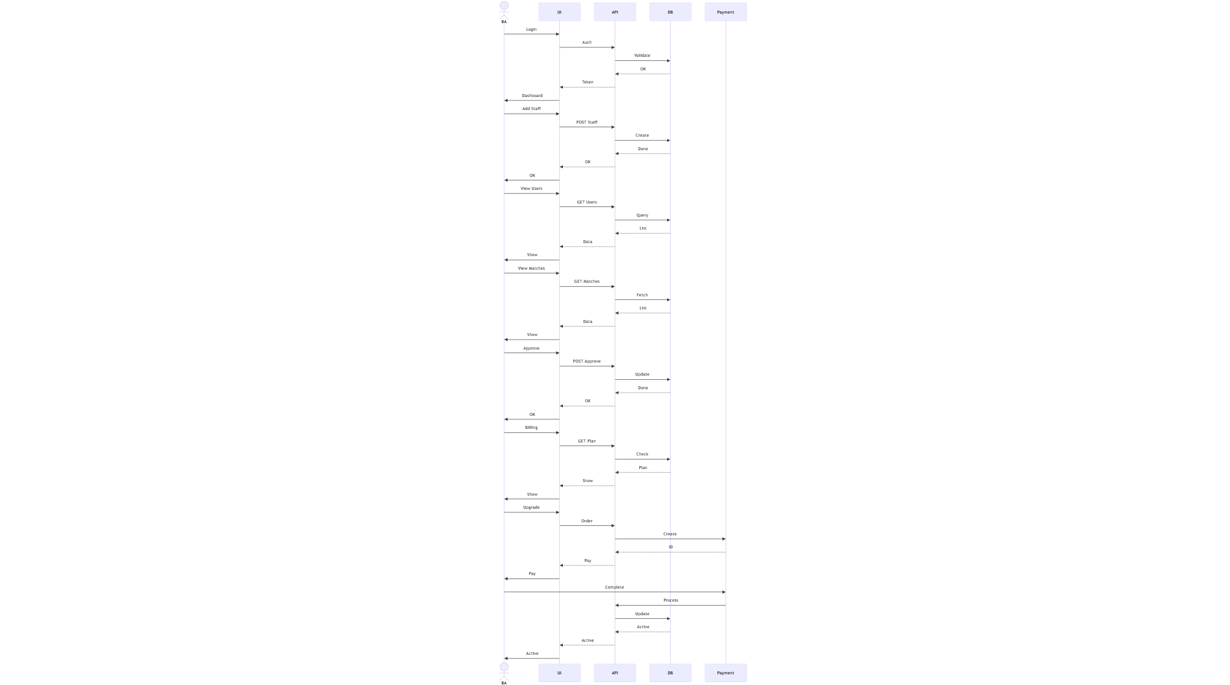

**Staff**

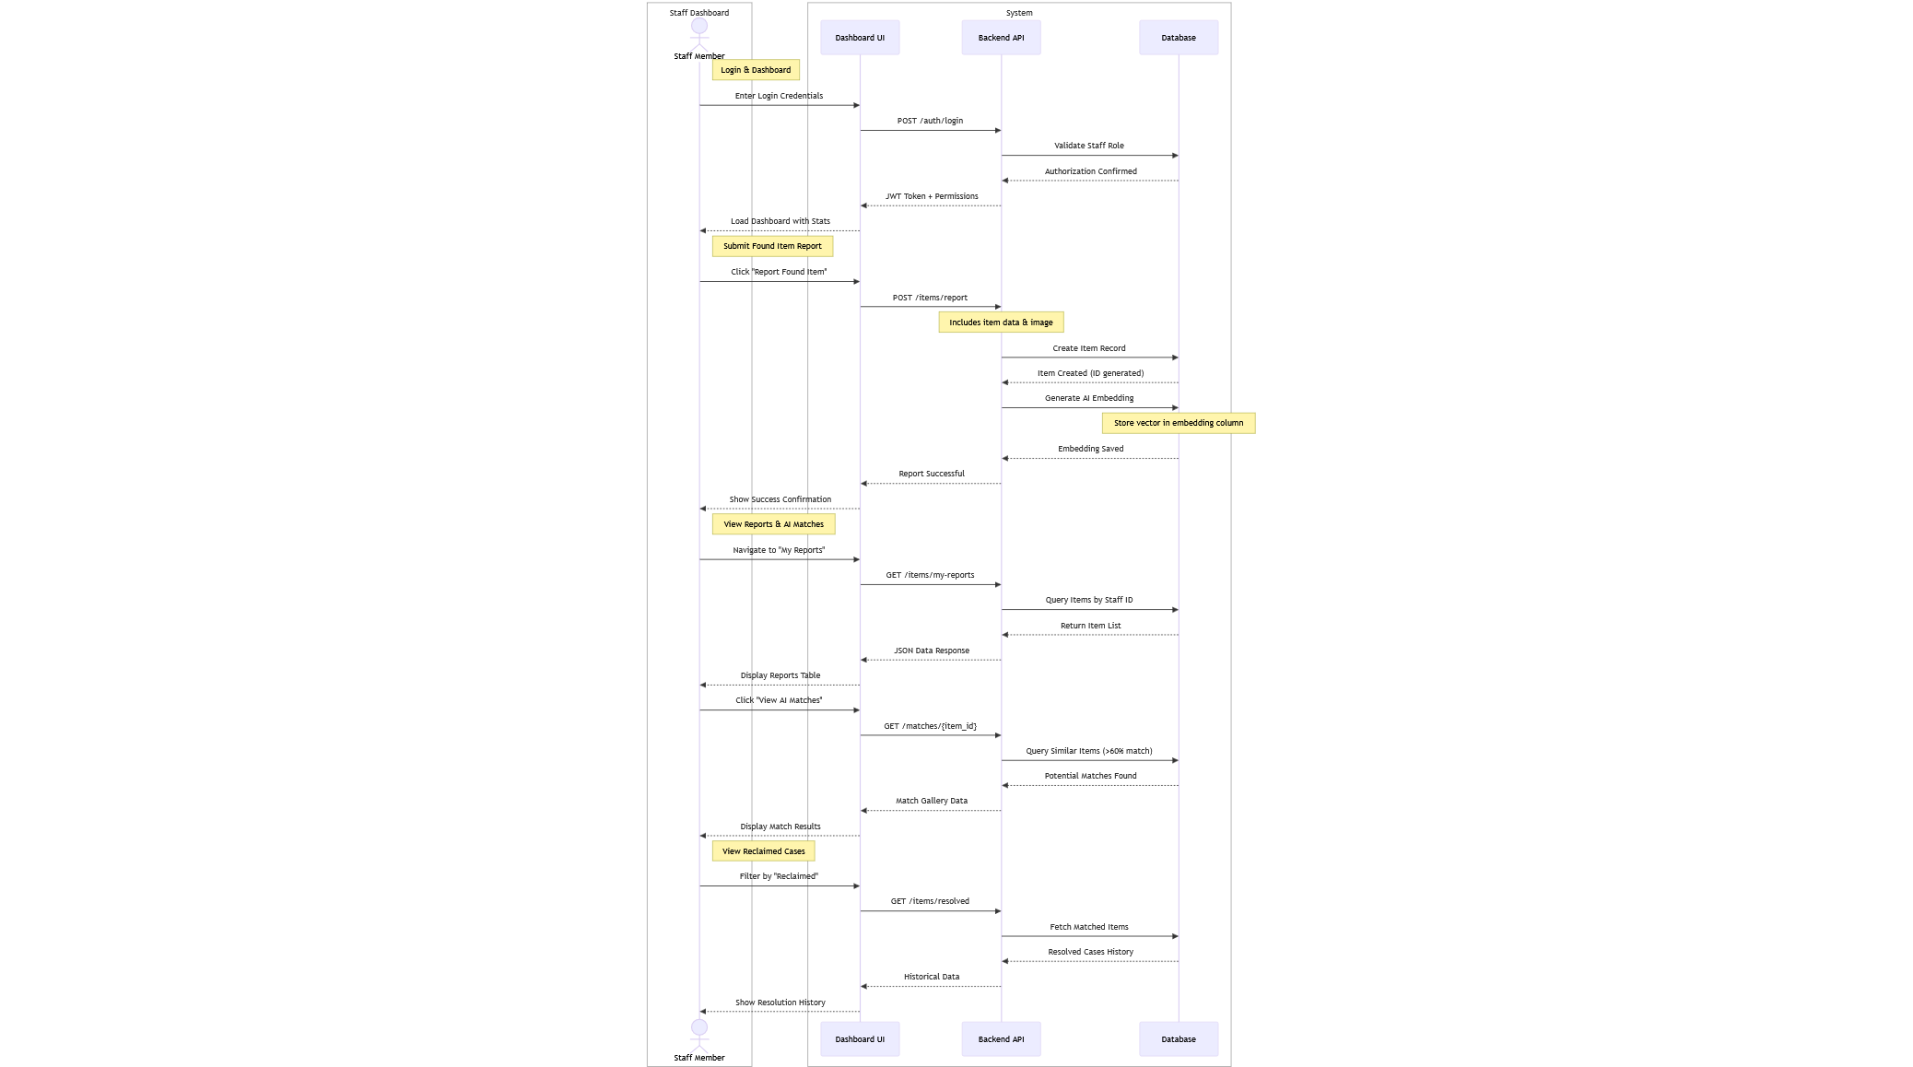

**End user**

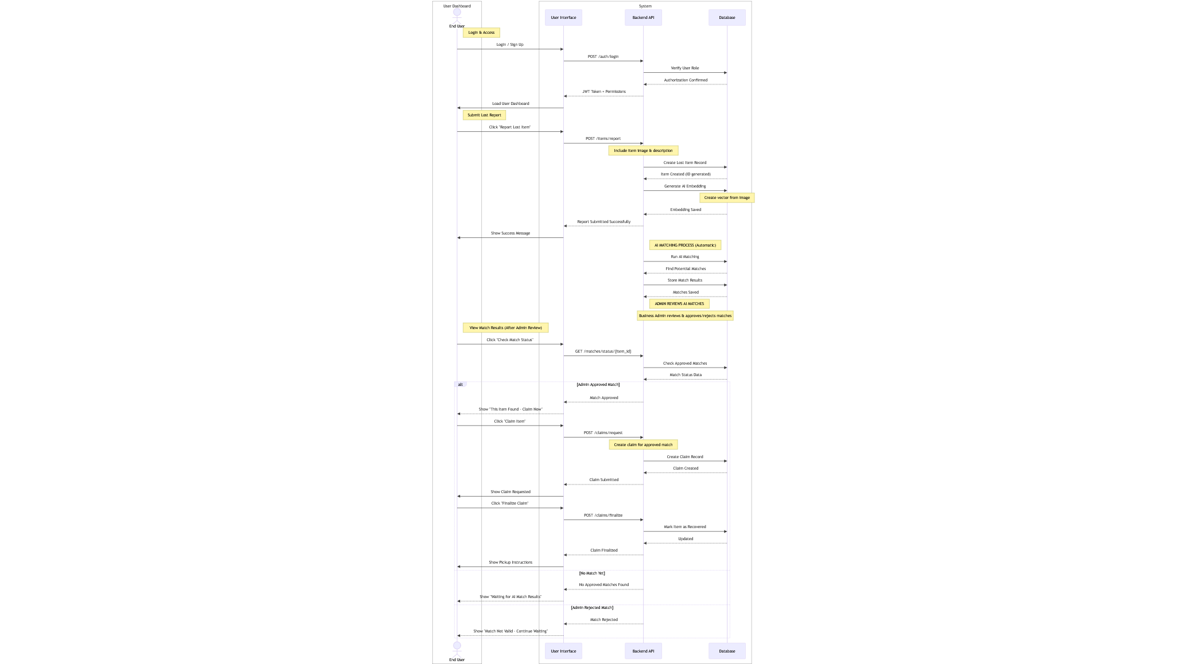

**CHAPTER 4- SYSTEM DESIGN**

**4.1 Basic Modules**

**Authentication & User Access Module**

This module handles secure login and access control for Super Admin, Admin, Staff, and End Users.  
Users are authenticated using valid credentials, and role-based permissions are applied to restrict or allow access to system features.  
This ensures security and proper usage of the ReClaim platform.

**Business Registration & Management Module**

This module manages the onboarding of businesses and organizations onto the ReClaim SaaS platform.  
It handles business registration requests, approval status, activation or deactivation of businesses, and linking admins to their respective businesses.  
This module supports the multi-tenant nature of the system.

**User Management Module**

This module allows admins to manage users within their business.  
It supports creating users, updating profiles, assigning roles, suspending accounts, and tracking user activity such as last login time.  
User profile information is maintained separately for better data organization.

**Lost & Found Item Management Module**

This module allows users to report lost items and allows admins or staff to post found items.  
Item details such as description, category, location, images, and status are stored and managed efficiently.  
This module forms the core functionality of the ReClaim system.

**AI Matching & Item Resolution Module**

This module uses AI-based similarity matching to compare lost and found items.  
Potential matches are generated automatically and forwarded to admins for verification and approval.  
Once approved, the item recovery process is completed and recorded in the system.

**Admin Dashboard Module**

This module provides admins with a centralized dashboard to monitor system activity.  
Admins can view reported items, AI match results, user information, and system notifications.  
It helps in efficient system management and decision-making.

**Notification & Alert Module**

This module sends real-time notifications to users regarding match updates, approvals, rejections, or item recovery.  
Notifications help keep users informed about important system events.  
Both system-generated and action-based alerts are supported.

**Subscription & Payment Module**

This module manages subscription plans and payment processing for businesses using the ReClaim platform.  
It handles plan selection, payment verification, subscription status, and plan expiry.  
This module supports the SaaS revenue model of the system.

**4.2. Data Design and Integrity Constraints**

**Users Table**

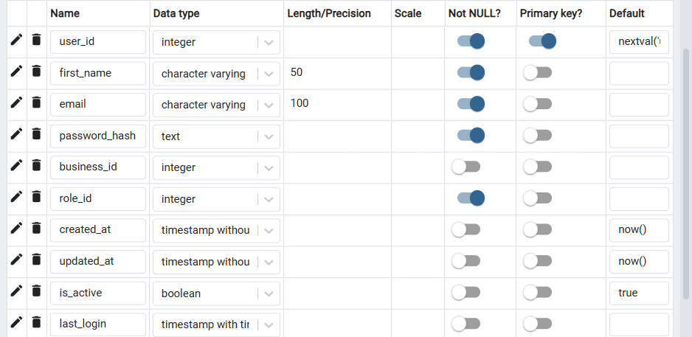

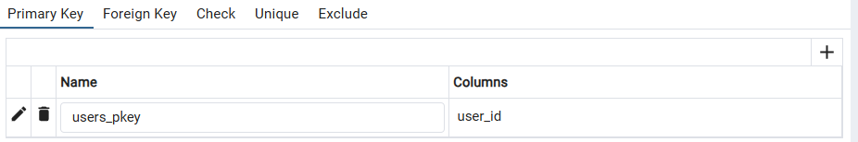

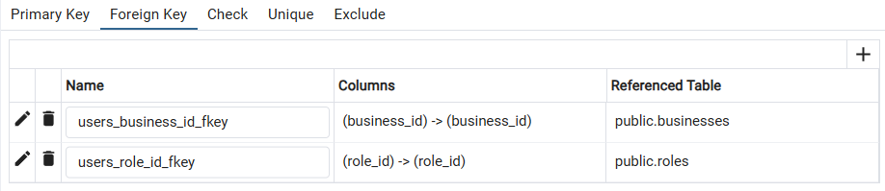

**User_profile**

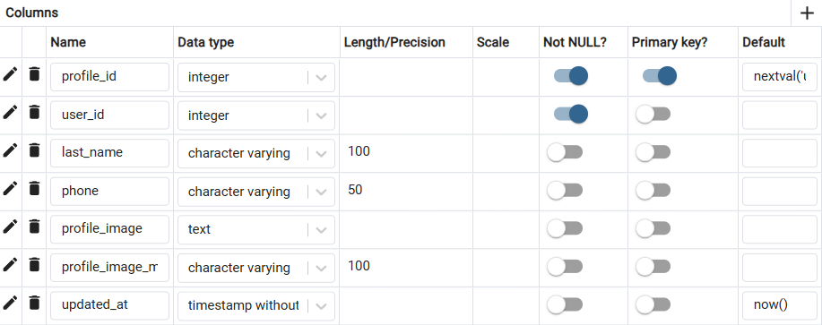

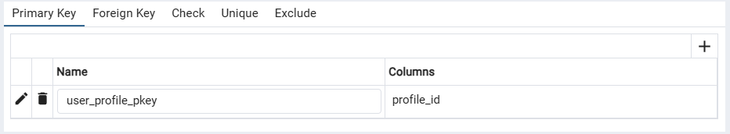

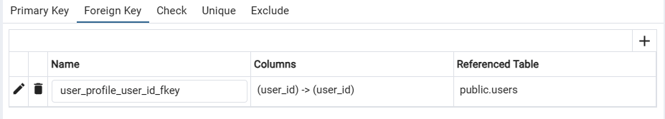

**Subscription_plans**

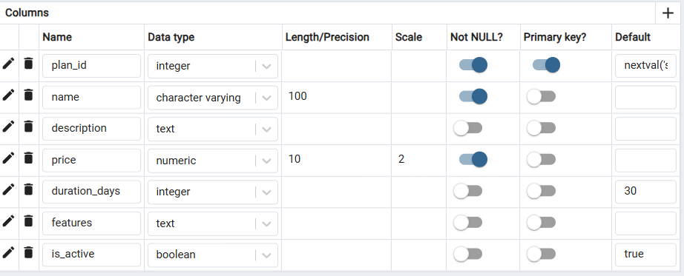

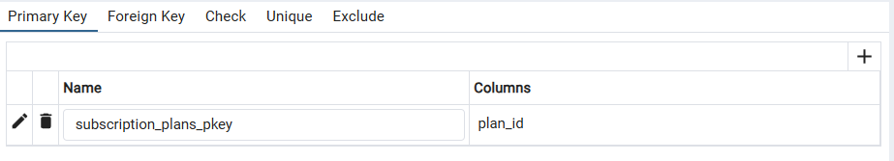

**Roles**

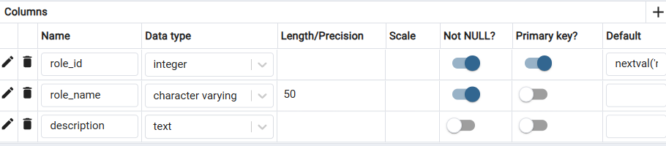

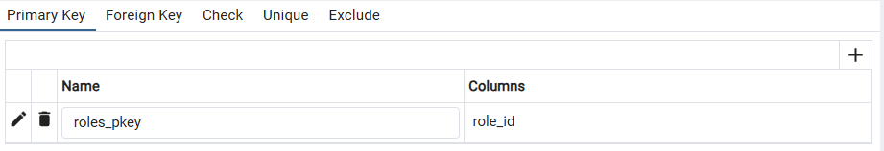

**Payments**

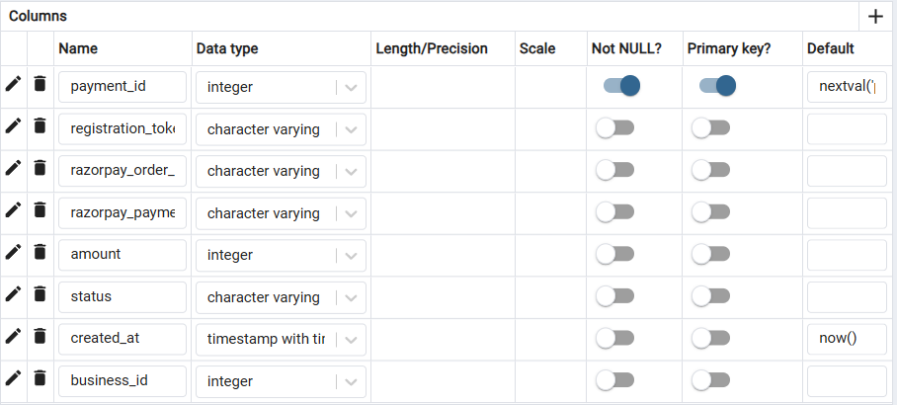

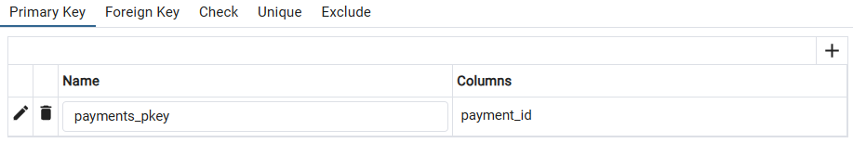

**Notifications**

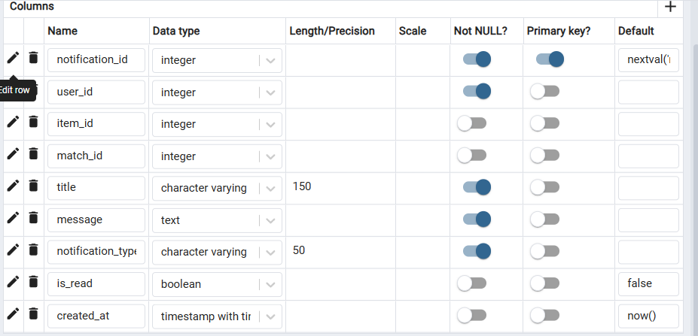

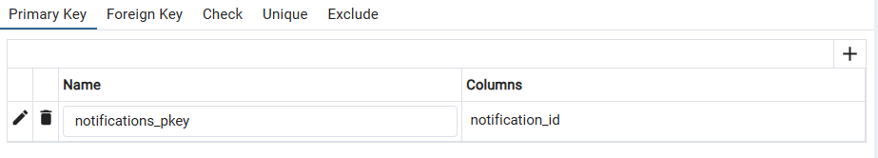

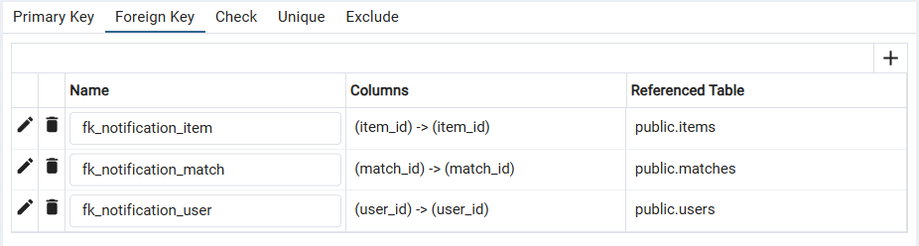

**Matches**

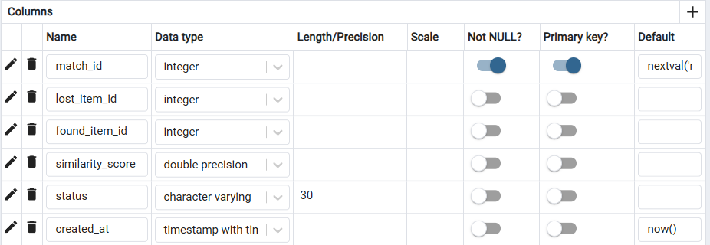

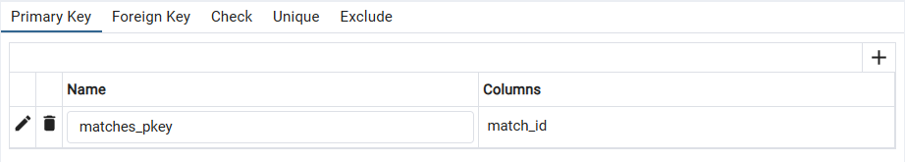

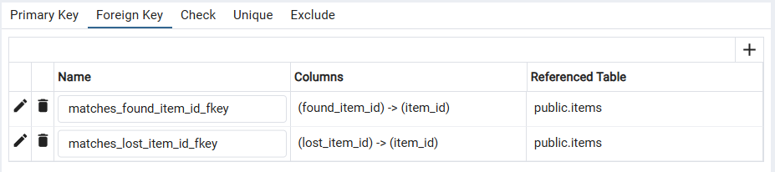

**Items**

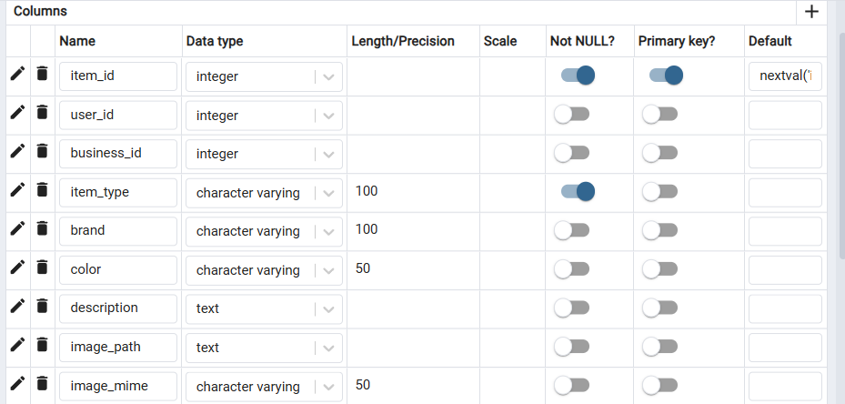

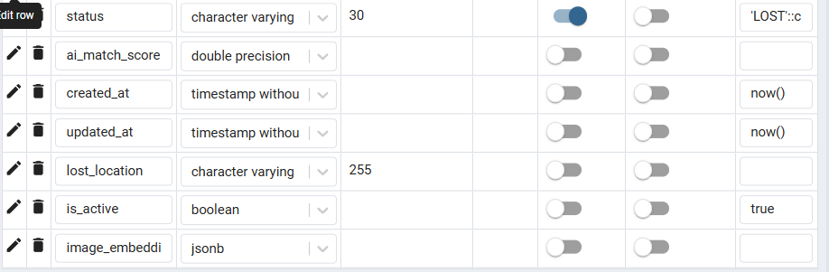

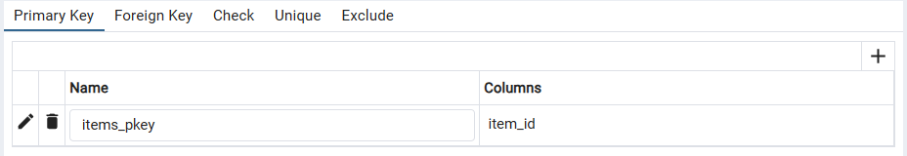

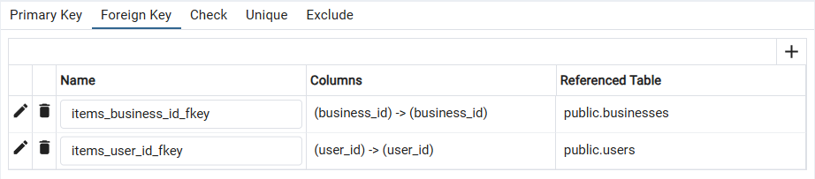

**Businesses**

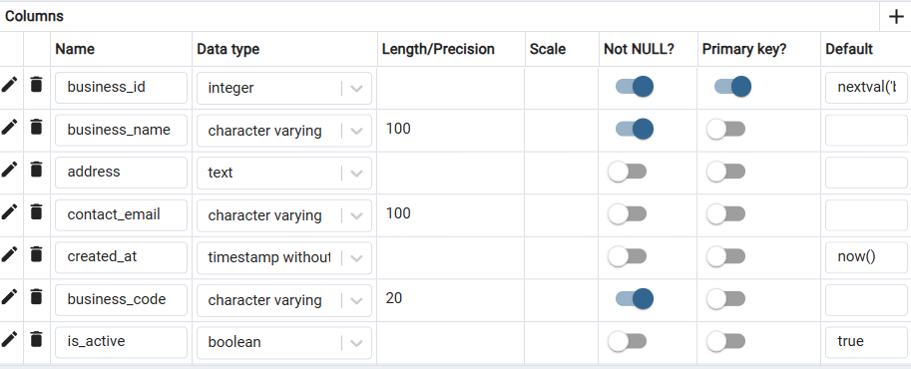

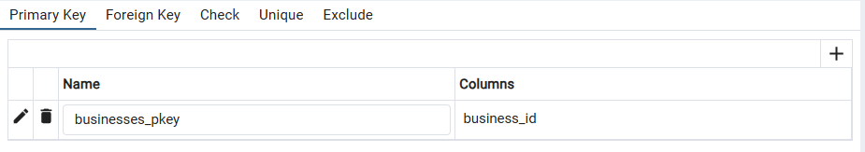

**Business_Subscription**

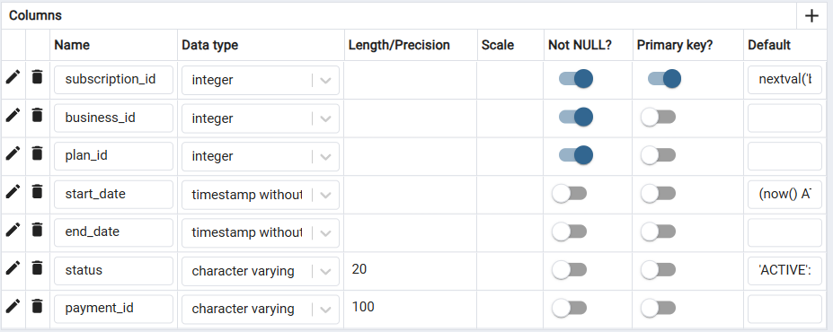

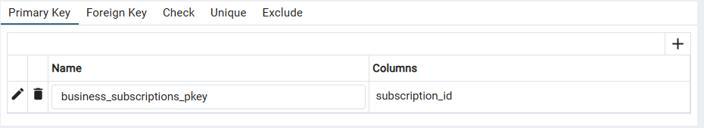

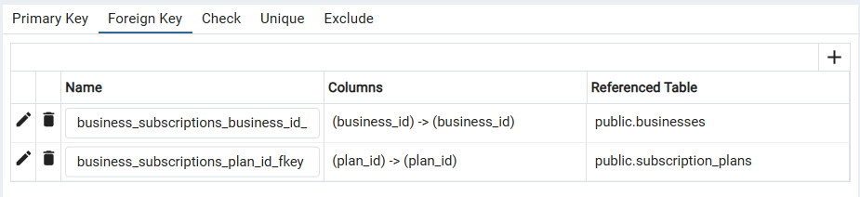

**Business_registration**

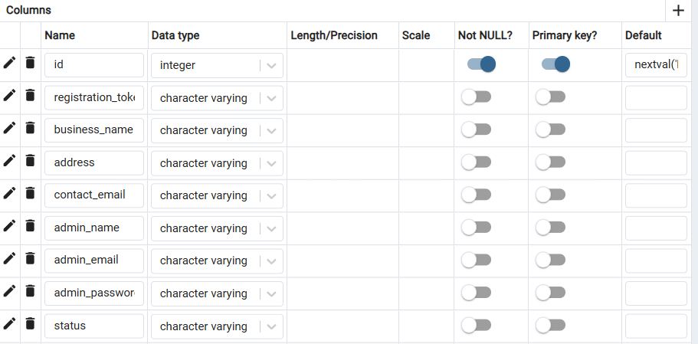

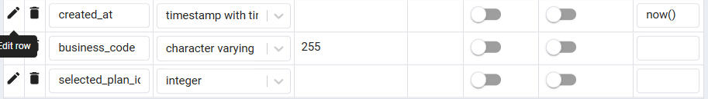

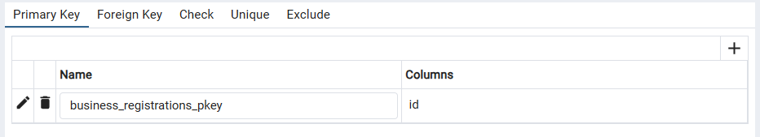

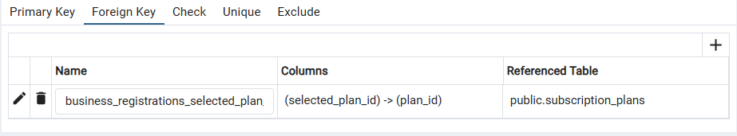

**4.3. User Interface Design**

**Landing**

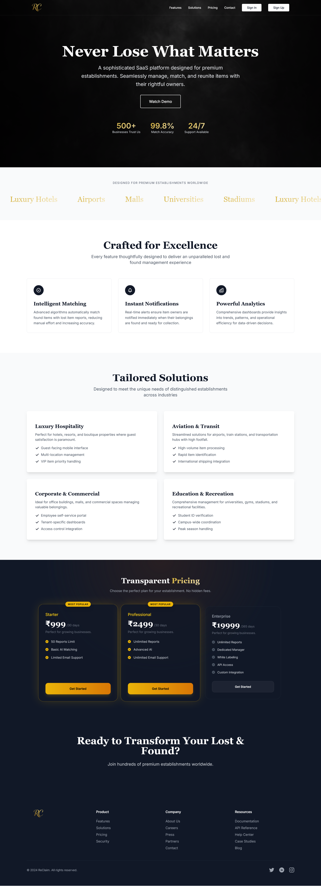

**Registration**

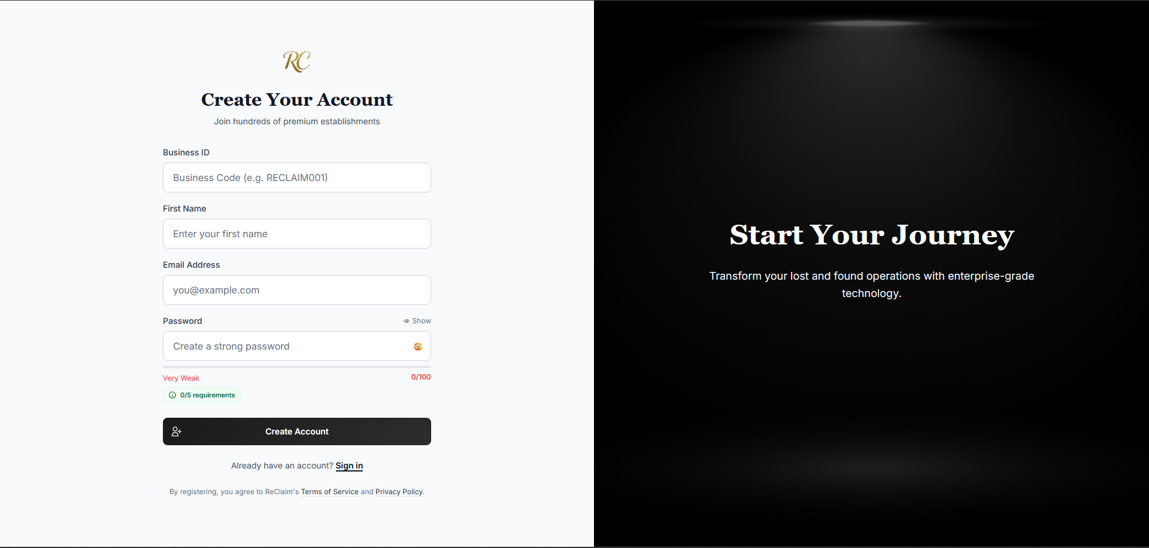

**Login**

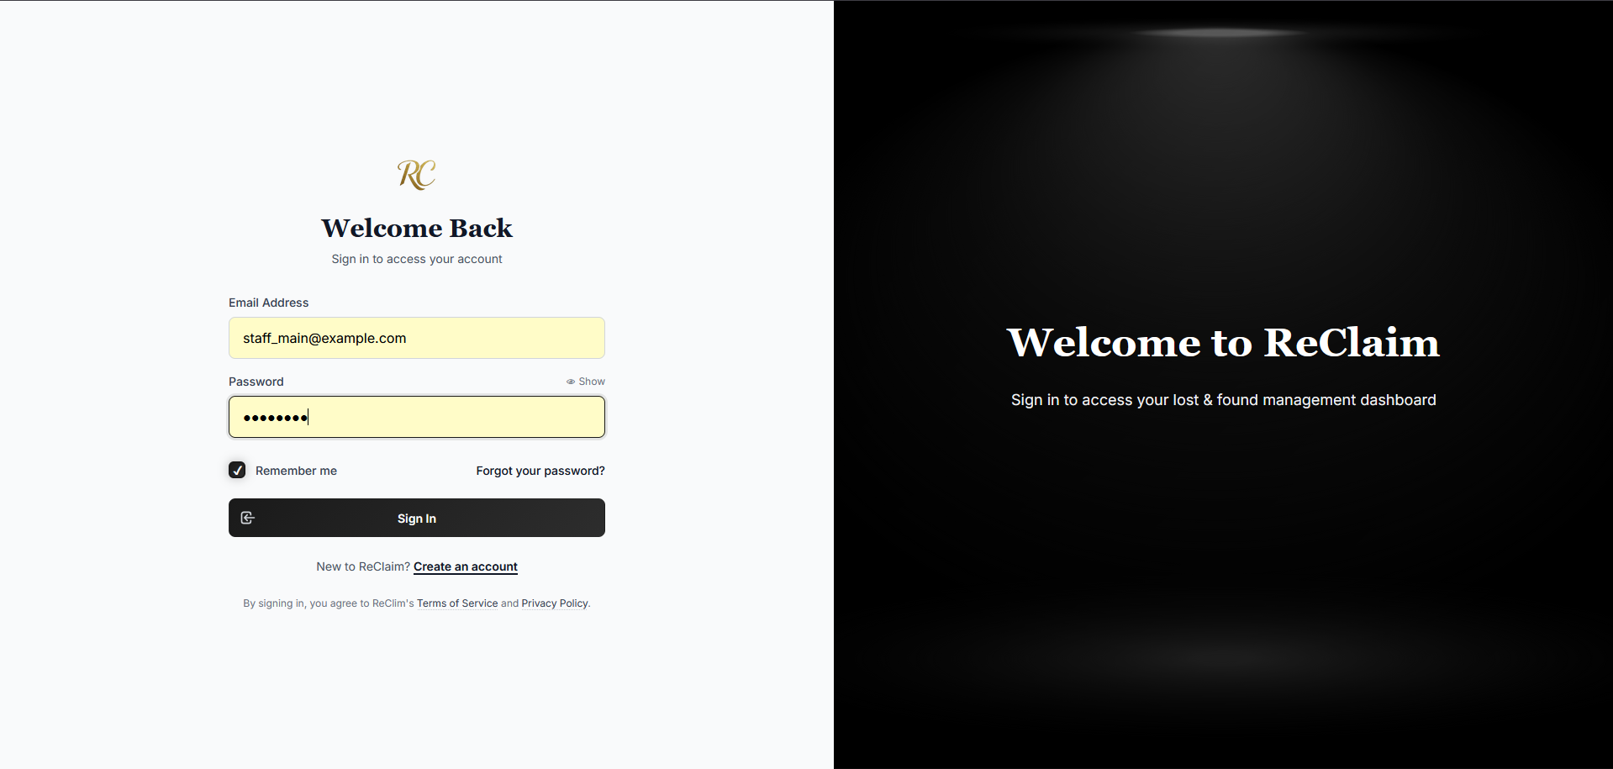

**End user:**

**1.Home**

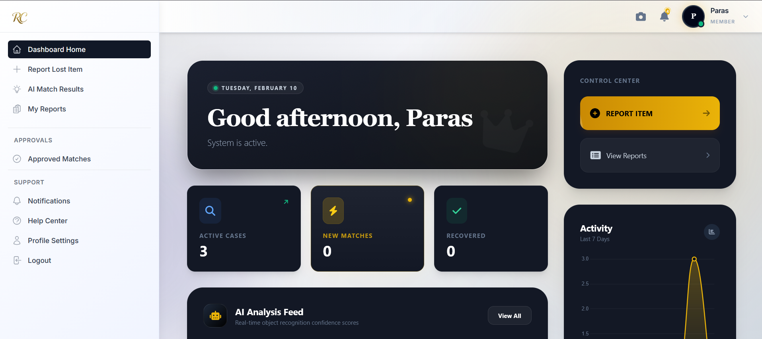

**2.Report Lost Item**

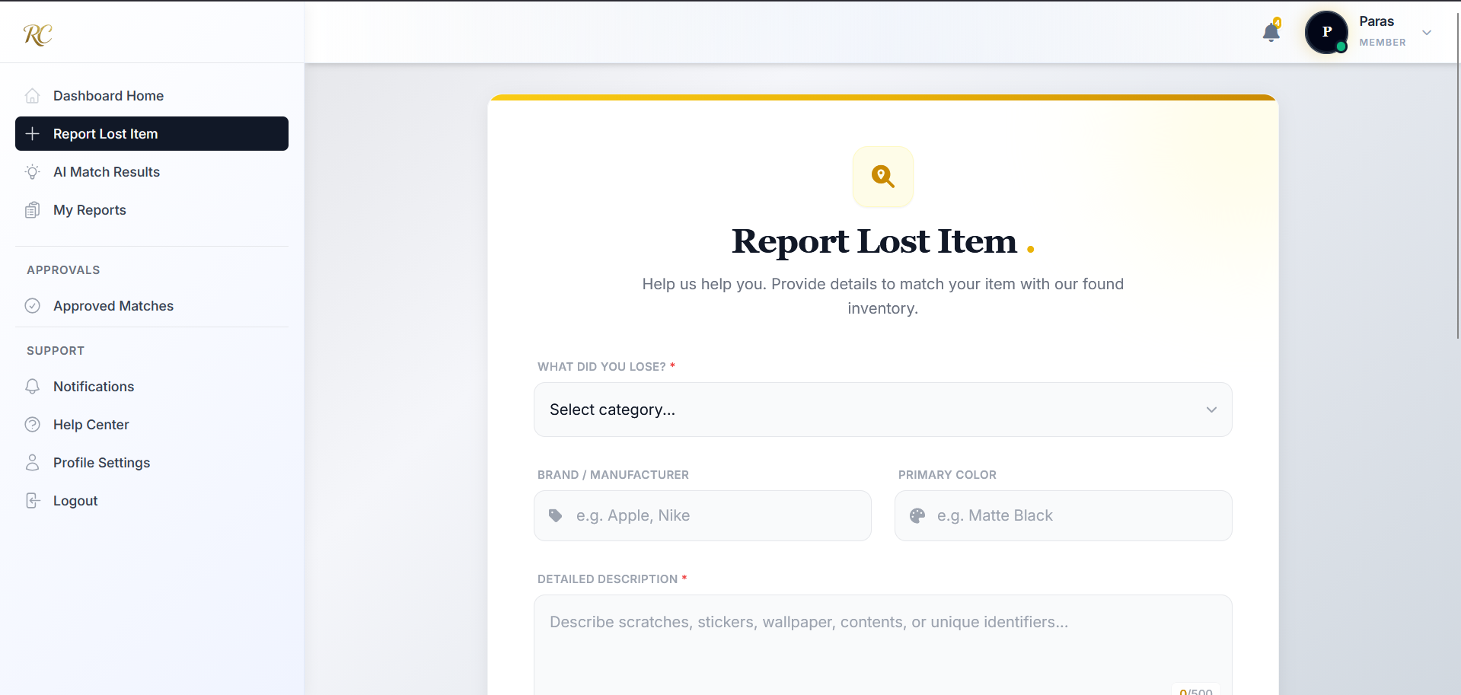

**3.AI Match Results**

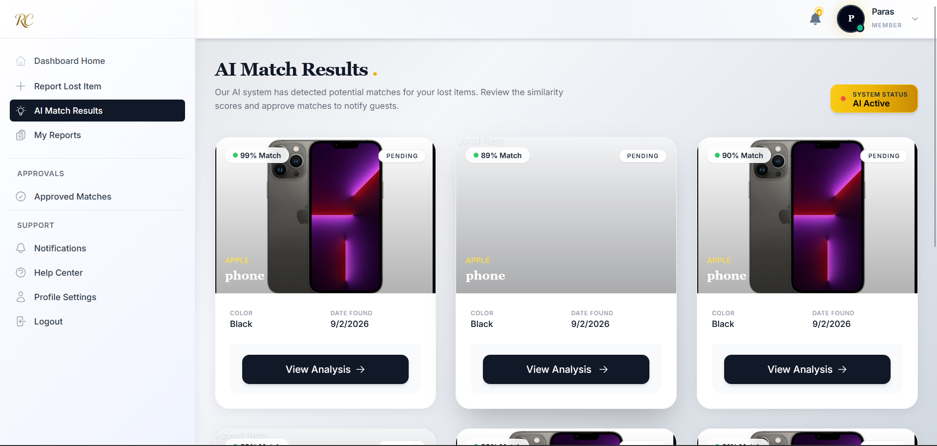

**4.My Reports**

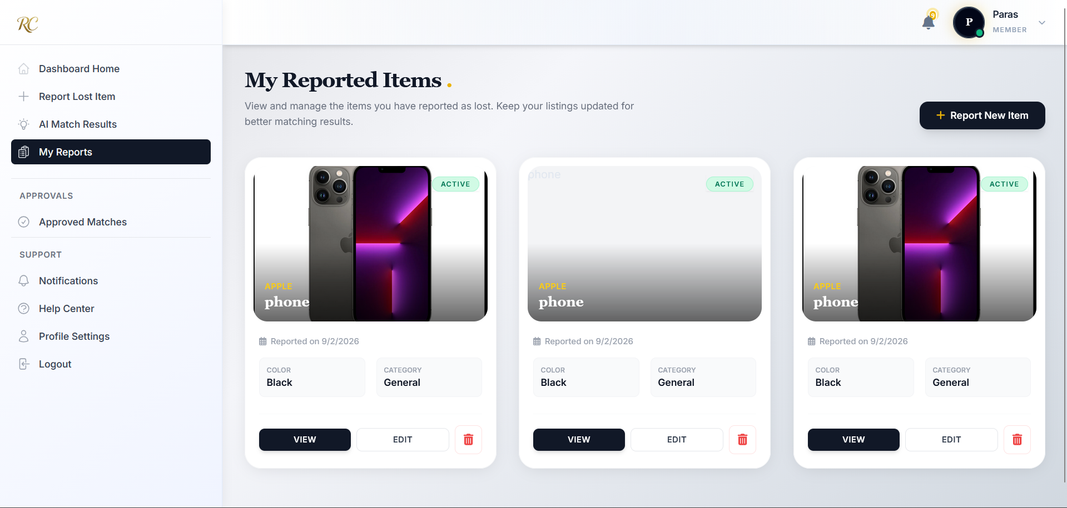

**5.Approved Matches**

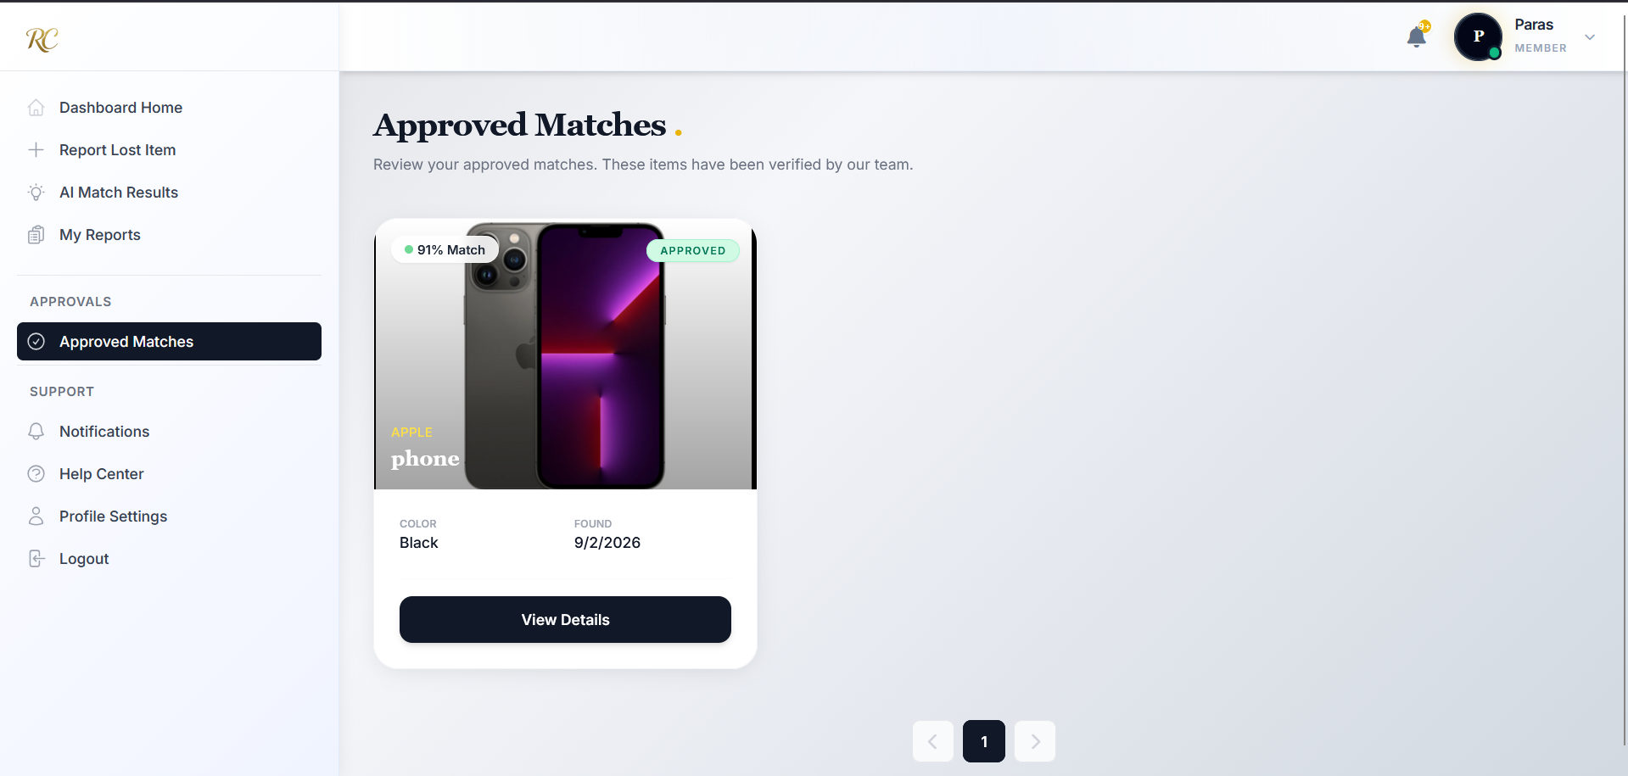

**6.Notifications**

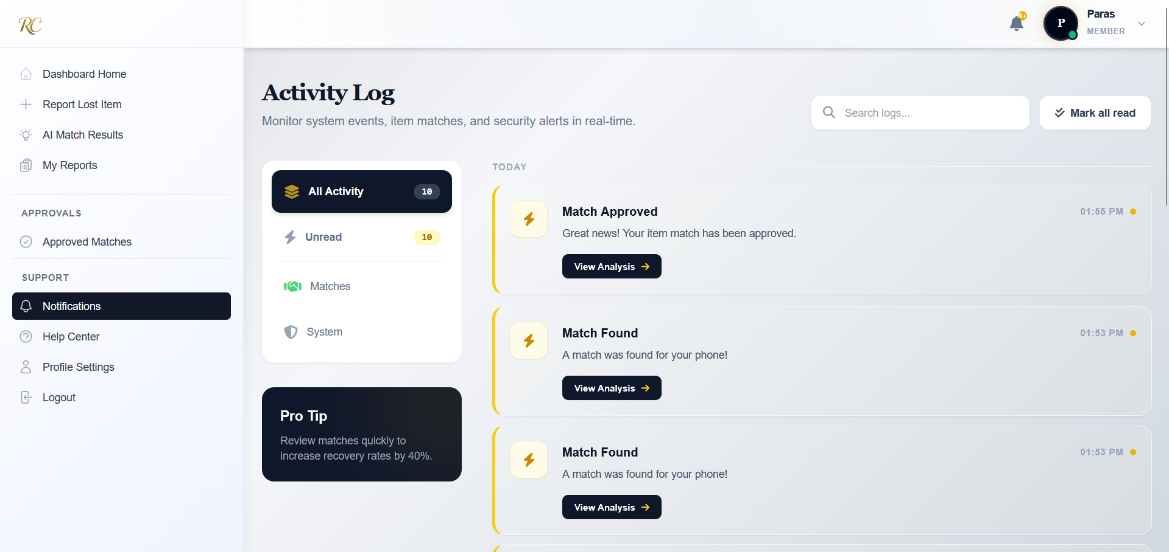

**7.Support**

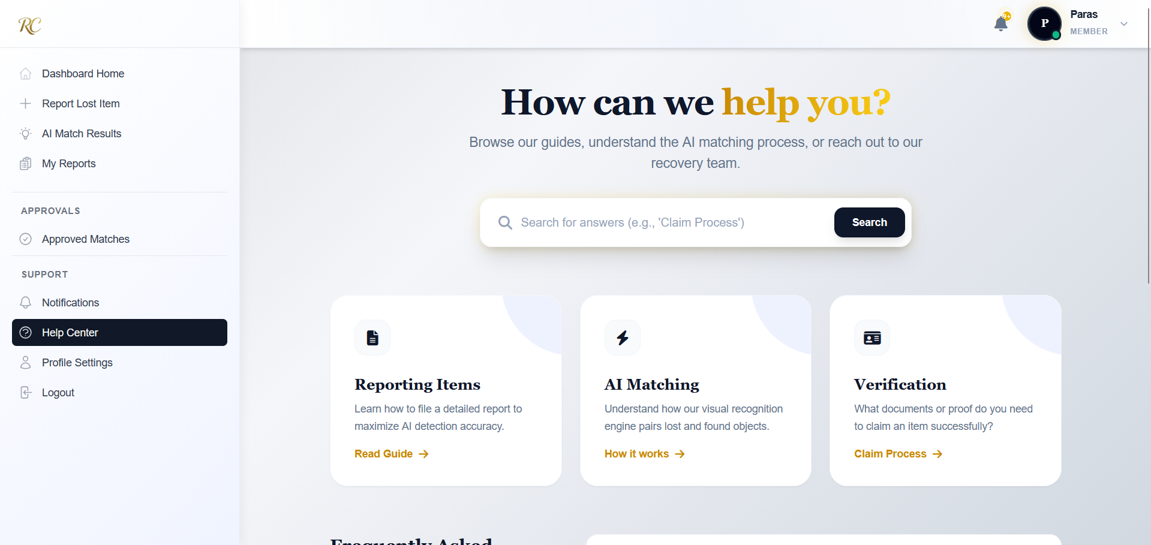

**8.Profile Settings**

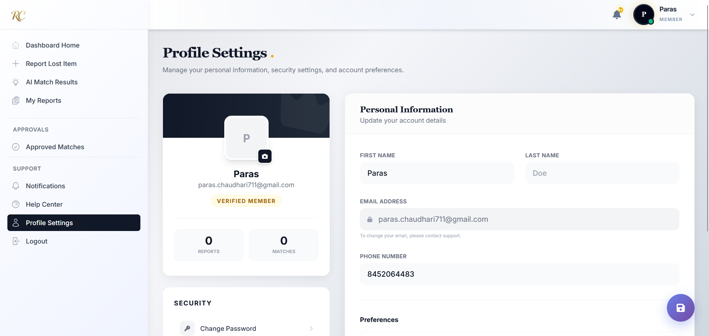

**9.Match Analysis**

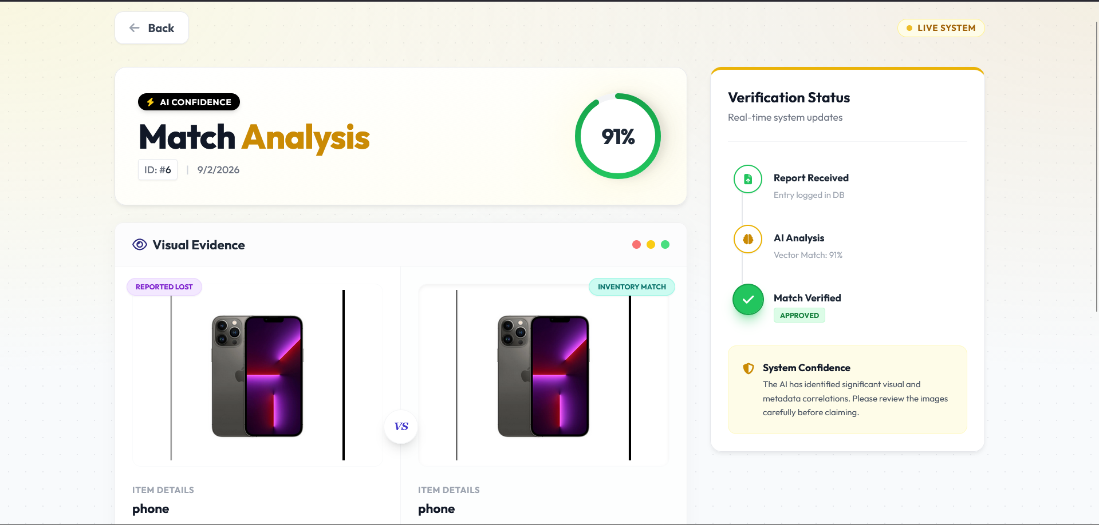

**10.View Report**

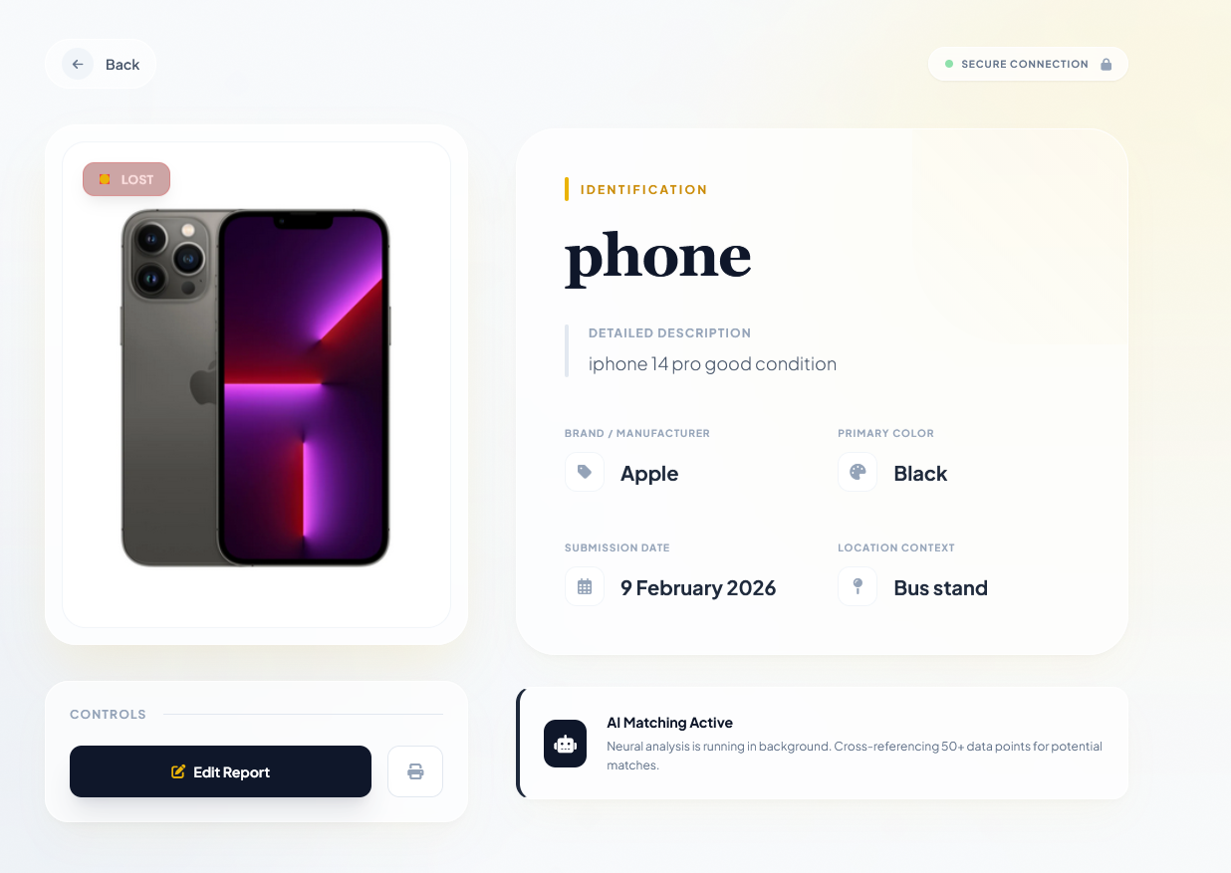

**11.Edit Report**

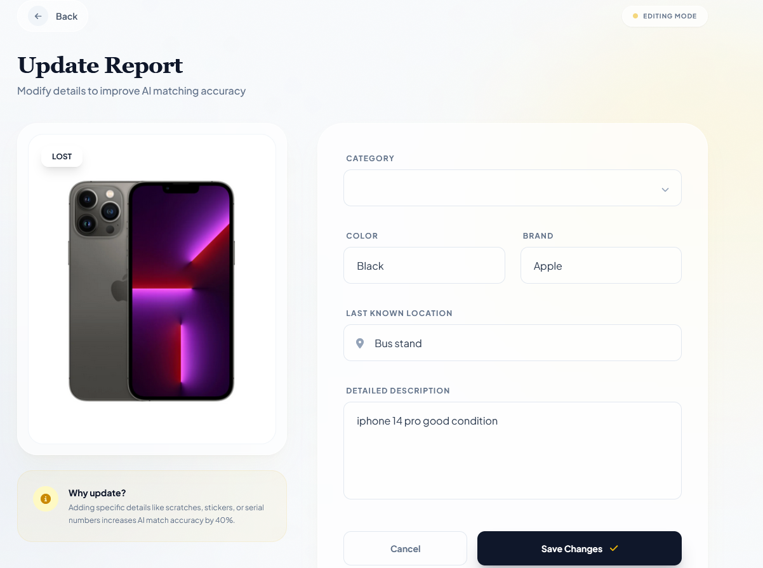

**Staff View:**

**1.Dashboard Home**

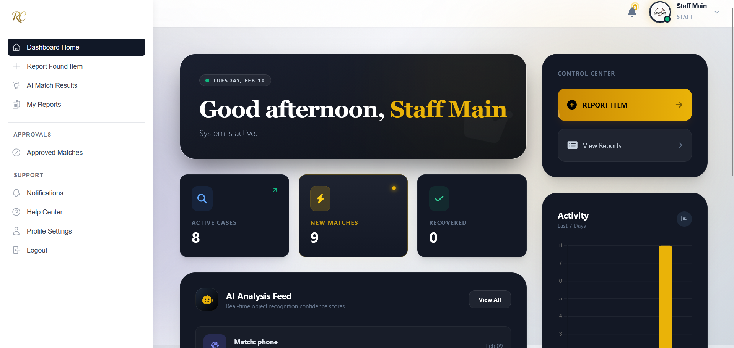

**2.Report Found Item**

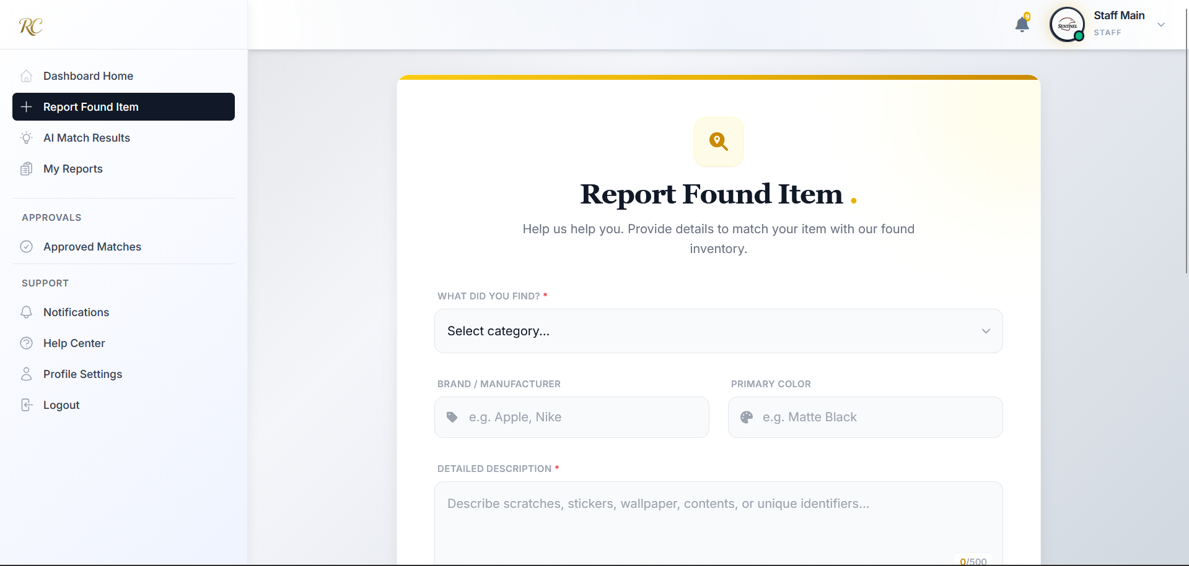

**3.AI Match Results**

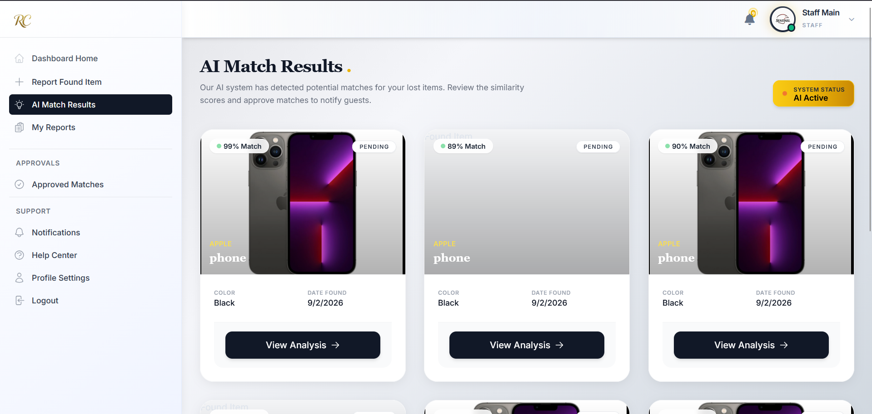

**4.My Reports**

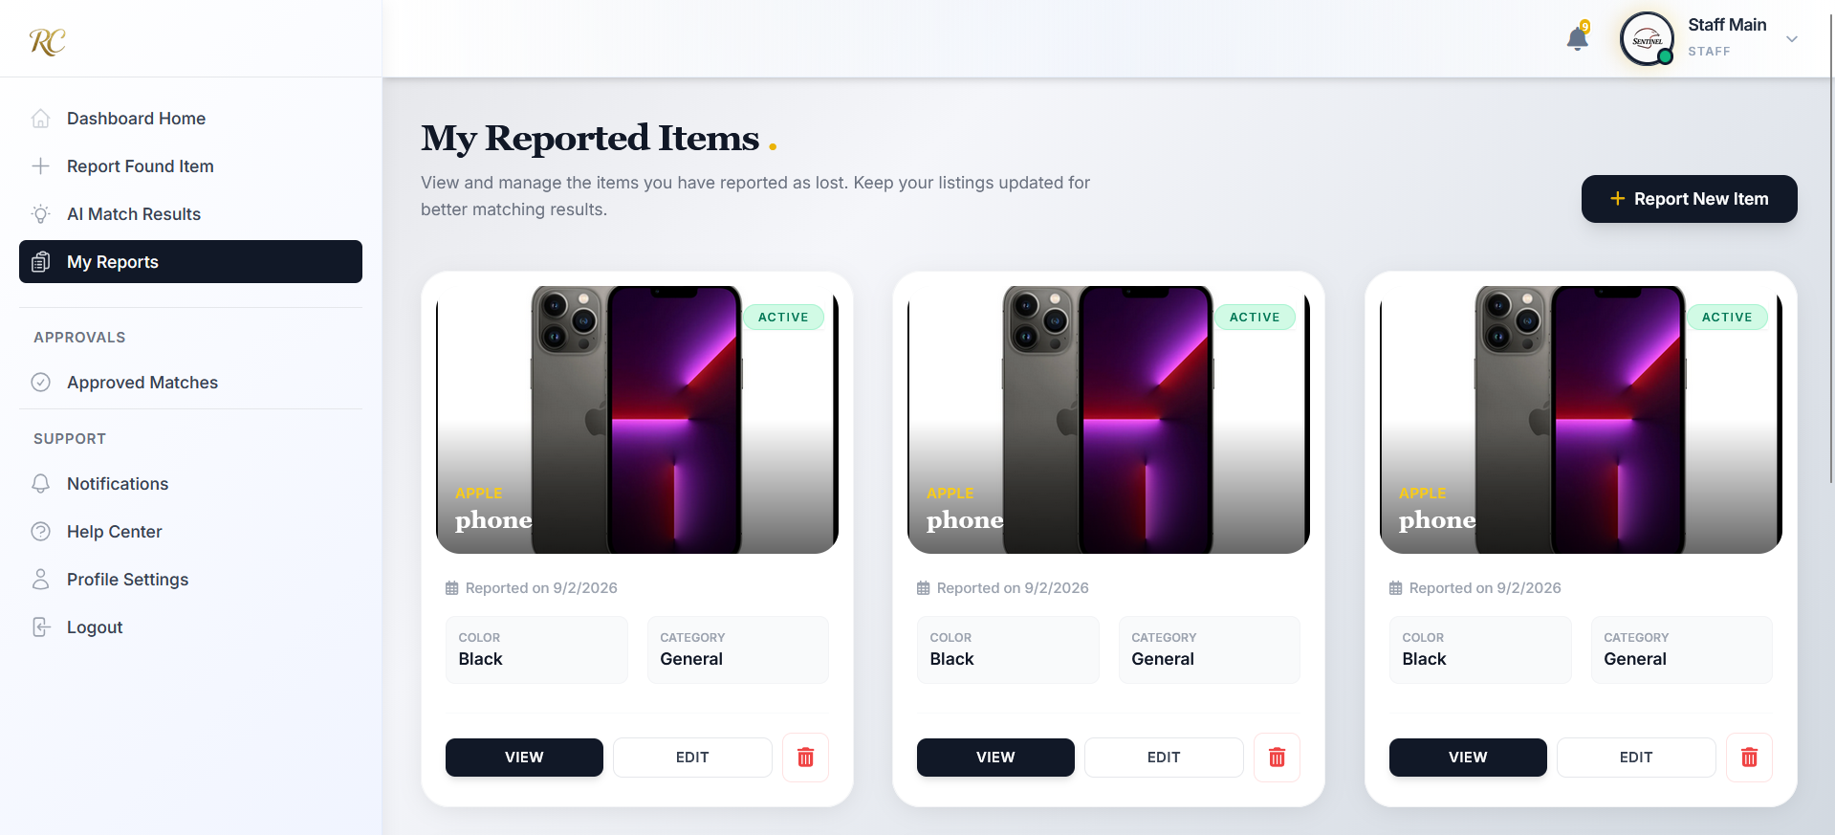

**5.Approved Matches**

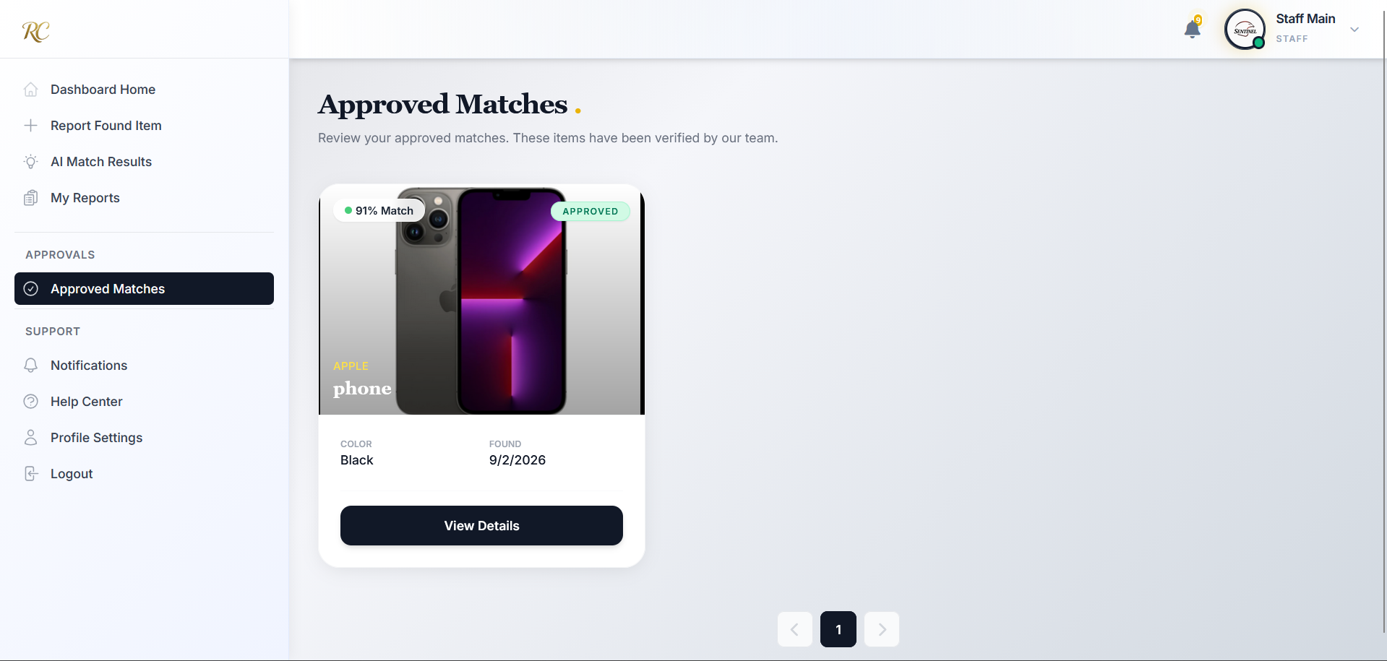

**Admin view:**

**1.Dashboard Home**

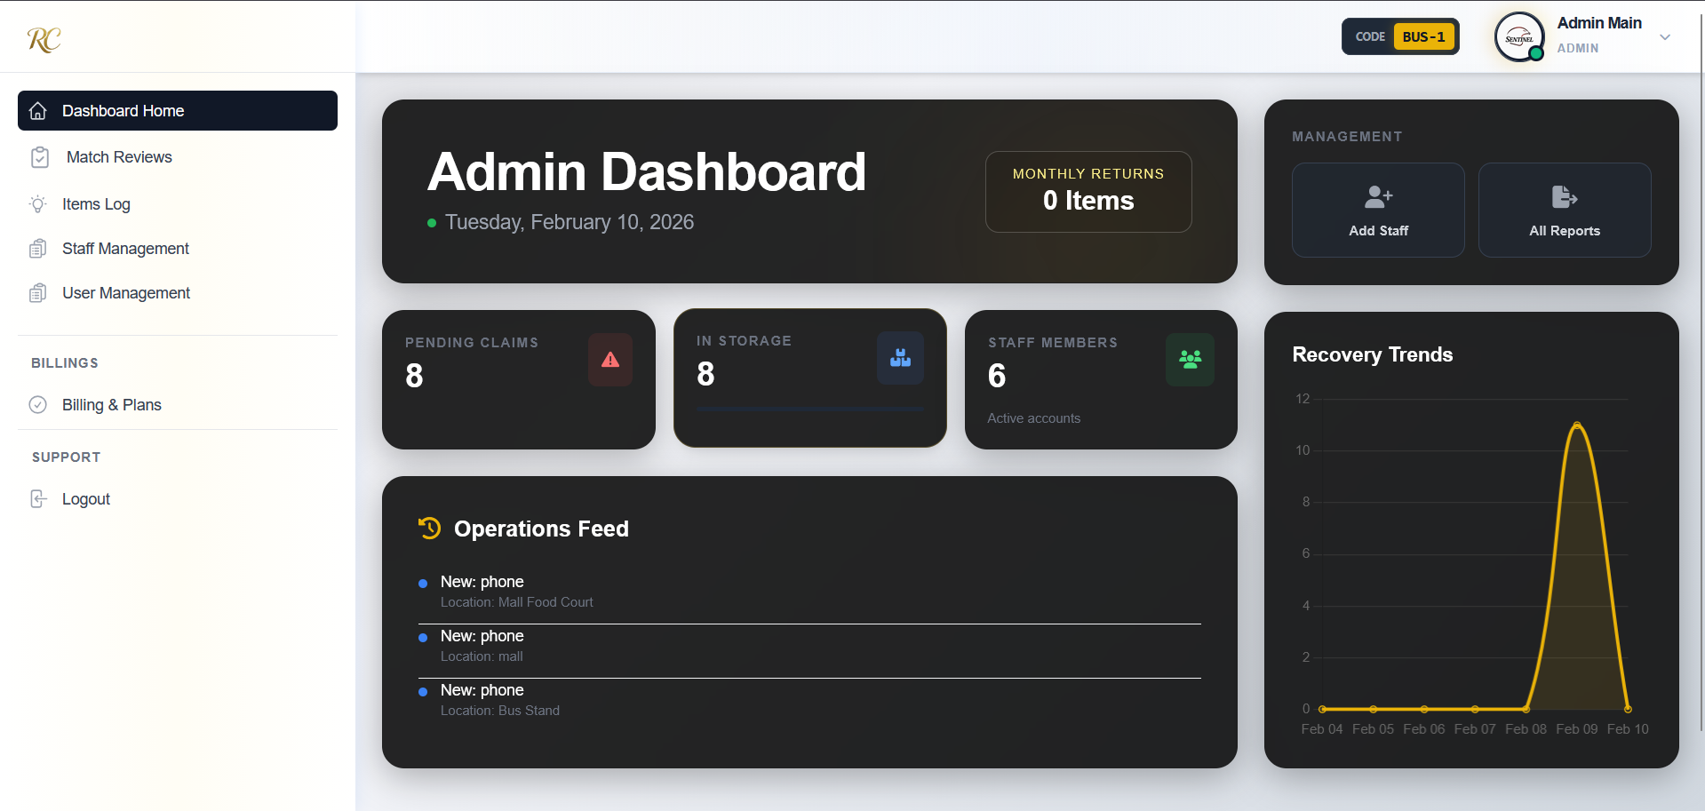

**2.AI Match Results**

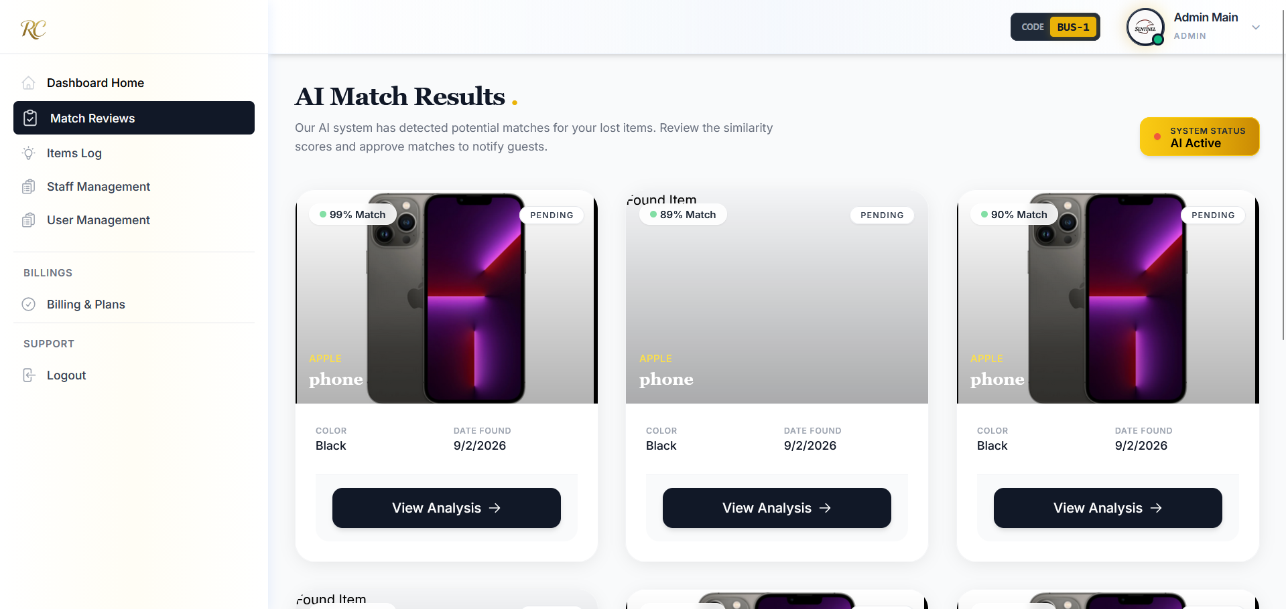

**3.Items Log**

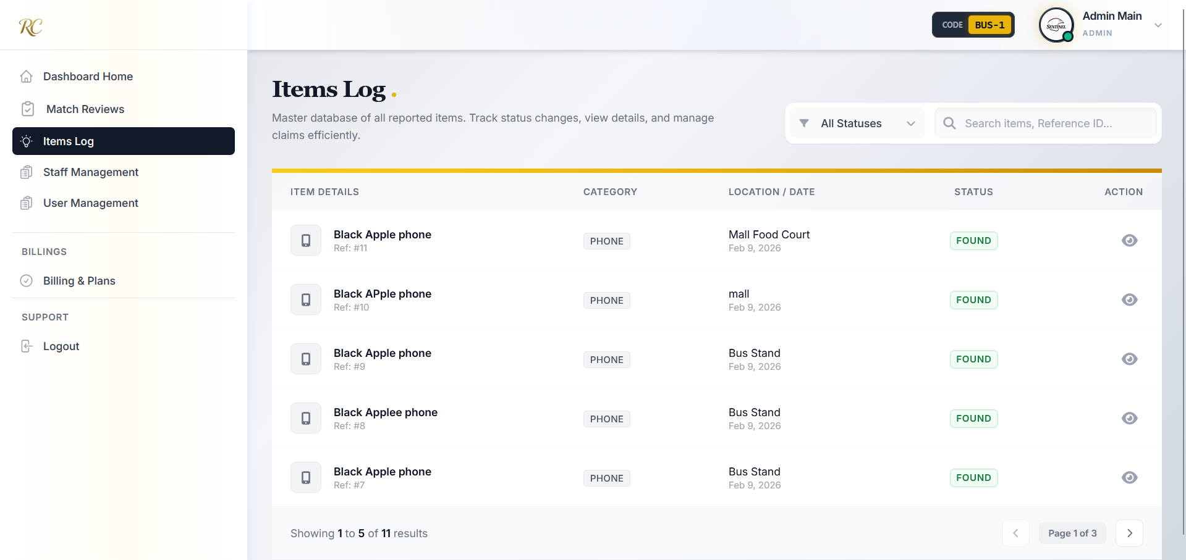

**4.Staff Management**

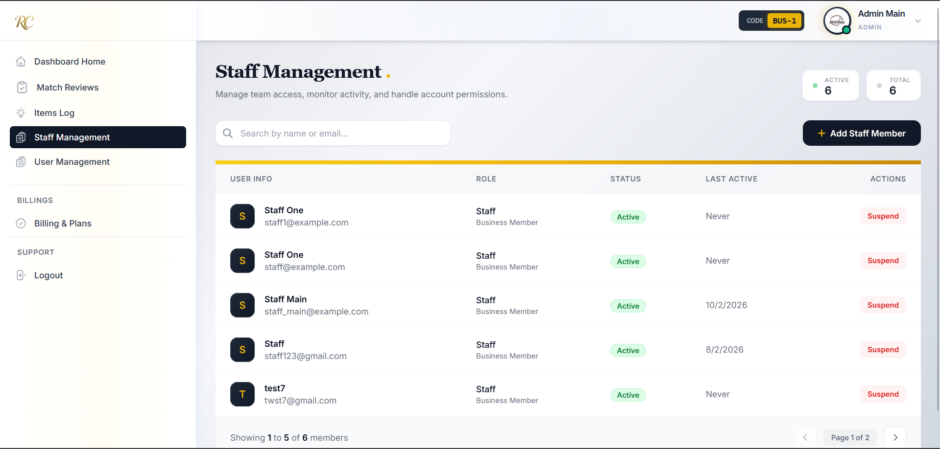

**5.User Management**

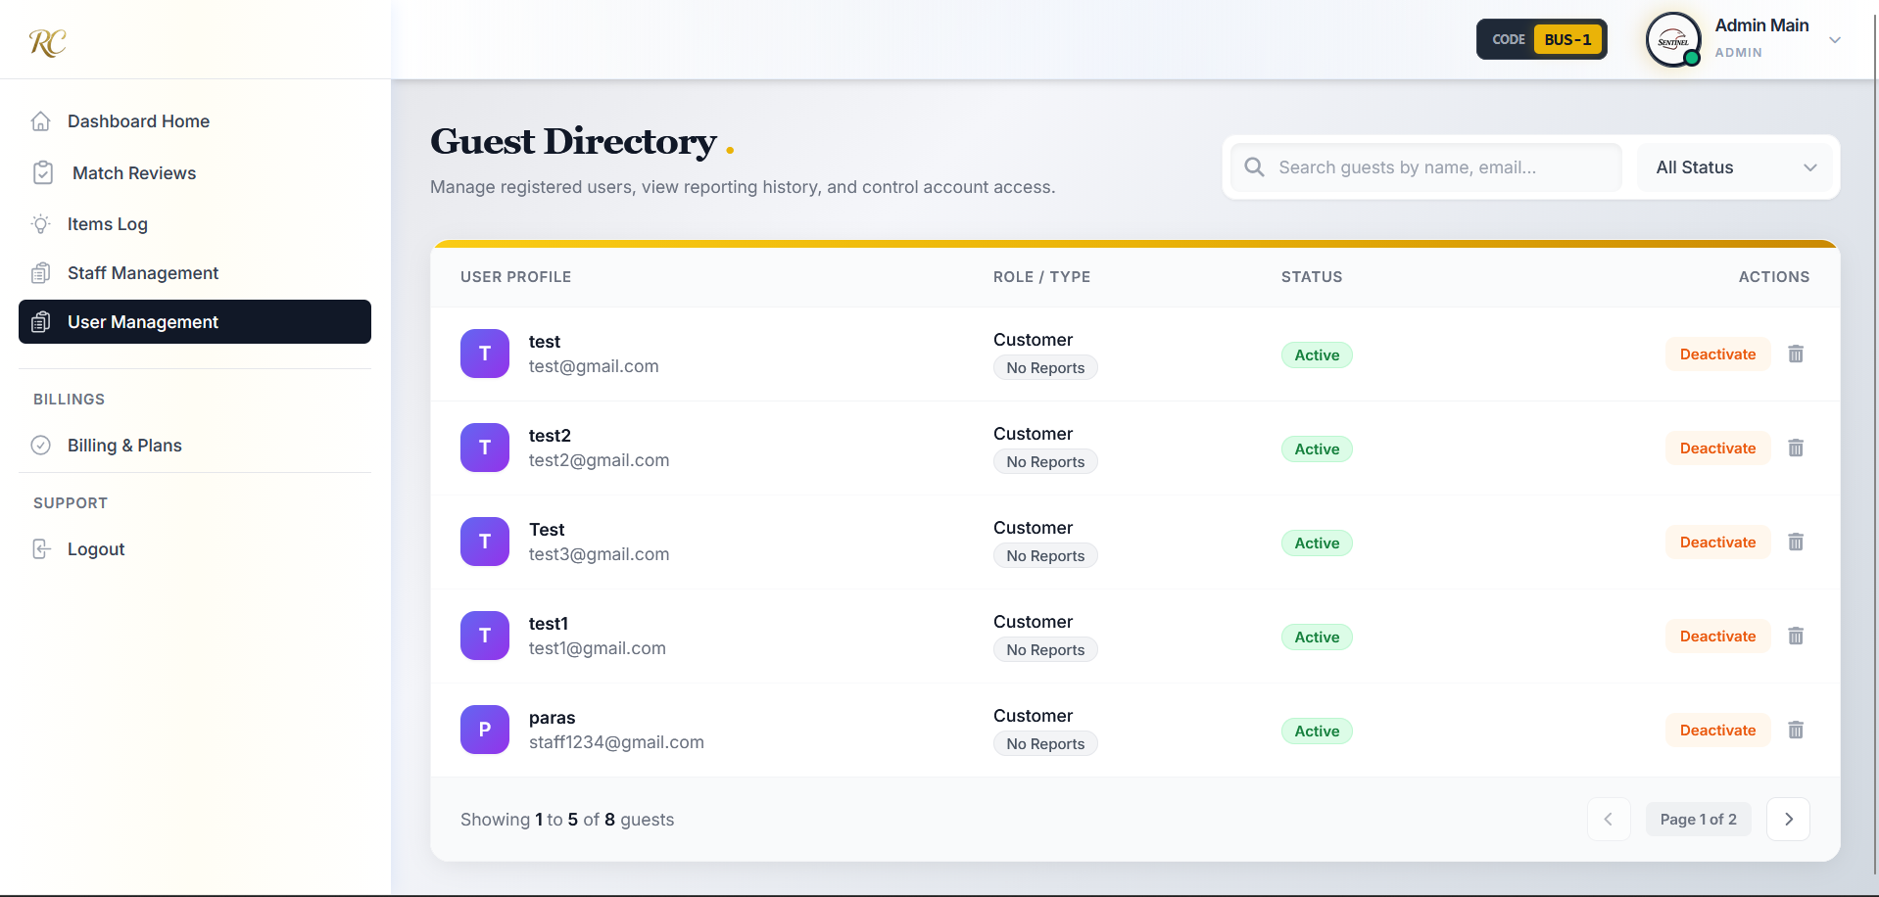

**6.Billings and Plans**

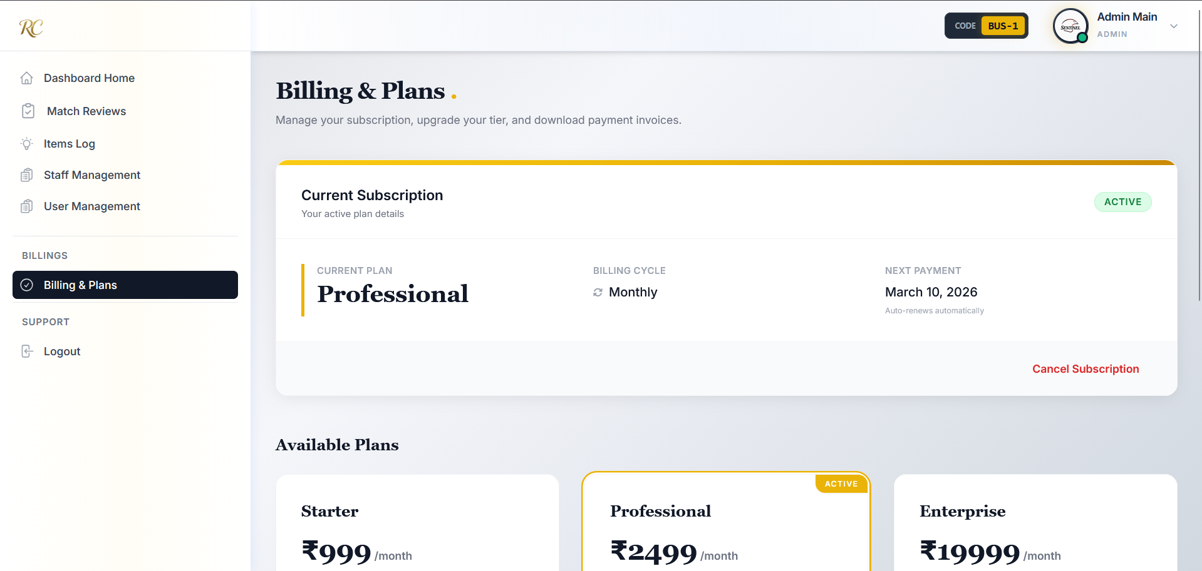

**Super-Admin View:**

**1.Dashboard**

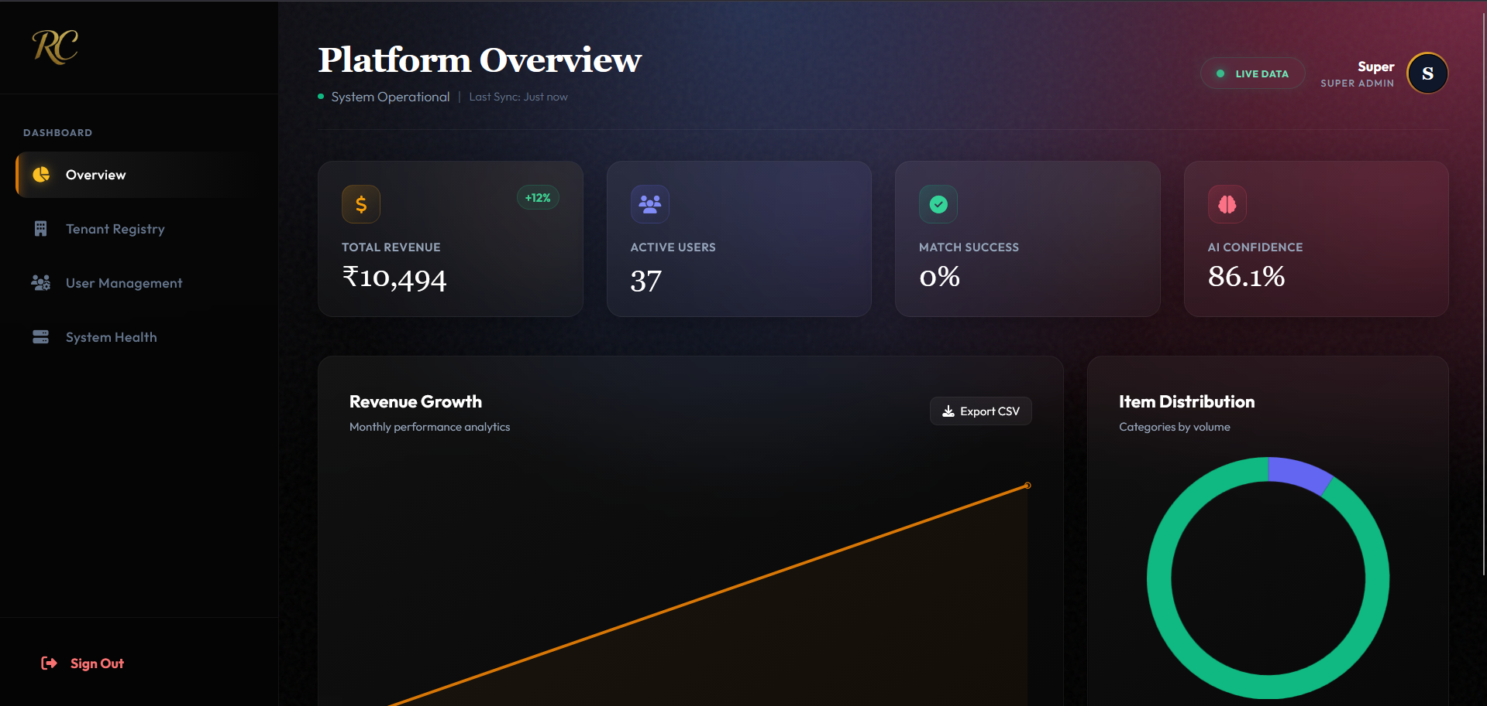

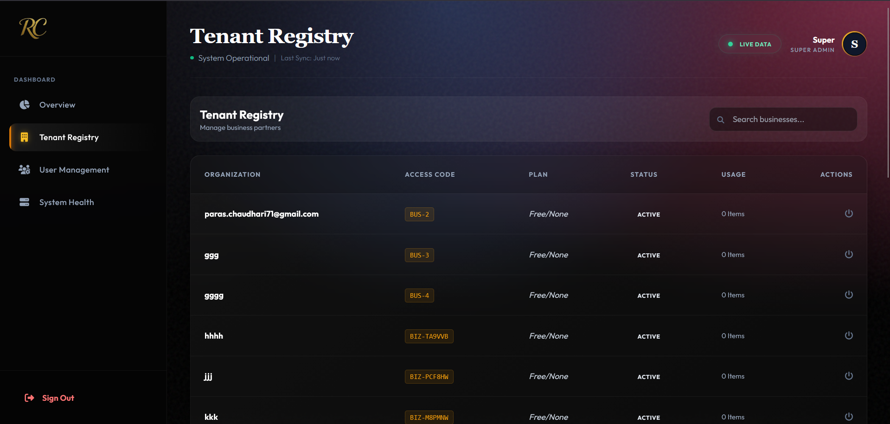

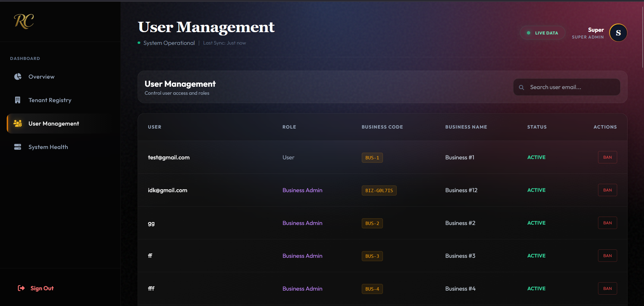

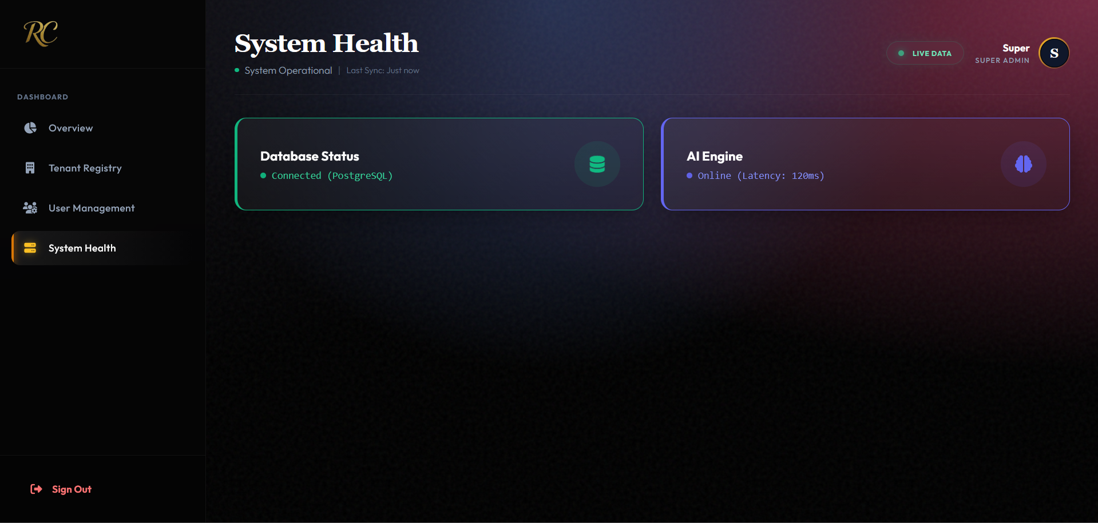

**4.4 Security Issues**

Web application security is a critical aspect of the ReClaim system, as it handles user information and sensitive item-related data. Various common website security issues were considered during the design and development of the system, and appropriate preventive measures were implemented.

**1. SQL Injection**

SQL Injection is a security vulnerability where attackers try to manipulate database queries through malicious input.  
In the ReClaim system, this risk is minimized by using parameterized queries and ORM-based database access, which prevent direct execution of user-supplied SQL code.  
Input validation is also performed to ensure that unexpected or harmful input is not processed.  
This helps protect the database from unauthorized access, data leakage, or modification.

**2. Cross-Site Scripting (XSS)**

Cross-Site Scripting (XSS) attacks occur when malicious scripts are injected into web pages viewed by other users.  
To prevent XSS attacks, ReClaim sanitizes and validates user input before storing or displaying it.  
User-generated content such as item descriptions is properly escaped before rendering on the frontend.  
This prevents attackers from executing malicious JavaScript in the user’s browser.

**3. Broken Authentication & Session Management**

Broken authentication can allow attackers to impersonate legitimate users.  
In ReClaim, authentication is securely handled using session-based or token-based mechanisms.  
Passwords are never stored in plain text; instead, bcrypt hashing is used to securely store passwords.  
This ensures that even if database access is compromised, original passwords cannot be recovered.

**4. Insecure Direct Object References (IDOR)**

Insecure Direct Object References occur when internal object identifiers are exposed and manipulated by users.  
ReClaim prevents this by validating user permissions before allowing access to any resource.  
Users can only access their own data such as claims, lost items, or found item records.  
Authorization checks ensure that one user cannot access another user’s information.

**5. Security Misconfiguration**

Security misconfiguration can arise due to improper server or database settings.  
In ReClaim, default credentials are removed, unnecessary services are disabled, and environment variables are used for sensitive configuration values.  
Database access is restricted based on roles, and proper error handling is implemented to avoid exposing system details.  
These steps reduce the risk of unauthorized system access.

**6. Cross-Site Request Forgery (CSRF)**

CSRF attacks attempt to perform unauthorized actions using a victim’s authenticated session.  
To prevent CSRF, ReClaim uses CSRF tokens for sensitive operations such as form submissions.  
Requests without valid tokens are rejected by the system.  
This ensures that only legitimate user-initiated requests are processed.

**Password Hashing Technique Used**

ReClaim uses bcrypt for password hashing.  
Bcrypt is a secure, adaptive hashing algorithm that protects against brute-force attacks.  
It applies salting and multiple hashing rounds automatically.  
No additional encryption algorithms are used in the system for password storage.

**4.5 Test Cases**

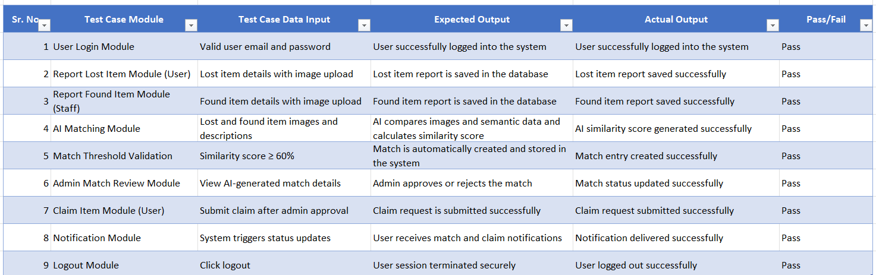

**CHAPTER 5-SYSTEM,CODING,IMPLEMENTATION AND TESTING**

**5.1 Coding Details**

**User_Routes.py**

from fastapi import APIRouter, Depends, HTTPException

from scipy import stats

from sqlalchemy.orm import Session

from datetime import datetime, timedelta

from sqlalchemy import func, desc

from database import get_db

from models import User, Item, Match, Notification

from fastapi import APIRouter, Depends

from sqlalchemy.orm import Session

from sqlalchemy import func, desc, or_

from datetime import datetime, timedelta

from typing import List

from auth import get_current_user

import models, auth

from database import get_db

router = APIRouter()

@router.get("/api/dashboard/{user_id}")

def get_dashboard(user_id: int, db: Session = Depends(get_db)):

# --- User Check ---

user = db.query(User).filter(User.user_id == user_id).first()

if not user:

return {"error": "User not found"}

now = datetime.utcnow()

# --- Time Ranges ---

yesterday = now - timedelta(days=1)

y_start = yesterday.replace(hour=0, minute=0, second=0, microsecond=0)

y_end = yesterday.replace(hour=23, minute=59, second=59, microsecond=999999)

today_start = now.replace(hour=0, minute=0, second=0, microsecond=0)

# --- Stats: Overview ---

# Total active reports

active_reports = db.query(Item).filter(

Item.user_id == user_id,

Item.status.in_(["LOST", "PENDING"])

).count()

# Total items recovered (All time)

total_recovered = db.query(Item).filter(

Item.user_id == user_id,

Item.status == "RECLAIMED"

).count()

# Matches found today

matches_today = db.query(Match).join(Item, Match.lost_item_id == Item.item_id).filter(

Item.user_id == user_id,

Match.created_at >= today_start

).count()

# --- Recent Data (For Lists) ---

# 1. Recent Matches (Top 5)

recent_matches_query = db.query(Match).join(Item, Match.lost_item_id == Item.item_id)\

.filter(Item.user_id == user_id)\

.order_by(Match.created_at.desc())\

.limit(5).all()

recent_matches_data = []

for m in recent_matches_query:

# Fetch the found item details for context

found_item = db.query(Item).filter(Item.item_id == m.found_item_id).first()

recent_matches_data.append({

"match_id": m.match_id,

"similarity": m.similarity_score,

"status": m.status,

"item_name": found_item.item_type if found_item else "Unknown Item",

"date": m.created_at.strftime("%b %d")

})

# 2. Recent Reports (Top 5)

recent_reports = db.query(Item).filter(

Item.user_id == user_id

).order_by(Item.created_at.desc()).limit(5).all()

# --- Activity Chart Data (Last 7 Days) ---

activity_data = []

for i in range(6, -1, -1):

day = now - timedelta(days=i)

d_start = day.replace(hour=0, minute=0, second=0)

d_end = day.replace(hour=23, minute=59, second=59)

count = db.query(Item).filter(

Item.user_id == user_id,

Item.created_at >= d_start,

Item.created_at <= d_end

).count()

activity_data.append({

"date": day.strftime("%a"), # Mon, Tue

"count": count

})

return {

"stats": {

"active_reports": active_reports,

"matches_today": matches_today,

"total_recovered": total_recovered

},

"recent_matches": recent_matches_data,

"recent_reports": [

{

"item_id": i.item_id,

"name": i.item_type,

"status": i.status,

"date": i.created_at.strftime("%b %d")

} for i in recent_reports

],

"activity_chart": activity_data

}

@router.get("/admin-stats")

def get_admin_dashboard_stats(

current_user: models.User = Depends(auth.get_current_user),

db: Session = Depends(get_db)

):

# Security: Ensure only Admin (2) or Staff (3) access this

if current_user.role_id not in [2, 3] or not current_user.business_id:

return {"error": "Unauthorized"}

bid = current_user.business_id

storage_count = db.query(models.Item).filter(

models.Item.business_id == bid,

models.Item.status == "FOUND" # Adjust if you use "LOGGED"

).count()

pending_claims = db.query(models.Match).join(

models.Item, models.Match.found_item_id == models.Item.item_id

).filter(

models.Item.business_id == bid,

models.Match.status == "PENDING"

).count()

# --- KPI 3: Staff Members ---

staff_count = db.query(models.User).filter(

models.User.business_id == bid,

models.User.role_id == 3

).count()

total_items = db.query(models.Item).filter(models.Item.business_id == bid).count()

returned_items = db.query(models.Item).filter(

models.Item.business_id == bid,

models.Item.status == "RECLAIMED"

).count()

match_rate = 0

if total_items > 0:

match_rate = round((returned_items / total_items) * 100)

# --- FEED: Recent Activity ---

# Using 'created_at' and 'item_type' from your models

recent_items = db.query(models.Item).filter(

models.Item.business_id == bid

).order_by(models.Item.created_at.desc()).limit(3).all()

feed_data = []

for item in recent_items:

feed_data.append({

"type": "ITEM_LOGGED",

"text": f"New: {item.item_type}",

"subtext": f"Location: {item.lost_location or 'Unknown'}",

"time": item.created_at

})

today = datetime.utcnow().date()

chart_labels = []

chart_data = []

for i in range(6, -1, -1):

day = today - timedelta(days=i)

count = db.query(models.Item).filter(

models.Item.business_id == bid,

func.date(models.Item.created_at) == day

).count()

chart_labels.append(day.strftime("%b %d"))

chart_data.append(count)

return {

"storage_count": storage_count,

"pending_claims": pending_claims,

"staff_count": staff_count,

"returned_month": returned_items,

"feed": feed_data,

"chart": {

"labels": chart_labels,

"data": chart_data

}

}

from sqlalchemy import func, case

from datetime import datetime, timedelta

@router.get("/api/dashboard/staff/{user_id}")

def get_staff_dashboard(user_id: int, db: Session = Depends(get_db), current_user = Depends(get_current_user)):

if current_user.user_id != user_id and current_user.role_id != 2:

raise HTTPException(status_code=403, detail="Unauthorized")

stats_result = db.query(

func.count(case((models.Item.status == 'FOUND', 1))).label('active_found'),

func.count(case((models.Item.status == 'RECLAIMED', 1))).label('recovered')

).filter(

models.Item.user_id == user_id

).first()

# Get count of matches specifically for items this staff member uploaded

user_found_items_subquery = db.query(models.Item.item_id).filter(models.Item.user_id == user_id)

matches_count = db.query(models.Match).filter(

models.Match.found_item_id.in_(user_found_items_subquery)

).count()

recent_matches_records = db.query(models.Match).filter(

models.Match.found_item_id.in_(user_found_items_subquery)

).order_by(models.Match.created_at.desc()).limit(5).all()

recent_matches_data = []

for m in recent_matches_records:

lost_item = db.query(models.Item).get(m.lost_item_id)

recent_matches_data.append({

"match_id": m.match_id,

"item_name": lost_item.item_type if lost_item else "Unknown Item",

"similarity": m.similarity_score,

"date": m.created_at.strftime("%b %d")

})

recent_logs = db.query(models.Item).filter(

models.Item.user_id == user_id

).order_by(models.Item.created_at.desc()).limit(5).all()

recent_logs_data = []

for item in recent_logs:

recent_logs_data.append({

"name": f"{item.color} {item.brand} {item.item_type}",

"status": item.status,

"date": item.created_at.strftime("%b %d")

})

today = datetime.utcnow().date()

chart_data = []

for i in range(6, -1, -1):

day = today - timedelta(days=i)

count = db.query(models.Item).filter(

models.Item.user_id == user_id,

func.date(models.Item.created_at) == day

).count()

chart_data.append({

"date": day.strftime("%a"),

"count": count

})

return {

"stats": {

"active_reports": getattr(stats_result, 'active_found', 0),

"total_recovered": getattr(stats_result, 'recovered', 0),

"matches_today": matches_count

},

"recent_matches": recent_matches_data,

"recent_reports": recent_logs_data,

"activity_chart": chart_data

}

**Subscription_Routes.py**

from fastapi import APIRouter, Depends

from sqlalchemy.orm import Session

from datetime import datetime, timedelta

from sqlalchemy import func, desc

from database import get_db

from auth import get_current_user

from models import User, Item, Match, Notification, BusinessSubscription

router = APIRouter(prefix="/subscriptions", tags=["Subscriptions"])

# Get subscription status

@router.get("/status")

def get_subscription_status(

    current_user: User = Depends(get_current_user),

    db: Session = Depends(get_db)

):

    sub = db.query(BusinessSubscription).filter(

        BusinessSubscription.business_id == current_user.business_id

    ).first()

    if not sub:

        return {"status": "NONE", "days_left": 0}

    # Calculate remaining time

    now = datetime.utcnow()

    if now > sub.end_date:

        days_left = 0

        status = "EXPIRED"

    else:

        # Calculate delta

        delta = sub.end_date - now

        days_left = delta.days

        status = sub.status

    return {

        "plan_name": sub.plan.name, # Assumes relationship is set up

        "status": status,

        "days_left": days_left,

        "expires_on": sub.end_date

    }

**Staff_Routes.py**

from fastapi import APIRouter, Depends, HTTPException, status

from sqlalchemy.orm import Session

from typing import List, Optional

from pydantic import BaseModel, EmailStr

import models,auth,crud

from datetime import datetime

from database import get_db

from auth import get_current_user

from crud import get_password_hash

router = APIRouter(prefix="/staff", tags=["Staff Management"])

# --- Pydantic Schemas for Inputs ---

class StaffCreate(BaseModel):

    first_name: str

    last_name: Optional[str] = None

    email: EmailStr

    password: str

class StaffResponse(BaseModel):

    user_id: int

    first_name: str

    last_name: Optional[str] = None

    email: str

    is_active: bool

    last_login: Optional[datetime] = None

    class Config:

        from_attributes = True

# --- Endpoints ---

@router.get("/my-staff", response_model=List[StaffResponse])

def get_my_staff(

    current_user: models.User = Depends(auth.get_current_user),

    db: Session = Depends(get_db)

):

    """

    Fetch all staff members (Role 3) belonging to the Admin's business.

    """

    # 1. Security Check: Only Admins (Role 2) can view staff list

    if current_user.role_id != 2:

        raise HTTPException(status_code=403, detail="Not authorized to view staff")

    if not current_user.business_id:

        raise HTTPException(status_code=400, detail="You are not linked to a business")

    # 2. Query: Find users with role_id=3 AND same business_id

    staff_members = db.query(models.User).filter(

        models.User.business_id == current_user.business_id,

        models.User.role_id == 3  # Strictly fetch staff, not other admins

    ).all()

    return staff_members

@router.post("/create", response_model=StaffResponse)

def create_staff_member(

    staff_data: StaffCreate,

    current_user: models.User = Depends(auth.get_current_user),

    db: Session = Depends(get_db)

):

    """

    Create a new Staff account (Role 3) linked to the Admin's business.

    """

    # 1. Security Check

    if current_user.role_id != 2:

        raise HTTPException(status_code=403, detail="Only Admins can create staff")

    # 2. Check if email exists

    existing_user = db.query(models.User).filter(models.User.email == staff_data.email).first()

    if existing_user:

        raise HTTPException(status_code=400, detail="Email already registered")

    # 3. Hash Password

    hashed_pw = crud.get_password_hash(staff_data.password)

    # 4. Create User Object

    new_staff = models.User(

        first_name=staff_data.first_name,

        email=staff_data.email,

        password_hash=hashed_pw,

        role_id=3,  # Force Role ID 3 (Staff)

        business_id=current_user.business_id, # Link to Admin's Business

        is_active=True

    )

    # Optional: Handle last name manually since it might not be in the model constructor depending on setup

    if hasattr(models.User, 'last_name'):

        new_staff.last_name = staff_data.last_name

    db.add(new_staff)

    db.commit()

    db.refresh(new_staff)

    # 5. Create Empty Profile (Optional, prevents errors later)

    new_profile = models.UserProfile(user_id=new_staff.user_id)

    db.add(new_profile)

    db.commit()

    return new_staff

@router.patch("/{user_id}/status")

def update_staff_status(

    user_id: int,

    active: bool,

    current_user: models.User = Depends(auth.get_current_user),

    db: Session = Depends(get_db)

):

    """

    Suspend or Activate a staff member.

    """

    if current_user.role_id != 2:

        raise HTTPException(status_code=403, detail="Not authorized")

    # 1. Find the staff member

    staff_member = db.query(models.User).filter(

        models.User.user_id == user_id,

        models.User.business_id == current_user.business_id

    ).first()

    if not staff_member:

        raise HTTPException(status_code=404, detail="Staff member not found")

    # 2. Update Status

    staff_member.is_active = active

    db.commit()

    return {"message": "Status updated", "is_active": staff_member.is_active}

**Profile_Routes.py**

from fastapi import APIRouter, Depends, HTTPException

from sqlalchemy.orm import Session

import crud, schemas

from database import get_db

from auth import get_current_user

import models

router = APIRouter(prefix="/users", tags=["Users"])

@router.get("/me", response_model=schemas.UserOut)

def read_current_user(

    current_user = Depends(get_current_user),

    db: Session = Depends(get_db)

):

    profile = crud.get_profile_by_user_id(db, current_user.user_id)

    return {

        "business_id": current_user.business_id,

        "user_id": current_user.user_id,

        "first_name": current_user.first_name,

        "email": current_user.email,

        "last_name": getattr(profile, "last_name", None),

        "phone": getattr(profile, "phone", None),

        "profile_image": getattr(profile, "profile_image", None),

        "profile_image_mime": getattr(profile, "profile_image_mime", None),

        "role_id": current_user.role_id

    }

@router.put("/profile", response_model=schemas.ProfileOut)

def update_profile(

    data: schemas.ProfileBase,

    current_user = Depends(get_current_user),

    db: Session = Depends(get_db)

):

    current_user.first_name = data.first_name

    current_user.email = data.email

    db.commit()

    profile = crud.create_or_update_profile(

        db,

        current_user.user_id,

        data.last_name,

        data.phone,

        data.profile_image,

        data.profile_image_mime

    )

    return profile

@router.get("/me/business-code")

def get_business_code(

    current_user = Depends(get_current_user),

    db: Session = Depends(get_db)

):

    """

    Simple endpoint to get just the business code for the dashboard.

    """

    if not current_user.business_id:

        return {"business_code": "NO-BUSINESS"}

    # Query the business table directly

    business = db.query(models.Business).filter(

        models.Business.business_id == current_user.business_id

    ).first()

    if business:

        return {"business_code": business.business_code}

    return {"business_code": "NOT-FOUND"}

**Notification_routes.py**

from fastapi import APIRouter, Depends, HTTPException

from sqlalchemy.orm import Session

from typing import List

from database import get_db

from models import Notification, User

from schemas import NotificationOut

from auth import get_current_user

router = APIRouter(prefix="/notifications", tags=["Notifications"])

@router.get("/unread_count")

def unread_count(db: Session = Depends(get_db), current_user: User = Depends(get_current_user)):

    count = db.query(Notification).filter_by(user_id=current_user.user_id, is_read=False).count()

    return {"count": count}

@router.get("/latest", response_model=List[NotificationOut])

def latest_notifications(limit: int = 5, db: Session = Depends(get_db), current_user: User = Depends(get_current_user)):

    notifications = (

        db.query(Notification)

        .filter_by(user_id=current_user.user_id)

        .order_by(Notification.created_at.desc())

        .limit(limit)

        .all()

    )

    return notifications

@router.patch("/{notification_id}/read")

def mark_as_read(notification_id: int, db: Session = Depends(get_db), current_user: User = Depends(get_current_user)):

    notification = db.query(Notification).filter_by(notification_id=notification_id, user_id=current_user.user_id).first()

    if not notification:

        raise HTTPException(status_code=404, detail="Notification not found")

    notification.is_read = True

    db.commit()

    return {"success": True}

@router.patch("/mark_all_read")

def mark_all_read(db: Session = Depends(get_db), current_user: User = Depends(get_current_user)):

    db.query(Notification).filter_by(user_id=current_user.user_id, is_read=False).update({"is_read": True})

    db.commit()

    return {"success": True}

**Customer_Routes.py**

from fastapi import APIRouter, Depends, HTTPException

from sqlalchemy.orm import Session

from sqlalchemy import func

from typing import List, Optional

from pydantic import BaseModel

import models, auth

from database import get_db

router = APIRouter(prefix="/customers", tags=["Customer Management"])

# --- Schema ---

class CustomerResponse(BaseModel):

    user_id: int

    first_name: str

    email: str

    items_reported: int

    last_active: Optional[str] = None

    status: str

@router.get("/customer", response_model=List[CustomerResponse])

def get_customers(

    current_user: models.User = Depends(auth.get_current_user),

    db: Session = Depends(get_db)

):

    if current_user.role_id not in [2, 3]:

        raise HTTPException(status_code=403, detail="Not authorized")

    query = db.query(models.User).filter(

        models.User.role_id == 4,

        models.User.business_id == current_user.business_id

    )

    users = query.all()

    results = []

    for user in users:

        item_count = db.query(models.Item).filter(models.Item.user_id == user.user_id).count()

        results.append({

            "user_id": user.user_id,

            "first_name": user.first_name,

            "email": user.email,

            "items_reported": item_count,

            "last_active": user.created_at.strftime("%Y-%m-%d") if user.created_at else None,

            "status": "Active" if user.is_active else "Inactive"

        })

    return results

@router.delete("/{user_id}")

def delete_customer(

    user_id: int,

    current_user: models.User = Depends(auth.get_current_user),

    db: Session = Depends(get_db)

):

    if current_user.role_id != 2: # Only Admin can delete

        raise HTTPException(status_code=403, detail="Not authorized")

    user = db.query(models.User).filter(

        models.User.user_id == user_id,

        models.User.role_id == 4,

        models.User.business_id == current_user.business_id

    ).first()

    if not user:

        raise HTTPException(status_code=404, detail="User not found")

    db.delete(user)

    db.commit()

    return {"message": "User removed"}

@router.patch("/{user_id}/toggle-status")

def toggle_user_status(

    user_id: int,

    current_user: models.User = Depends(auth.get_current_user),

    db: Session = Depends(get_db)

):

    # Only Admin can change status

    if current_user.role_id != 2:

        raise HTTPException(status_code=403, detail="Not authorized")

    user = db.query(models.User).filter(

        models.User.user_id == user_id,

        models.User.business_id == current_user.business_id

    ).first()

    if not user:

        raise HTTPException(status_code=404, detail="User not found")

    # Toggle the boolean

    user.is_active = not user.is_active

    db.commit()

    status_msg = "activated" if user.is_active else "deactivated"

    return {"message": f"User {status_msg} successfully", "new_status": user.is_active}

**Auth_routes.py**

from fastapi import APIRouter, Depends, HTTPException, Body,status

from sqlalchemy.orm import Session

from datetime import timedelta

from datetime import datetime

import crud, models, schemas

from database import get_db

from auth import create_access_token, decode_access_token

from email_utils import send_reset_email

router = APIRouter(prefix="/auth", tags=["Auth"])

@router.post("/register", response_model=schemas.UserOut)

def register_user(user: schemas.UserCreate, db: Session = Depends(get_db)):

business = db.query(models.Business).filter(

models.Business.business_code == user.business_code

).first()

if not business:

raise HTTPException(status_code=404, detail="Invalid business code")

db_user = db.query(models.User).filter(

models.User.email == user.email,

models.User.business_id == business.business_id

).first()

if db_user:

raise HTTPException(status_code=400, detail="Email already registered")

return crud.create_user(db, user, business.business_id)

@router.post("/login")

def login_user(user: schemas.UserLogin, db: Session = Depends(get_db)):

# 1. Find User

db_user = db.query(models.User).filter(

models.User.email == user.email

).first()

if not db_user or not crud.verify_password(user.password, db_user.password_hash):

raise HTTPException(status_code=401, detail="Invalid credentials")

if not db_user.is_active:

raise HTTPException(

status_code=status.HTTP_403_FORBIDDEN,

detail="Your account has been suspended."

)

if db_user.business_id is not None:

business = db.query(models.Business).filter(

models.Business.business_id == db_user.business_id

).first()

# If business exists and is marked as inactive

if business and not business.is_active:

raise HTTPException(

status_code=status.HTTP_403_FORBIDDEN,

detail="Your organization's access has been suspended. Please contact support."

)

db_user.last_login = datetime.utcnow()

db.commit()

# 6. Generate Token

token = create_access_token({

"sub": str(db_user.user_id),

"business_id": db_user.business_id,

"role_id": db_user.role_id

})

return {

"access_token": token,

"token_type": "bearer",

"user_id": db_user.user_id,

"role_id": db_user.role_id,

"business_id": db_user.business_id

}

@router.post("/forgot-password")

def forgot_password(data: dict, db: Session = Depends(get_db)):

user = crud.get_user_by_email(db, data.get("email"))

if not user:

raise HTTPException(status_code=404, detail="Email not registered")

token = create_access_token(

{"sub": str(user.user_id)},

expires_delta=timedelta(minutes=15)

)

reset_link = f"http://127.0.0.1:56311/frontend/reset_password.html?token={token}"

send_reset_email(user.email, reset_link)

return {"message": "Reset link sent to your email."}

@router.post("/reset-password")

def reset_password(data: dict = Body(...), db: Session = Depends(get_db)):

payload = decode_access_token(data["token"])

user = crud.get_user_by_id(db, int(payload["sub"]))

user.password_hash = crud.get_password_hash(data["new_password"])

db.commit()

return {"message": "Password reset successful"}

**Admin_routes.py**

from fastapi import APIRouter, BackgroundTasks, Depends, HTTPException

from sqlalchemy.orm import Session

from email_utils import create_notification, send_match_approved_task, send_match_rejected_task

import models

from database import get_db

from auth import get_current_user

router = APIRouter(prefix="/admin", tags=["Admin"])

@router.post("/admin/approve-match/{match_id}")

def approve_match(

    match_id: int,

    background_tasks: BackgroundTasks, # <--- 1. Inject BackgroundTasks

    db: Session = Depends(get_db),

    current_user = Depends(get_current_user)

):

    if current_user.role_id != 2:

        raise HTTPException(status_code=403, detail="Admin access only")

    match = db.query(models.Match).filter(

        models.Match.match_id == match_id

    ).first()

    if not match:

        raise HTTPException(status_code=404, detail="Match not found")

    if match.status.lower() != "pending":

        raise HTTPException(

            status_code=400,

            detail=f"Cannot approve a {match.status} match"

        )

    match.status = "APPROVED"

    db.commit()

    db.refresh(match)

    lost_item = db.get(models.Item, match.lost_item_id)

    user = db.get(models.User, lost_item.user_id)

    create_notification(

        db=db,

        user_id=user.user_id,

        item_id=lost_item.item_id,

        match_id=match.match_id,

        title="Match Approved",

        message="Great news! Your item match has been approved.",

        notification_type="MATCH_APPROVED"

    )

    background_tasks.add_task(

        send_match_approved_task,

        user_email=user.email,

        item_type=lost_item.item_type

    )

    return {

        "message": "Match approved successfully",

        "match_id": match_id,

        "status": "approved"

    }

@router.post("/admin/reject-match/{match_id}")

def reject_match(

    match_id: int,

    background_tasks: BackgroundTasks, # <--- 1. Inject BackgroundTasks

    db: Session = Depends(get_db),

    current_user = Depends(get_current_user)

):

    if current_user.role_id != 2:

        raise HTTPException(status_code=403, detail="Admin access only")

    match = db.query(models.Match).filter(

        models.Match.match_id == match_id

    ).first()

    if not match:

        raise HTTPException(status_code=404, detail="Match not found")

    if match.status.lower() != "pending":

        raise HTTPException(

            status_code=400,

            detail=f"Cannot reject a {match.status} match"

        )

    match.status = "REJECTED"

    db.commit()

    db.refresh(match)

    lost_item = db.get(models.Item, match.lost_item_id)

    user = db.get(models.User, lost_item.user_id)

    create_notification(

        db=db,

        user_id=user.user_id,

        item_id=lost_item.item_id,

        match_id=match.match_id,

        title="Match Rejected",

        message="Update: Your potential item match was not approved.",

        notification_type="MATCH_REJECTED"

    )

    # 2. Send Email (Async Background)

    background_tasks.add_task(

        send_match_rejected_task,

        user_email=user.email,

        item_type=lost_item.item_type

    )

    return {

        "message": "Match rejected successfully",

        "match_id": match_id,

        "status": "rejected"

    }

**Dashboard_normal.html**

<!DOCTYPE html>

<html class="h-full bg-gray-100">

<head>

<meta charset="UTF-8">

<meta name="viewport" content="width=device-width, initial-scale=1.0">

<title>ReClaim - Dashboard</title>

<script src="https://cdn.tailwindcss.com"></script>

<link rel="stylesheet" href="css/common.css">

<link rel="stylesheet" href="https://cdnjs.cloudflare.com/ajax/libs/font-awesome/6.4.0/css/all.min.css">

<script src="javascript/dashboard_data_normie.js" type="module" defer></script>

<script src="javascript/common.js" defer></script>

<script src="javascript/profile-dropdown.js" type="module" defer></script>

<script src="https://cdn.jsdelivr.net/npm/chart.js"></script>

<script src="javascript/dashboard_data_normie.js" type="module" defer></script>

<script src="javascript/notifications.js" type="module" defer></script>

<Script src="javascript/report-lost.js" type="module" defer></Script>

<script src="javascript/visual-search.js" type="module" defer></scrip

</head>

<body class="h-full">

<!-- Sidebar Overlay -->

<div class="sidebar-overlay" id="sidebarOverlay"></div>

<!-- Fixed Sidebar -->

<div class=" sidebar-container" id="sidebar">

<div class="px-6 pt-5 pb-3 border-b border-gray-200">

<div class="flex items-center space-x-3">

<img src="images/logo.png" alt="ReClaim Logo" class="w-8 h-8 object-contain">

<button class="ml-auto lg:hidden" id="closeSidebar">

<svg class="h-6 w-6 text-gray-400" fill="none" viewBox="0 0 24 24" stroke="currentColor">

<path stroke-linecap="round" stroke-linejoin="round" stroke-width="2" d="M6 18L18 6M6 6l12 12" />

</svg>

</button>

</div>

</div>

<nav class="p-4 space-y-1">

<!-- Main Navigation -->

<div class="space-y-1 pb-4">

<a href="index.html" class="sidebar-active flex items-center px-3 py-2 text-sm font-medium rounded-md bg-gray-900 text-white">

<svg class="text-gray-300 flex-shrink-0 -ml-1 mr-3 h-5 w-5" fill="none" viewBox="0 0 24 24" stroke="currentColor">

<path stroke-linecap="round" stroke-linejoin="round" stroke-width="1.5" d="M3 12l2-2m0 0l7-7 7 7M5 10v10a1 1 0 001 1h3m10-11l2 2m-2-2v10a1 1 0 01-1 1h-3m-6 0a1 1 0 001-1v-4a1 1 0 011-1h2a1 1 0 011 1v4a1 1 0 001 1m-6 0h6" />

</svg>

Dashboard Home

</a>

<a href="report-lost.html" class="flex items-center px-3 py-2 text-sm font-medium rounded-md text-gray-700 hover:bg-gray-50">

<svg class="text-gray-400 flex-shrink-0 -ml-1 mr-3 h-5 w-5" fill="none" viewBox="0 0 24 24" stroke="currentColor">

<path stroke-linecap="round" stroke-linejoin="round" stroke-width="1.5" d="M12 4v16m8-8H4" />

</svg>

<span id="page-title-text">Report Lost Item</span>

</a>

<a href="AI-match.html" class="flex items-center px-3 py-2 text-sm font-medium rounded-md text-gray-700 hover:bg-gray-50">

<svg class="text-gray-400 flex-shrink-0 -ml-1 mr-3 h-5 w-5" fill="none" viewBox="0 0 24 24" stroke="currentColor">

<path stroke-linecap="round" stroke-linejoin="round" stroke-width="1.5" d="M9.663 17h4.673M12 3v1m6.364 1.636l-.707.707M21 12h-1M4 12H3m3.343-5.657l-.707-.707m2.828 9.9a5 5 0 117.072 0l-.548.547A3.374 3.374 0 0014 18.469V19a2 2 0 11-4 0v-.531c0-.895-.356-1.754-.988-2.386l-.548-.547z" />

</svg>

AI Match Results

</a>

<a href="my-reports.html" class="flex items-center px-3 py-2 text-sm font-medium rounded-md text-gray-700 hover:bg-gray-50">

<svg class="text-gray-400 flex-shrink-0 -ml-1 mr-3 h-5 w-5" fill="none" viewBox="0 0 24 24" stroke="currentColor">

<path stroke-linecap="round" stroke-linejoin="round" stroke-width="1.5" d="M9 12h3.75M9 15h3.75M9 18h3.75m3 .75H18a2.25 2.25 0 002.25-2.25V6.108c0-1.135-.845-2.098-1.976-2.192a48.424 48.424 0 00-1.123-.08m-5.801 0c-.065.21-.1.433-.1.664 0 .414.336.75.75.75h4.5a.75.75 0 00.75-.75 2.25 2.25 0 00-.1-.664m-5.801 0A2.251 2.251 0 0113.5 2.25H15c1.012 0 1.867.668 2.15 1.586m-5.801 0c-.376.023-.75.05-1.124.08C9.095 4.01 8.25 4.973 8.25 6.108V8.25m0 0H4.875c-.621 0-1.125.504-1.125 1.125v11.25c0 .621.504 1.125 1.125 1.125h9.75c.621 0 1.125-.504 1.125-1.125V9.375c0-.621-.504-1.125-1.125-1.125H8.25zM6.75 12h.008v.008H6.75V12zm0 3h.008v.008H6.75V15zm0 3h.008v.008H6.75V18z" />

</svg>

My Reports

</a>

</div>

<!-- Claims Section -->

<div class="pt-4 border-t border-gray-200">

<p class="px-3 text-xs font-semibold text-gray-500 uppercase tracking-wider mb-3">Approvals</p>

<div class="space-y-1">

<a href="approved-matches.html" class="flex items-center px-3 py-2 text-sm font-medium rounded-md text-gray-700 hover:bg-gray-50">

<svg class="text-gray-400 flex-shrink-0 -ml-1 mr-3 h-5 w-5" fill="none" viewBox="0 0 24 24" stroke="currentColor">

<path stroke-linecap="round" stroke-linejoin="round" stroke-width="1.5" d="M9 12.75L11.25 15 15 9.75M21 12a9 9 0 11-18 0 9 9 0 0118 0z" />

</svg>

Approved Matches

</a>

</div>

</div>

<!-- Support Section -->

<div class="pt-4 border-t border-gray-200">

<p class="px-3 text-xs font-semibold text-gray-500 uppercase tracking-wider mb-3">Support</p>

<div class="space-y-1">

<a href="notifications.html" class="flex items-center px-3 py-2 text-sm font-medium rounded-md text-gray-700 hover:bg-gray-50">

<svg class="text-gray-400 flex-shrink-0 -ml-1 mr-3 h-5 w-5" fill="none" viewBox="0 0 24 24" stroke="currentColor">

<path stroke-linecap="round" stroke-linejoin="round" stroke-width="1.5" d="M14.857 17.082a23.848 23.848 0 005.454-1.31A8.967 8.967 0 0118 9.75v-.7V9A6 6 0 006 9v.75a8.967 8.967 0 01-2.312 6.022c1.733.64 3.56 1.085 5.455 1.31m5.714 0a24.255 24.255 0 01-5.714 0m5.714 0a3 3 0 11-5.714 0" />

</svg>

Notifications

</a>

<a href="support.html" class="flex items-center px-3 py-2 text-sm font-medium rounded-md text-gray-700 hover:bg-gray-50">

<svg class="text-gray-400 flex-shrink-0 -ml-1 mr-3 h-5 w-5" fill="none" viewBox="0 0 24 24" stroke="currentColor">

<path stroke-linecap="round" stroke-linejoin="round" stroke-width="1.5" d="M8.228 9c.549-1.165 2.03-2 3.772-2 2.21 0 4 1.343 4 3 0 1.4-1.278 2.575-3.006 2.907-.542.104-.994.54-.994 1.093m0 3h.01M21 12a9 9 0 11-18 0 9 9 0 0118 0z" />

</svg>

Help Center

</a>

<a href="profile.html" class="flex items-center px-3 py-2 text-sm font-medium rounded-md text-gray-700 hover:bg-gray-50">

<svg class="text-gray-400 flex-shrink-0 -ml-1 mr-3 h-5 w-5" fill="none" viewBox="0 0 24 24" stroke="currentColor">

<path stroke-linecap="round" stroke-linejoin="round" stroke-width="1.5" d="M15.75 6a3.75 3.75 0 11-7.5 0 3.75 3.75 0 017.5 0zM4.501 20.118a7.5 7.5 0 0114.998 0A17.933 17.933 0 0112 21.75c-2.676 0-5.216-.584-7.499-1.632z" />

</svg>

Profile Settings

</a>

<a href="login.html" id="logoutbtn" class="flex items-center px-3 py-2 text-sm font-medium rounded-md text-gray-700 hover:bg-gray-50">

<svg class="text-gray-400 flex-shrink-0 -ml-1 mr-3 h-5 w-5" fill="none" viewBox="0 0 24 24" stroke="currentColor">

<path stroke-linecap="round" stroke-linejoin="round" stroke-width="1.5" d="M15.75 9V5.25A2.25 2.25 0 0013.5 3h-6a2.25 2.25 0 00-2.25 2.25v13.5A2.25 2.25 0 007.5 21h6a2.25 2.25 0 002.25-2.25V15M12 9l-3 3m0 0l3 3m-3-3h12.75" />

</svg>

Logout

</a>

</div>

</div>

</nav>

</div>

<!-- Main Layout -->

<div class="min-h-full lg:ml-80 transition-all duration-300">

<!-- Header -->

<header class="bg-gradient-to-r from-white via-blue-50/40 to-white shadow-md border-b border-blue-100/50">

<div class="mx-auto max-w-7xl px-4 sm:px-6 lg:px-8">

<div class="flex h-16 justify-between items-center">

<!-- Left side: Menu button and Logo -->

<div class="flex items-center space-x-3">

<button class="mobile-menu-btn p-2 rounded-md text-gray-400 hover:text-gray-900 hover:bg-gray-100 lg:hidden" id="toggleSidebar">

<svg class="h-6 w-6" fill="none" viewBox="0 0 24 24" stroke="currentColor">

<path stroke-linecap="round" stroke-linejoin="round" stroke-width="2" d="M4 6h16M4 12h16M4 18h16" />

</svg>

</button>

<div class="flex items-center space-x-2">

<!----

<img src="images/logo.png" alt="ReClaim Logo" class="w-8 h-8 object-contain">

-->

</div>

</div>

<!-- Right side -->

<div class="flex items-center space-x-4">

<div class="relative font-sans ml-4">

<button id="visual-search-btn" class="group p-3 rounded-2xl transition-all duration-300 hover:bg-slate-100 focus:outline-none" title="Search by Image">

<div class="relative z-10 text-slate-500 group-hover:text-indigo-600 transition-colors duration-300">

<i class="fas fa-camera text-xl"></i>

</div>

<div class="absolute inset-0 bg-indigo-400/20 rounded-2xl blur-md opacity-0 group-hover:opacity-100 transition-opacity duration-300 scale-75 group-hover:scale-100"></div>

</button>

<button id="notification-bell" class="group relative p-3 rounded-2xl transition-all duration-300 hover:bg-slate-100 focus:outline-none">

<div class="relative z-10 text-slate-500 group-hover:text-slate-800 transition-colors duration-300">

<i class="fas fa-bell text-xl"></i>

</div>

<div class="absolute inset-0 bg-yellow-400/20 rounded-2xl blur-md opacity-0 group-hover:opacity-100 transition-opacity duration-300 scale-75 group-hover:scale-100"></div>

<span id="notification-badge" class="absolute top-2 right-2 flex h-3 w-3">

<span class="animate-ping absolute inline-flex h-full w-full rounded-full bg-yellow-400 opacity-75"></span>

<span class="relative inline-flex rounded-full h-3 w-3 bg-yellow-500 border-2 border-white"></span>

</span>

</button>

<div id="notification-dropdown"

class="hidden absolute right-0 mt-4 w-[420px] bg-white rounded-3xl shadow-[0_20px_60px_rgba(59,130,246,0.25)] border border-blue-100 transform origin-top-right transition-all duration-300 z-50 overflow-hidden">

<div class="px-6 py-5 border-b border-blue-100 bg-gradient-to-r from-blue-50 to-blue-50/70 flex justify-between items-center relative">

<div class="flex items-baseline gap-2">

<h3 class="font-serif font-bold text-xl text-slate-900 tracking-tight">Inbox</h3>

<span class="text-xs font-bold text-blue-600 px-2 py-0.5 rounded-full bg-blue-100 border border-blue-200">Recent</span>

</div>

<div class="flex gap-2">

<button id="mark-all-read" class="text-[10px] font-bold uppercase tracking-widest text-slate-500 hover:text-blue-600 transition-colors px-3 py-1.5 rounded-lg hover:bg-blue-100/50">

Mark all read

</button>

<button id="notifications-settings" class="text-slate-400 hover:text-blue-600 transition-colors px-2 rounded-lg hover:bg-blue-100/50">

<i class="fas fa-cog"></i>

</button>

</div>

</div>

<div class="max-h-[450px] overflow-y-auto custom-scrollbar bg-white">

<ul id="notifications-list" class="divide-y divide-blue-100">

<li id="notifications-loading" class="p-6 space-y-4">

<div class="flex gap-4 animate-pulse">

<div class="w-12 h-12 bg-blue-200 rounded-full flex-shrink-0"></div>

<div class="flex-1 space-y-2">

<div class="h-4 bg-blue-200 rounded w-3/4"></div>

<div class="h-3 bg-blue-100 rounded w-1/2"></div>

</div>

</div>

<div class="flex gap-4 animate-pulse">

<div class="w-12 h-12 bg-blue-200 rounded-full flex-shrink-0"></div>

<div class="flex-1 space-y-2">

<div class="h-4 bg-blue-200 rounded w-2/3"></div>

<div class="h-3 bg-blue-100 rounded w-1/2"></div>

</div>

</div>

</li>

</ul>

<div id="notifications-empty" class="hidden flex flex-col items-center justify-center py-16 text-center">

<div class="w-16 h-16 bg-blue-50 rounded-2xl flex items-center justify-center mb-3 shadow-sm">

<i class="far fa-bell-slash text-blue-400 text-2xl"></i>

</div>

<p class="text-slate-900 font-bold">All caught up!</p>

<p class="text-xs text-slate-500 mt-1">No new notifications at the moment.</p>

</div>

</div>

<div class="p-2 bg-blue-50/50 border-t border-blue-100">

<a href="notifications.html" class="flex items-center justify-center gap-2 w-full py-3 rounded-xl text-sm font-bold text-slate-700 hover:text-blue-700 hover:bg-blue-100/60 transition-all group">

View Full History

<i class="fas fa-arrow-right text-xs opacity-0 group-hover:opacity-100 transform group-hover:translate-x-1 transition-all text-blue-600"></i>

</a>

</div>

</div>

</div>

<!-- Profile -->

<div class="relative">

<a href="profile.html" class="flex items-center space-x-3">

<div class="h-8 w-8 rounded-full bg-gray-900 flex items-center justify-center overflow-hidden">

<img id="dashboard-profile-img" class="hidden w-full h-full object-cover rounded-full" />

<span id="user-initial" class="text-white font-medium">U</span>

</div>

<span id="username" class="hidden md:block text-sm font-medium text-gray-900">

User Account

</span>

</a>

</div>

</div>

</div>

</div>

</header>

<!-- Main Content Area -->

<div class="relative w-full min-h-screen text-slate-300 font-sans selection:bg-yellow-500/30 overflow-hidden">

<div class="fixed inset-0 z-0 pointer-events-none">

<div class="absolute inset-0 bg-[url('https://grainy-gradients.vercel.app/noise.svg')] opacity-5 mix-blend-overlay"></div>

<div class="absolute top-0 right-0 w-[600px] h-[600px] bg-yellow-600/10 rounded-full blur-[120px] mix-blend-screen animate-drift"></div>

<div class="absolute bottom-0 left-0 w-[500px] h-[500px] bg-indigo-900/20 rounded-full blur-[120px] mix-blend-screen animate-drift animation-delay-2000"></div>

<div class="absolute top-[40%] left-[40%] w-[300px] h-[300px] bg-yellow-500/5 rounded-full blur-[100px] animate-pulse-slow"></div>

<div id="interactive-glow" class="absolute w-[800px] h-[800px] bg-gradient-radial from-white/5 to-transparent rounded-full blur-[80px] opacity-0 transition-opacity duration-700 ease-out translate-x-[-50%] translate-y-[-50%] will-change-transform"></div>

</div>

<div class="relative z-10 w-full px-4 sm:px-6 lg:px-8 py-8">

<div class="main-content-grid grid grid-cols-1 lg:grid-cols-3 gap-8">

<div class="lg:col-span-2 flex flex-col gap-8">

<div class="relative overflow-hidden rounded-[2rem] p-10 group border border-white/5 shadow-2xl shadow-black/50">

<div class="absolute inset-0 bg-gradient-to-br from-[#1A1F2E] to-[#0F1219]"></div>

<div class="absolute inset-0 bg-[url('https://grainy-gradients.vercel.app/noise.svg')] opacity-10 mix-blend-overlay"></div>

<div class="absolute right-0 top-0 w-96 h-96 bg-gradient-to-b from-yellow-500/10 to-transparent rounded-full blur-[80px] -mr-20 -mt-20 group-hover:bg-yellow-500/20 transition-all duration-1000"></div>

<div class="relative z-10">

<div class="inline-flex items-center gap-2 px-3 py-1 rounded-full bg-white/5 border border-white/10 backdrop-blur-md mb-6">

<span class="relative flex h-2 w-2">

<span class="animate-ping absolute inline-flex h-full w-full rounded-full bg-emerald-400 opacity-75"></span>

<span class="relative inline-flex rounded-full h-2 w-2 bg-emerald-500"></span>

</span>

<span id="current-date" class="text-[10px] font-bold text-slate-300 tracking-[0.2em] uppercase">Loading date...</span>

</div>

<h1 class="text-4xl md:text-5xl font-serif font-bold text-white mb-3 tracking-tight leading-tight">

<span id="welcome-message">Welcome back</span>

</h1>

<p class="text-slate-400 text-lg font-light max-w-lg">

System is active.

</p>

</div>

<div class="absolute right-8 bottom-8 text-8xl text-white/[0.03] rotate-12 group-hover:-translate-y-2 group-hover:text-white/[0.05] transition-all duration-700">

<i class="fas fa-crown"></i>

</div>

</div>

<div class="grid grid-cols-1 sm:grid-cols-3 gap-5">

<div class="relative p-6 rounded-2xl bg-[#131825] border border-white/5 shadow-lg group hover:border-blue-500/30 transition-all duration-300">

<div class="flex justify-between items-start mb-4">

<div class="p-3 bg-blue-500/10 rounded-xl text-blue-400 group-hover:bg-blue-500 group-hover:text-white transition-colors duration-300">

<i class="fas fa-search text-xl"></i>

</div>

<i class="fas fa-arrow-up text-xs text-emerald-500 transform rotate-45"></i>

</div>

<p class="text-xs font-bold text-slate-500 uppercase tracking-widest mb-1">Active Cases</p>

<h3 class="text-3xl font-bold text-white tracking-tight" id="stat-active">0</h3>

</div>

<div class="relative p-6 rounded-2xl bg-gradient-to-b from-[#1E2330] to-[#131825] border border-yellow-500/30 shadow-[0_0_30px_-10px_rgba(234,179,8,0.15)] group hover:-translate-y-1 transition-all duration-300">

<div class="flex justify-between items-start mb-4">

<div class="p-3 bg-yellow-500/20 rounded-xl text-yellow-400 ring-1 ring-yellow-500/30">

<i class="fas fa-bolt text-xl"></i>

</div>

<span class="flex h-2 w-2 rounded-full bg-yellow-500 shadow-[0_0_10px_#EAB308]"></span>

</div>

<p class="text-xs font-bold text-yellow-500/80 uppercase tracking-widest mb-1">New Matches</p>

<h3 class="text-3xl font-bold text-white tracking-tight" id="stat-matches">0</h3>

</div>

<div class="relative p-6 rounded-2xl bg-[#131825] border border-white/5 shadow-lg group hover:border-emerald-500/30 transition-all duration-300">

<div class="flex justify-between items-start mb-4">

<div class="p-3 bg-emerald-500/10 rounded-xl text-emerald-400 group-hover:bg-emerald-500 group-hover:text-white transition-colors duration-300">

<i class="fas fa-check text-xl"></i>

</div>

</div>

<p class="text-xs font-bold text-slate-500 uppercase tracking-widest mb-1">Recovered</p>

<h3 class="text-3xl font-bold text-white tracking-tight" id="stat-recovered">0</h3>

</div>

</div>

<div class="bg-[#131825] border border-white/5 rounded-[2rem] p-8 flex-grow shadow-xl">

<div class="flex items-center justify-between mb-8">

<div class="flex items-center gap-4">

<div class="w-12 h-12 rounded-2xl bg-gradient-to-br from-slate-800 to-black border border-white/10 flex items-center justify-center shadow-inner">

<i class="fas fa-robot text-yellow-500 text-lg"></i>

</div>

<div>

<h3 class="text-lg font-bold text-white">AI Analysis Feed</h3>

<p class="text-xs text-slate-500">Real-time object recognition confidence scores</p>

</div>

</div>

<a href="ai-match.html" class="px-5 py-2.5 rounded-xl bg-white/5 border border-white/10 text-xs font-bold text-white hover:bg-white hover:text-black transition-all duration-300">

View All

</a>

</div>

<div id="recent-matches-list" class="space-y-4">

<div class="animate-pulse flex items-center justify-between p-4 rounded-xl border border-white/5 bg-white/[0.02]">

<div class="flex items-center gap-4">

<div class="w-12 h-12 bg-white/5 rounded-xl"></div>

<div class="space-y-2">

<div class="h-3 w-32 bg-white/5 rounded"></div>

<div class="h-2 w-20 bg-white/5 rounded"></div>

</div>

</div>

<div class="h-4 w-12 bg-white/5 rounded"></div>

</div>

</div>

</div>

</div>

<div class="flex flex-col gap-8">

<div class="bg-[#131825] border border-white/5 rounded-[2rem] p-8 shadow-xl">

<h3 class="text-xs font-bold text-slate-500 uppercase tracking-widest mb-6">Control Center</h3>

<div class="grid grid-cols-1 gap-4">

<a href="report-lost.html" class="group relative overflow-hidden p-5 rounded-2xl bg-gradient-to-r from-yellow-600 to-yellow-500 text-black shadow-lg shadow-yellow-900/20 hover:scale-[1.02] transition-all duration-300">

<div class="absolute inset-0 bg-white/20 translate-x-[-100%] group-hover:translate-x-[100%] transition-transform duration-700 skew-x-12"></div>

<div class="relative flex items-center justify-between">

<div class="flex items-center gap-3">

<i class="fas fa-plus-circle text-xl"></i>

<span class="font-bold text-sm tracking-wide">REPORT ITEM</span>

</div>

<i class="fas fa-arrow-right opacity-50 group-hover:translate-x-1 transition-transform"></i>

</div>

</a>

<a href="my-reports.html" class="p-5 rounded-2xl bg-white/5 border border-white/5 hover:bg-white/10 hover:border-white/10 transition-all flex items-center justify-between group">

<div class="flex items-center gap-3 text-slate-300 group-hover:text-white">

<i class="fas fa-list-alt text-lg"></i>

<span class="font-medium text-sm">View Reports</span>

</div>

<i class="fas fa-chevron-right text-xs text-slate-500 group-hover:text-white transition-colors"></i>

</a>

</div>

</div>

<div class="bg-[#131825] border border-white/5 rounded-[2rem] p-8 flex-grow flex flex-col min-h-[350px] shadow-xl">

<div class="flex items-center justify-between mb-6">

<div>

<h3 class="text-lg font-bold text-white">Activity</h3>

<p class="text-xs text-slate-500">Last 7 Days</p>

</div>

<div class="w-8 h-8 rounded-full bg-slate-800 flex items-center justify-center text-slate-400">

<i class="fas fa-chart-bar text-xs"></i>

</div>

</div>

<div class="relative w-full flex-grow">

<canvas id="activityChart"></canvas>

</div>

</div>

<div class="bg-[#131825] border border-white/5 rounded-[2rem] p-8 shadow-xl">

<h3 class="text-xs font-bold text-slate-500 uppercase tracking-widest mb-6">Recent Logs</h3>

<div id="recent-reports-list" class="space-y-0 divide-y divide-white/5">

</div>

</div>

</div>

</div>

</div>

</div>

</div>

</div>

</div>

<div id="visual-search-modal" class="fixed inset-0 z-50 hidden font-sans" aria-labelledby="modal-title" role="dialog" aria-modal="true">

<div class="fixed inset-0 bg-stone-900/60 backdrop-blur-md transition-opacity opacity-0 duration-300" id="modal-backdrop"></div>

<div class="fixed inset-0 z-10 overflow-y-auto">

<div class="flex min-h-full items-center justify-center p-4 text-center sm:p-0">

<div class="relative transform overflow-hidden rounded-[2.5rem] bg-white text-left shadow-[0_20px_60px_-15px_rgba(0,0,0,0.3)] border border-amber-100 transition-all sm:my-8 sm:w-full sm:max-w-md opacity-0 translate-y-8 duration-500 ease-out" id="modal-panel">

<div class="absolute top-0 right-0 -mr-16 -mt-16 w-48 h-48 bg-gradient-to-br from-amber-100/40 to-transparent rounded-full blur-3xl pointer-events-none"></div>

<div class="relative px-8 pt-8 pb-4 bg-white/80 backdrop-blur-sm z-10">

<div class="flex justify-between items-start">

<div>

<span class="inline-block py-1 px-3 rounded-full bg-amber-50 border border-amber-100 text-[10px] font-bold tracking-[0.2em] text-amber-600 uppercase mb-3">

Visual Intelligence

</span>

<h3 class="text-2xl font-serif font-bold text-slate-800 flex items-center gap-2">

<i class="fas fa-robot text-amber-500"></i> AI Visual Search

</h3>

<p class="text-slate-400 text-sm mt-1 font-medium">Upload a photo to scan our premium vault.</p>

</div>

<button id="close-search-modal" class="group w-10 h-10 rounded-full flex items-center justify-center bg-slate-50 hover:bg-amber-50 text-slate-400 hover:text-amber-600 transition-all duration-300 border border-transparent hover:border-amber-200">

<i class="fas fa-times text-lg transition-transform group-hover:rotate-90"></i>

</button>

</div>

</div>

<div class="px-8 pb-8 bg-white relative z-10">

<div id="drop-zone" class="relative group cursor-pointer w-full h-56 border-2 border-dashed border-slate-200 rounded-[2rem] bg-slate-50/50 hover:border-amber-400 hover:bg-amber-50/30 transition-all duration-500 ease-out overflow-hidden shadow-inner hover:shadow-[0_0_20px_rgba(245,158,11,0.1)]">

<div id="upload-prompt" class="absolute inset-0 flex flex-col items-center justify-center transition-all duration-300 group-hover:scale-105">

<div class="w-16 h-16 bg-white border border-slate-100 text-slate-300 rounded-full flex items-center justify-center mb-4 shadow-lg group-hover:border-amber-200 group-hover:text-amber-500 transition-all duration-300">

<i class="fas fa-camera text-2xl"></i>

</div>

<p class="text-sm font-bold text-slate-600 group-hover:text-slate-800 transition-colors">Drop image or click to upload</p>

<p class="text-[10px] uppercase tracking-widest text-slate-400 mt-2 group-hover:text-amber-600 transition-colors">Supports JPG, PNG</p>

</div>

<div id="image-preview-container" class="hidden absolute inset-0 bg-slate-900 flex items-center justify-center">

<img id="preview-img" src="" class="w-full h-full object-cover opacity-40 blur-md scale-110 grayscale" />

<img id="preview-img-front" src="" class="absolute max-h-[85%] max-w-[85%] object-contain shadow-2xl rounded-xl border border-white/10" />

<button id="remove-image" class="absolute top-4 right-4 bg-black/60 hover:bg-red-600 text-white w-10 h-10 rounded-full backdrop-blur-md transition-all shadow-xl hover:scale-110 z-20 flex items-center justify-center border border-white/10">

<i class="fas fa-trash-alt text-xs"></i>

</button>

</div>

<input id="file-upload" type="file" class="hidden" accept="image/*" />

</div>

<button id="trigger-search" disabled class="group mt-6 w-full py-4 bg-slate-100 text-slate-400 font-bold rounded-xl shadow-none flex items-center justify-center gap-3 cursor-not-allowed transition-all duration-300 active:scale-[0.98] border border-transparent disabled:opacity-70 data-[active=true]:bg-slate-900 data-[active=true]:text-white data-[active=true]:shadow-xl data-[active=true]:cursor-pointer data-[active=true]:border-slate-800 overflow-hidden relative">

<div class="absolute inset-0 bg-gradient-to-r from-slate-800 to-black opacity-0 group-[&:not(:disabled)]:opacity-100 transition-opacity"></div>

<div class="absolute inset-0 bg-[linear-gradient(45deg,transparent_25%,rgba(255,255,255,0.05)_50%,transparent_75%,transparent_100%)] bg-[length:250%_250%] bg-[position:100%_0] group-hover:bg-[position:0_0] transition-[background-position] duration-[1500ms] opacity-0 group-[&:not(:disabled)]:opacity-100"></div>

<span class="relative z-10 flex items-center gap-2">

Start Scanning <i class="fas fa-arrow-right group-hover:translate-x-1 transition-transform text-amber-500"></i>

</span>

</button>

<div id="search-loader" class="hidden py-10 flex flex-col items-center justify-center">

<span class="relative flex h-16 w-16">

<span class="animate-ping absolute inline-flex h-full w-full rounded-full bg-amber-400 opacity-20"></span>

<span class="relative inline-flex rounded-full h-16 w-16 bg-gradient-to-br from-amber-400 to-amber-600 items-center justify-center shadow-[0_0_30px_rgba(245,158,11,0.4)]">

<i class="fas fa-bolt text-white text-xl animate-pulse"></i>

</span>

</span>

<p class="text-xs font-bold uppercase tracking-widest text-amber-600 mt-6 animate-pulse">Analyzing Visual Features...</p>

</div>

<div id="search-results" class="mt-8 hidden">

<div class="flex items-center justify-between mb-4 border-b border-slate-100 pb-2">

<h4 class="text-xs font-bold text-slate-400 uppercase tracking-widest">Top Matches</h4>

<span class="flex items-center gap-1 text-[10px] bg-amber-50 border border-amber-100 text-amber-700 px-2 py-1 rounded-full font-bold uppercase tracking-wide">

<i class="fas fa-check-circle"></i> AI Verified

</span>

</div>

<div id="results-list" class="space-y-3 max-h-64 overflow-y-auto pr-2 custom-scrollbar">

</div>

</div>

</div>

</div>

</div>

</div>

</div>

<div id="item-details-modal" class="fixed inset-0 z-[60] hidden font-sans" aria-labelledby="modal-title" role="dialog" aria-modal="true">

<div class="fixed inset-0 bg-stone-900/60 backdrop-blur-md transition-opacity" id="details-backdrop"></div>

<div class="fixed inset-0 z-10 overflow-y-auto">

<div class="flex min-h-full items-center justify-center p-4 text-center sm:p-6">

<div class="relative transform overflow-hidden rounded-[2.5rem] bg-white text-left shadow-[0_20px_60px_-15px_rgba(0,0,0,0.3)] border border-amber-100 transition-all sm:w-full sm:max-w-5xl animate-fade-in-up">

<div class="flex flex-col md:flex-row min-h-[600px]">

<div class="relative w-full md:w-[45%] bg-slate-900 group overflow-hidden">

<img id="modal-item-image" src="" alt="Item" class="h-full w-full object-cover transition-transform duration-1000 group-hover:scale-110 opacity-90">

<div class="absolute inset-0 bg-gradient-to-t from-black/90 via-black/20 to-black/30"></div>

<button id="close-details-btn" class="absolute top-6 left-6 bg-white/10 hover:bg-amber-500 text-white px-5 py-2.5 rounded-full backdrop-blur-md transition-all text-sm font-bold flex items-center gap-2 border border-white/20 hover:border-amber-500 shadow-xl active:scale-95 group/btn">

<i class="fas fa-arrow-left group-hover/btn:-translate-x-1 transition-transform"></i> Back

</button>

<div class="absolute bottom-8 left-8">

<div id="modal-match-badge" class="bg-gradient-to-r from-amber-400 to-amber-600 text-white px-5 py-2.5 rounded-xl text-sm font-black shadow-[0_0_20px_rgba(245,158,11,0.4)] backdrop-blur-md flex items-center gap-2 tracking-wide uppercase border border-white/10">

<i class="fas fa-certificate text-lg animate-pulse"></i>

<span class="drop-shadow-sm">98% Match</span>

</div>

</div>

</div>

<div class="w-full md:w-[55%] p-8 md:p-12 flex flex-col bg-white relative overflow-hidden">

<div class="absolute top-0 right-0 -mr-20 -mt-20 w-64 h-64 bg-amber-50/50 rounded-full blur-3xl pointer-events-none"></div>

<div class="mb-8 relative z-10">

<div class="inline-flex items-center gap-2 px-3 py-1 rounded-full bg-amber-50 border border-amber-100 text-[10px] font-bold tracking-[0.2em] text-amber-600 uppercase mb-3">

<i class="fas fa-search"></i> Found Item Scan

</div>

<h3 class="text-4xl font-serif font-bold text-slate-800 leading-tight tracking-tight" id="modal-item-name">Apple MacBook Pro</h3>

<div class="flex items-center gap-3 mt-4 text-slate-500 font-medium border-l-2 border-amber-200 pl-4">

<div class="w-6 h-6 rounded-full bg-amber-50 flex items-center justify-center text-amber-600 shadow-sm">

<i class="fas fa-location-dot text-xs"></i>

</div>

<span id="modal-item-location" class="text-sm italic">Library, 2nd Floor</span>

</div>

</div>

<div class="grid grid-cols-1 gap-6 mb-8 relative z-10">

<div class="bg-slate-50 p-6 rounded-2xl border border-slate-100 relative group hover:border-amber-200 transition-colors">

<h5 class="text-[10px] font-bold text-slate-400 uppercase tracking-widest mb-2 group-hover:text-amber-600 transition-colors">Observations</h5>

<p class="text-slate-600 text-sm leading-relaxed font-serif italic" id="modal-item-desc">

Silver laptop with stickers on the lid. Found near the study desks.

</p>

</div>

<div class="bg-amber-50/40 border border-amber-100 p-6 rounded-2xl flex gap-4">

<div class="shrink-0 w-10 h-10 bg-white rounded-full flex items-center justify-center text-amber-600 shadow-sm border border-amber-100">

<i class="fas fa-shield-halved"></i>

</div>

<div>

<h4 class="font-bold text-slate-800 text-sm">Concierge Verification</h4>

<p class="text-slate-500 text-[11px] leading-relaxed mt-1">

Security Protocol Active. Manual ownership proof is required for claim release.

</p>

</div>

</div>

</div>

<div class="flex-grow relative z-10">

<h5 class="text-[10px] font-bold text-slate-400 uppercase tracking-widest mb-6 border-b border-slate-100 pb-2">Reclaim Timeline</h5>

<div class="grid grid-cols-2 gap-x-8 gap-y-6">

<div class="flex gap-3 group">

<span class="flex-none w-6 h-6 rounded-full bg-gradient-to-br from-amber-400 to-amber-600 text-white text-[10px] flex items-center justify-center font-bold shadow-md ring-2 ring-white">1</span>

<div>

<h6 class="text-xs font-bold text-slate-800 group-hover:text-amber-600 transition-colors">Submit Report</h6>

<p class="text-[10px] text-slate-400 mt-0.5">Identify unique marks.</p>

</div>

</div>

<div class="flex gap-3 opacity-60">

<span class="flex-none w-6 h-6 rounded-full bg-slate-100 border border-slate-200 text-slate-400 text-[10px] flex items-center justify-center font-bold">2</span>

<div>

<h6 class="text-xs font-bold text-slate-800">AI Matching</h6>

<p class="text-[10px] text-slate-400 mt-0.5">Vault validation.</p>

</div>

</div>

<div class="flex gap-3 opacity-60">

<span class="flex-none w-6 h-6 rounded-full bg-slate-100 border border-slate-200 text-slate-400 text-[10px] flex items-center justify-center font-bold">3</span>

<div>

<h6 class="text-xs font-bold text-slate-800">Staff Review</h6>

<p class="text-[10px] text-slate-400 mt-0.5">Physical approval.</p>

</div>

</div>

<div class="flex gap-3 opacity-60">

<span class="flex-none w-6 h-6 rounded-full bg-slate-100 border border-slate-200 text-slate-400 text-[10px] flex items-center justify-center font-bold">4</span>

<div>

<h6 class="text-xs font-bold text-slate-800">Collect Item</h6>

<p class="text-[10px] text-slate-400 mt-0.5">Secure pickup.</p>

</div>

</div>

</div>

</div>

<div class="mt-10 pt-6 border-t border-slate-50 relative z-10">

<a href="report-lost.html" class="group relative flex items-center justify-between w-full p-2 pr-6 bg-slate-900 rounded-2xl overflow-hidden hover:scale-[1.01] active:scale-[0.99] transition-all duration-300 shadow-xl">

<div class="absolute inset-0 bg-gradient-to-r from-slate-900 to-black"></div>

<div class="absolute inset-0 bg-[linear-gradient(45deg,transparent_25%,rgba(255,255,255,0.05)_50%,transparent_75%,transparent_100%)] bg-[length:250%_250%] bg-[position:100%_0] group-hover:bg-[position:0_0] transition-[background-position] duration-[1500ms]"></div>

<div class="relative flex items-center gap-4">

<div class="w-12 h-12 bg-white/10 rounded-xl flex items-center justify-center text-white border border-white/10 group-hover:border-amber-500/50 group-hover:text-amber-400 transition-all">

<i class="fas fa-file-signature text-lg"></i>

</div>

<div>

<span class="block text-white font-bold text-sm tracking-wide">Initiate Recovery</span>

<span class="block text-[10px] text-slate-400">Start Step 1: File Report</span>

</div>

</div>

<i class="fas fa-chevron-right text-white/30 group-hover:translate-x-1 group-hover:text-amber-400 transition-all relative z-10"></i>

</a>

</div>

</div>

</div>

</div>

</div>

</div>

</div>

<div id="onboarding-modal" class="fixed inset-0 z-[100] hidden font-sans" aria-labelledby="modal-title" role="dialog" aria-modal="true">

<div class="fixed inset-0 bg-stone-900/60 backdrop-blur-md transition-opacity"></div>

<div class="fixed inset-0 z-10 overflow-y-auto">

<div class="flex min-h-full items-center justify-center p-4 text-center sm:p-0">

<div class="relative transform overflow-hidden rounded-[2.5rem] bg-white text-left shadow-[0_20px_60px_-15px_rgba(0,0,0,0.3)] border border-amber-100 transition-all sm:w-full sm:max-w-xl animate-fade-in-up">

<div class="absolute top-0 right-0 -mt-20 -mr-20 w-80 h-80 bg-gradient-to-br from-amber-100/40 to-transparent rounded-full blur-3xl pointer-events-none"></div>

<div class="relative z-10 pt-10 px-8 text-center">

<div class="w-20 h-20 bg-amber-50 border border-amber-100 rounded-full flex items-center justify-center mx-auto mb-6 shadow-[0_0_20px_rgba(245,158,11,0.2)]">

<i class="fas fa-hand-sparkles text-3xl text-amber-500"></i>

</div>

<h3 class="text-3xl font-serif font-bold text-slate-800 tracking-tight">Welcome to <span class="italic text-amber-600">ReClaim</span></h3>

<p class="text-slate-500 text-sm mt-2 max-w-xs mx-auto">The premium standard for secure item recovery.</p>

</div>

<div class="px-10 py-10 relative z-10">

<div class="relative border-l border-amber-200/50 ml-3 space-y-10">

<div class="relative pl-8 group">

<span class="absolute -left-[5px] top-1.5 h-2.5 w-2.5 rounded-full bg-gradient-to-r from-amber-400 to-amber-600 ring-4 ring-white shadow-md group-hover:scale-125 transition-transform duration-300"></span>

<h4 class="font-serif font-bold text-slate-800 text-lg">1. Report Lost Item</h4>

<p class="text-xs text-slate-400 mt-1 font-medium leading-relaxed">

Submit your "Lost Item" declaration. <span class="text-amber-600">Precision details</span> are key to proving ownership.

</p>

</div>

<div class="relative pl-8 group">

<span class="absolute -left-[5px] top-1.5 h-2.5 w-2.5 rounded-full bg-amber-300 ring-4 ring-white shadow-md group-hover:scale-125 transition-transform duration-300"></span>

<h4 class="font-serif font-bold text-slate-800 text-lg">2. Intelligent Scan</h4>

<p class="text-xs text-slate-400 mt-1 font-medium leading-relaxed">

Our <span class="text-amber-600">AI Algorithms</span> instantly cross-reference your report against the vault inventory.

</p>

</div>

<div class="relative pl-8 group">

<span class="absolute -left-[5px] top-1.5 h-2.5 w-2.5 rounded-full bg-amber-200 ring-4 ring-white shadow-md group-hover:scale-125 transition-transform duration-300"></span>

<h4 class="font-serif font-bold text-slate-800 text-lg">3. Verification</h4>

<p class="text-xs text-slate-400 mt-1 font-medium leading-relaxed">

Upon a match, a concierge administrator reviews credentials to ensure <span class="text-amber-600">zero fraud</span>.

</p>

</div>

<div class="relative pl-8 group">

<span class="absolute -left-[5px] top-1.5 h-2.5 w-2.5 rounded-full bg-slate-200 ring-4 ring-white shadow-md group-hover:bg-amber-400 transition-colors duration-300"></span>

<h4 class="font-serif font-bold text-slate-800 text-lg">4. Secure Retrieval</h4>

<p class="text-xs text-slate-400 mt-1 font-medium leading-relaxed">

Once approved, present your Digital ID at the desk to reclaim your property.

</p>

</div>

</div>

<button id="close-onboarding" class="mt-12 group relative w-full overflow-hidden px-8 py-4 bg-slate-900 text-white font-bold rounded-xl shadow-xl hover:shadow-2xl hover:scale-[1.01] active:scale-[0.99] transition-all border border-slate-800">

<div class="absolute inset-0 bg-gradient-to-r from-slate-800 to-black"></div>

<div class="absolute inset-0 bg-[linear-gradient(45deg,transparent_25%,rgba(255,255,255,0.05)_50%,transparent_75%,transparent_100%)] bg-[length:250%_250%] bg-[position:100%_0] group-hover:bg-[position:0_0] transition-[background-position] duration-[1500ms]"></div>

<span class="relative z-10 flex items-center justify-center gap-3 tracking-wide">

Get Started <i class="fas fa-arrow-right text-amber-400 group-hover:translate-x-1 transition-transform"></i>

</span>

</button>

</div>

</div>

</div>

</div>

</div>

</body>

</html>

**Dashboard_staff.html**

<!DOCTYPE html>

<html class="h-full bg-gray-50">

<head>

<meta charset="UTF-8">

<meta name="viewport" content="width=device-width, initial-scale=1.0">

<title>ReClaim - Dashboard</title>

<script src="https://cdn.tailwindcss.com"></script>

<link rel="stylesheet" href="css/common.css">

<link rel="stylesheet" href="https://cdnjs.cloudflare.com/ajax/libs/font-awesome/6.4.0/css/all.min.css">

<script src="javascript/common.js" defer></script>

<script src="javascript/profile-dropdown.js" type="module" defer></script>

<script src="https://cdn.jsdelivr.net/npm/chart.js"></script>

<script src="javascript/dashboard_staff.js" type="module" defer></script>

<script src="javascript/notifications.js" type="module" defer></script>

<Script src="javascript/report-lost.js" type="module" defer></Script>

</head>

<body class="h-full">

<!-- Sidebar Overlay -->

<div class="sidebar-overlay" id="sidebarOverlay"></div>

<!-- Fixed Sidebar -->

<div class=" sidebar-container" id="sidebar">

<div class="px-6 pt-5 pb-3 border-b border-gray-200">

<div class="flex items-center space-x-3">

<img src="images/logo.png" alt="ReClaim Logo" class="w-8 h-8 object-contain">

<button class="ml-auto lg:hidden" id="closeSidebar">

<svg class="h-6 w-6 text-gray-400" fill="none" viewBox="0 0 24 24" stroke="currentColor">

<path stroke-linecap="round" stroke-linejoin="round" stroke-width="2" d="M6 18L18 6M6 6l12 12" />

</svg>

</button>

</div>

</div>

<nav class="p-4 space-y-1">

<!-- Main Navigation -->

<div class="space-y-1 pb-4">

<a href="index.html" class="sidebar-active flex items-center px-3 py-2 text-sm font-medium rounded-md bg-gray-900 text-white">

<svg class="text-gray-300 flex-shrink-0 -ml-1 mr-3 h-5 w-5" fill="none" viewBox="0 0 24 24" stroke="currentColor">

<path stroke-linecap="round" stroke-linejoin="round" stroke-width="1.5" d="M3 12l2-2m0 0l7-7 7 7M5 10v10a1 1 0 001 1h3m10-11l2 2m-2-2v10a1 1 0 01-1 1h-3m-6 0a1 1 0 001-1v-4a1 1 0 011-1h2a1 1 0 011 1v4a1 1 0 001 1m-6 0h6" />

</svg>

Dashboard Home

</a>

<a href="report-lost.html" class="flex items-center px-3 py-2 text-sm font-medium rounded-md text-gray-700 hover:bg-gray-50">

<svg class="text-gray-400 flex-shrink-0 -ml-1 mr-3 h-5 w-5" fill="none" viewBox="0 0 24 24" stroke="currentColor">

<path stroke-linecap="round" stroke-linejoin="round" stroke-width="1.5" d="M12 4v16m8-8H4" />

</svg>

<span id="page-title-text">Report Lost Item</span>

</a>

<a href="AI-match.html" class="flex items-center px-3 py-2 text-sm font-medium rounded-md text-gray-700 hover:bg-gray-50">

<svg class="text-gray-400 flex-shrink-0 -ml-1 mr-3 h-5 w-5" fill="none" viewBox="0 0 24 24" stroke="currentColor">

<path stroke-linecap="round" stroke-linejoin="round" stroke-width="1.5" d="M9.663 17h4.673M12 3v1m6.364 1.636l-.707.707M21 12h-1M4 12H3m3.343-5.657l-.707-.707m2.828 9.9a5 5 0 117.072 0l-.548.547A3.374 3.374 0 0014 18.469V19a2 2 0 11-4 0v-.531c0-.895-.356-1.754-.988-2.386l-.548-.547z" />

</svg>

AI Match Results

</a>

<a href="my-reports.html" class="flex items-center px-3 py-2 text-sm font-medium rounded-md text-gray-700 hover:bg-gray-50">

<svg class="text-gray-400 flex-shrink-0 -ml-1 mr-3 h-5 w-5" fill="none" viewBox="0 0 24 24" stroke="currentColor">

<path stroke-linecap="round" stroke-linejoin="round" stroke-width="1.5" d="M9 12h3.75M9 15h3.75M9 18h3.75m3 .75H18a2.25 2.25 0 002.25-2.25V6.108c0-1.135-.845-2.098-1.976-2.192a48.424 48.424 0 00-1.123-.08m-5.801 0c-.065.21-.1.433-.1.664 0 .414.336.75.75.75h4.5a.75.75 0 00.75-.75 2.25 2.25 0 00-.1-.664m-5.801 0A2.251 2.251 0 0113.5 2.25H15c1.012 0 1.867.668 2.15 1.586m-5.801 0c-.376.023-.75.05-1.124.08C9.095 4.01 8.25 4.973 8.25 6.108V8.25m0 0H4.875c-.621 0-1.125.504-1.125 1.125v11.25c0 .621.504 1.125 1.125 1.125h9.75c.621 0 1.125-.504 1.125-1.125V9.375c0-.621-.504-1.125-1.125-1.125H8.25zM6.75 12h.008v.008H6.75V12zm0 3h.008v.008H6.75V15zm0 3h.008v.008H6.75V18z" />

</svg>

My Reports

</a>

</div>

<!-- Claims Section -->

<div class="pt-4 border-t border-gray-200">

<p class="px-3 text-xs font-semibold text-gray-500 uppercase tracking-wider mb-3">Approvals</p>

<div class="space-y-1">

<a href="approved-matches.html" class="flex items-center px-3 py-2 text-sm font-medium rounded-md text-gray-700 hover:bg-gray-50">

<svg class="text-gray-400 flex-shrink-0 -ml-1 mr-3 h-5 w-5" fill="none" viewBox="0 0 24 24" stroke="currentColor">

<path stroke-linecap="round" stroke-linejoin="round" stroke-width="1.5" d="M9 12.75L11.25 15 15 9.75M21 12a9 9 0 11-18 0 9 9 0 0118 0z" />

</svg>

Approved Matches

</a>

</div>

</div>

<!-- Support Section -->

<div class="pt-4 border-t border-gray-200">

<p class="px-3 text-xs font-semibold text-gray-500 uppercase tracking-wider mb-3">Support</p>

<div class="space-y-1">

<a href="notifications.html" class="flex items-center px-3 py-2 text-sm font-medium rounded-md text-gray-700 hover:bg-gray-50">

<svg class="text-gray-400 flex-shrink-0 -ml-1 mr-3 h-5 w-5" fill="none" viewBox="0 0 24 24" stroke="currentColor">

<path stroke-linecap="round" stroke-linejoin="round" stroke-width="1.5" d="M14.857 17.082a23.848 23.848 0 005.454-1.31A8.967 8.967 0 0118 9.75v-.7V9A6 6 0 006 9v.75a8.967 8.967 0 01-2.312 6.022c1.733.64 3.56 1.085 5.455 1.31m5.714 0a24.255 24.255 0 01-5.714 0m5.714 0a3 3 0 11-5.714 0" />

</svg>

Notifications

</a>

<a href="support.html" class="flex items-center px-3 py-2 text-sm font-medium rounded-md text-gray-700 hover:bg-gray-50">

<svg class="text-gray-400 flex-shrink-0 -ml-1 mr-3 h-5 w-5" fill="none" viewBox="0 0 24 24" stroke="currentColor">

<path stroke-linecap="round" stroke-linejoin="round" stroke-width="1.5" d="M8.228 9c.549-1.165 2.03-2 3.772-2 2.21 0 4 1.343 4 3 0 1.4-1.278 2.575-3.006 2.907-.542.104-.994.54-.994 1.093m0 3h.01M21 12a9 9 0 11-18 0 9 9 0 0118 0z" />

</svg>

Help Center

</a>

<a href="profile.html" class="flex items-center px-3 py-2 text-sm font-medium rounded-md text-gray-700 hover:bg-gray-50">

<svg class="text-gray-400 flex-shrink-0 -ml-1 mr-3 h-5 w-5" fill="none" viewBox="0 0 24 24" stroke="currentColor">

<path stroke-linecap="round" stroke-linejoin="round" stroke-width="1.5" d="M15.75 6a3.75 3.75 0 11-7.5 0 3.75 3.75 0 017.5 0zM4.501 20.118a7.5 7.5 0 0114.998 0A17.933 17.933 0 0112 21.75c-2.676 0-5.216-.584-7.499-1.632z" />

</svg>

Profile Settings

</a>

<a href="landing.html" id="logoutbtn" class="flex items-center px-3 py-2 text-sm font-medium rounded-md text-gray-700 hover:bg-gray-50">

<svg class="text-gray-400 flex-shrink-0 -ml-1 mr-3 h-5 w-5" fill="none" viewBox="0 0 24 24" stroke="currentColor">

<path stroke-linecap="round" stroke-linejoin="round" stroke-width="1.5" d="M15.75 9V5.25A2.25 2.25 0 0013.5 3h-6a2.25 2.25 0 00-2.25 2.25v13.5A2.25 2.25 0 007.5 21h6a2.25 2.25 0 002.25-2.25V15M12 9l-3 3m0 0l3 3m-3-3h12.75" />

</svg>

Logout

</a>

</div>

</div>

</nav>

</div>

<!-- Main Layout -->

<div class="min-h-full lg:ml-80 transition-all duration-300">

<!-- Header -->

<header class="bg-white shadow-sm">

<div class="mx-auto max-w-7xl px-4 sm:px-6 lg:px-8">

<div class="flex h-16 justify-between items-center">

<!-- Left side: Menu button and Logo -->

<div class="flex items-center space-x-3">

<button class="mobile-menu-btn p-2 rounded-md text-gray-400 hover:text-gray-900 hover:bg-gray-100 lg:hidden" id="toggleSidebar">

<svg class="h-6 w-6" fill="none" viewBox="0 0 24 24" stroke="currentColor">

<path stroke-linecap="round" stroke-linejoin="round" stroke-width="2" d="M4 6h16M4 12h16M4 18h16" />

</svg>

</button>

<div class="flex items-center space-x-2">

<!----

<img src="images/logo.png" alt="ReClaim Logo" class="w-8 h-8 object-contain">

-->

</div>

</div>

<!-- Right side -->

<div class="flex items-center space-x-4">

<div class="relative font-sans ml-4">

<button id="notification-bell" class="group relative p-3 rounded-2xl transition-all duration-300 hover:bg-slate-100 focus:outline-none">

<div class="relative z-10 text-slate-500 group-hover:text-slate-800 transition-colors duration-300">

<i class="fas fa-bell text-xl"></i>

</div>

<div class="absolute inset-0 bg-yellow-400/20 rounded-2xl blur-md opacity-0 group-hover:opacity-100 transition-opacity duration-300 scale-75 group-hover:scale-100"></div>

<span id="notification-badge" class="absolute top-2 right-2 flex h-3 w-3">

<span class="animate-ping absolute inline-flex h-full w-full rounded-full bg-yellow-400 opacity-75"></span>

<span class="relative inline-flex rounded-full h-3 w-3 bg-yellow-500 border-2 border-white"></span>

</span>

</button>

<div id="notification-dropdown"

class="hidden absolute right-0 mt-4 w-[420px] bg-white/95 backdrop-blur-2xl rounded-3xl shadow-[0_50px_100px_-20px_rgba(50,50,93,0.25),0_30px_60px_-30px_rgba(0,0,0,0.3)] border border-white/50 ring-1 ring-slate-900/5 transform origin-top-right transition-all duration-300 z-50 overflow-hidden">

<div class="px-6 py-5 border-b border-slate-100 bg-gradient-to-b from-white to-slate-50/50 flex justify-between items-center relative">

<div class="flex items-baseline gap-2">

<h3 class="font-serif font-bold text-xl text-slate-900 tracking-tight">Inbox</h3>

<span class="text-xs font-bold text-slate-400 px-2 py-0.5 rounded-full bg-slate-100 border border-slate-200">Recent</span>

</div>

<div class="flex gap-2">

<button id="mark-all-read" class="text-[10px] font-bold uppercase tracking-widest text-slate-400 hover:text-yellow-600 transition-colors px-3 py-1.5 rounded-lg hover:bg-yellow-50">

Mark all read

</button>

<button id="notifications-settings" class="text-slate-400 hover:text-slate-700 transition-colors px-2 rounded-lg hover:bg-slate-100">

<i class="fas fa-cog"></i>

</button>

</div>

</div>

<div class="max-h-[450px] overflow-y-auto custom-scrollbar bg-slate-50/30">

<ul id="notifications-list" class="divide-y divide-slate-100/80">

<li id="notifications-loading" class="p-6 space-y-4">

<div class="flex gap-4 animate-pulse">

<div class="w-12 h-12 bg-slate-200 rounded-full flex-shrink-0"></div>

<div class="flex-1 space-y-2">

<div class="h-4 bg-slate-200 rounded w-3/4"></div>

<div class="h-3 bg-slate-100 rounded w-1/2"></div>

</div>

</div>

<div class="flex gap-4 animate-pulse">

<div class="w-12 h-12 bg-slate-200 rounded-full flex-shrink-0"></div>

<div class="flex-1 space-y-2">

<div class="h-4 bg-slate-200 rounded w-2/3"></div>

<div class="h-3 bg-slate-100 rounded w-1/2"></div>

</div>

</div>

</li>

</ul>

<div id="notifications-empty" class="hidden flex flex-col items-center justify-center py-16 text-center">

<div class="w-16 h-16 bg-slate-50 rounded-2xl flex items-center justify-center mb-3 shadow-inner">

<i class="far fa-bell-slash text-slate-300 text-2xl"></i>

</div>

<p class="text-slate-900 font-bold">All caught up!</p>

<p class="text-xs text-slate-400 mt-1">No new notifications at the moment.</p>

</div>

</div>

<div class="p-2 bg-white border-t border-slate-100">

<a href="notifications.html" class="flex items-center justify-center gap-2 w-full py-3 rounded-xl text-sm font-bold text-slate-600 hover:text-slate-900 hover:bg-slate-50 transition-all group">

View Full History

<i class="fas fa-arrow-right text-xs opacity-0 group-hover:opacity-100 transform group-hover:translate-x-1 transition-all text-yellow-500"></i>

</a>

</div>

</div>

</div>

<!-- Profile -->

<div class="relative">

<a href="profile.html" class="flex items-center space-x-3">

<div class="h-8 w-8 rounded-full bg-gray-900 flex items-center justify-center overflow-hidden">

<img id="dashboard-profile-img" class="hidden w-full h-full object-cover rounded-full" />

<span id="user-initial" class="text-white font-medium">U</span>

</div>

<span id="username" class="hidden md:block text-sm font-medium text-gray-900">

User Account

</span>

</a>

</div>

</div>

</div>

</div>

</header>

<!-- Main Content Area -->

<div class="relative w-full min-h-screen bg-[white] text-slate-300 font-sans selection:bg-yellow-500/30 overflow-hidden">

<div class="fixed inset-0 z-0 pointer-events-none">

<div class="absolute inset-0 bg-[url('https://grainy-gradients.vercel.app/noise.svg')] opacity-5 mix-blend-overlay"></div>

<div class="absolute top-0 right-0 w-[600px] h-[600px] bg-yellow-600/10 rounded-full blur-[120px] mix-blend-screen animate-drift"></div>

<div class="absolute bottom-0 left-0 w-[500px] h-[500px] bg-indigo-900/20 rounded-full blur-[120px] mix-blend-screen animate-drift animation-delay-2000"></div>

<div class="absolute top-[40%] left-[40%] w-[300px] h-[300px] bg-yellow-500/5 rounded-full blur-[100px] animate-pulse-slow"></div>

<div id="interactive-glow" class="absolute w-[800px] h-[800px] bg-gradient-radial from-white/5 to-transparent rounded-full blur-[80px] opacity-0 transition-opacity duration-700 ease-out translate-x-[-50%] translate-y-[-50%] will-change-transform"></div>

</div>

<div class="relative z-10 w-full px-4 sm:px-6 lg:px-8 py-8">

<div class="main-content-grid grid grid-cols-1 lg:grid-cols-3 gap-8">

<div class="lg:col-span-2 flex flex-col gap-8">

<div class="relative overflow-hidden rounded-[2rem] p-10 group border border-white/5 shadow-2xl shadow-black/50">

<div class="absolute inset-0 bg-gradient-to-br from-[#1A1F2E] to-[#0F1219]"></div>

<div class="absolute inset-0 bg-[url('https://grainy-gradients.vercel.app/noise.svg')] opacity-10 mix-blend-overlay"></div>

<div class="absolute right-0 top-0 w-96 h-96 bg-gradient-to-b from-yellow-500/10 to-transparent rounded-full blur-[80px] -mr-20 -mt-20 group-hover:bg-yellow-500/20 transition-all duration-1000"></div>

<div class="relative z-10">

<div class="inline-flex items-center gap-2 px-3 py-1 rounded-full bg-white/5 border border-white/10 backdrop-blur-md mb-6">

<span class="relative flex h-2 w-2">

<span class="animate-ping absolute inline-flex h-full w-full rounded-full bg-emerald-400 opacity-75"></span>

<span class="relative inline-flex rounded-full h-2 w-2 bg-emerald-500"></span>

</span>

<span id="current-date" class="text-[10px] font-bold text-slate-300 tracking-[0.2em] uppercase">Loading date...</span>

</div>

<h1 class="text-4xl md:text-5xl font-serif font-bold text-white mb-3 tracking-tight leading-tight">

<span id="welcome-message">Welcome back</span>

</h1>

<p class="text-slate-400 text-lg font-light max-w-lg">

System is active.

</p>

</div>

<div class="absolute right-8 bottom-8 text-8xl text-white/[0.03] rotate-12 group-hover:-translate-y-2 group-hover:text-white/[0.05] transition-all duration-700">

<i class="fas fa-crown"></i>

</div>

</div>

<div class="grid grid-cols-1 sm:grid-cols-3 gap-5">

<div class="relative p-6 rounded-2xl bg-[#131825] border border-white/5 shadow-lg group hover:border-blue-500/30 transition-all duration-300">

<div class="flex justify-between items-start mb-4">

<div class="p-3 bg-blue-500/10 rounded-xl text-blue-400 group-hover:bg-blue-500 group-hover:text-white transition-colors duration-300">

<i class="fas fa-search text-xl"></i>

</div>

<i class="fas fa-arrow-up text-xs text-emerald-500 transform rotate-45"></i>

</div>

<p class="text-xs font-bold text-slate-500 uppercase tracking-widest mb-1">Active Cases</p>

<h3 class="text-3xl font-bold text-white tracking-tight" id="stat-active">0</h3>

</div>

<div class="relative p-6 rounded-2xl bg-gradient-to-b from-[#1E2330] to-[#131825] border border-yellow-500/30 shadow-[0_0_30px_-10px_rgba(234,179,8,0.15)] group hover:-translate-y-1 transition-all duration-300">

<div class="flex justify-between items-start mb-4">

<div class="p-3 bg-yellow-500/20 rounded-xl text-yellow-400 ring-1 ring-yellow-500/30">

<i class="fas fa-bolt text-xl"></i>

</div>

<span class="flex h-2 w-2 rounded-full bg-yellow-500 shadow-[0_0_10px_#EAB308]"></span>

</div>

<p class="text-xs font-bold text-yellow-500/80 uppercase tracking-widest mb-1">New Matches</p>

<h3 class="text-3xl font-bold text-white tracking-tight" id="stat-matches">0</h3>

</div>

<div class="relative p-6 rounded-2xl bg-[#131825] border border-white/5 shadow-lg group hover:border-emerald-500/30 transition-all duration-300">

<div class="flex justify-between items-start mb-4">

<div class="p-3 bg-emerald-500/10 rounded-xl text-emerald-400 group-hover:bg-emerald-500 group-hover:text-white transition-colors duration-300">

<i class="fas fa-check text-xl"></i>

</div>

</div>

<p class="text-xs font-bold text-slate-500 uppercase tracking-widest mb-1">Recovered</p>

<h3 class="text-3xl font-bold text-white tracking-tight" id="stat-recovered">0</h3>

</div>

</div>

<div class="bg-[#131825] border border-white/5 rounded-[2rem] p-8 flex-grow shadow-xl">

<div class="flex items-center justify-between mb-8">

<div class="flex items-center gap-4">

<div class="w-12 h-12 rounded-2xl bg-gradient-to-br from-slate-800 to-black border border-white/10 flex items-center justify-center shadow-inner">

<i class="fas fa-robot text-yellow-500 text-lg"></i>

</div>

<div>

<h3 class="text-lg font-bold text-white">AI Analysis Feed</h3>

<p class="text-xs text-slate-500">Real-time object recognition confidence scores</p>

</div>

</div>

<a href="ai-match.html" class="px-5 py-2.5 rounded-xl bg-white/5 border border-white/10 text-xs font-bold text-white hover:bg-white hover:text-black transition-all duration-300">

View All

</a>

</div>

<div id="recent-matches-list" class="space-y-4">

<div class="animate-pulse flex items-center justify-between p-4 rounded-xl border border-white/5 bg-white/[0.02]">

<div class="flex items-center gap-4">

<div class="w-12 h-12 bg-white/5 rounded-xl"></div>

<div class="space-y-2">

<div class="h-3 w-32 bg-white/5 rounded"></div>

<div class="h-2 w-20 bg-white/5 rounded"></div>

</div>

</div>

<div class="h-4 w-12 bg-white/5 rounded"></div>

</div>

</div>

</div>

</div>

<div class="flex flex-col gap-8">

<div class="bg-[#131825] border border-white/5 rounded-[2rem] p-8 shadow-xl">

<h3 class="text-xs font-bold text-slate-500 uppercase tracking-widest mb-6">Control Center</h3>

<div class="grid grid-cols-1 gap-4">

<a href="report-lost.html" class="group relative overflow-hidden p-5 rounded-2xl bg-gradient-to-r from-yellow-600 to-yellow-500 text-black shadow-lg shadow-yellow-900/20 hover:scale-[1.02] transition-all duration-300">

<div class="absolute inset-0 bg-white/20 translate-x-[-100%] group-hover:translate-x-[100%] transition-transform duration-700 skew-x-12"></div>

<div class="relative flex items-center justify-between">

<div class="flex items-center gap-3">

<i class="fas fa-plus-circle text-xl"></i>

<span class="font-bold text-sm tracking-wide">REPORT ITEM</span>

</div>

<i class="fas fa-arrow-right opacity-50 group-hover:translate-x-1 transition-transform"></i>

</div>

</a>

<a href="my-reports.html" class="p-5 rounded-2xl bg-white/5 border border-white/5 hover:bg-white/10 hover:border-white/10 transition-all flex items-center justify-between group">

<div class="flex items-center gap-3 text-slate-300 group-hover:text-white">

<i class="fas fa-list-alt text-lg"></i>

<span class="font-medium text-sm">View Reports</span>

</div>

<i class="fas fa-chevron-right text-xs text-slate-500 group-hover:text-white transition-colors"></i>

</a>

</div>

</div>

<div class="bg-[#131825] border border-white/5 rounded-[2rem] p-8 flex-grow flex flex-col min-h-[350px] shadow-xl">

<div class="flex items-center justify-between mb-6">

<div>

<h3 class="text-lg font-bold text-white">Activity</h3>

<p class="text-xs text-slate-500">Last 7 Days</p>

</div>

<div class="w-8 h-8 rounded-full bg-slate-800 flex items-center justify-center text-slate-400">

<i class="fas fa-chart-bar text-xs"></i>

</div>

</div>

<div class="relative w-full flex-grow">

<canvas id="activityChart"></canvas>

</div>

</div>

<div class="bg-[#131825] border border-white/5 rounded-[2rem] p-8 shadow-xl">

<h3 class="text-xs font-bold text-slate-500 uppercase tracking-widest mb-6">Recent Logs</h3>

<div id="recent-reports-list" class="space-y-0 divide-y divide-white/5">

</div>

</div>

</div>

</div>

</div>

</div>

</div>

</div>

</div>

</body>

</html>

**Dashboard_admin.html**

<!DOCTYPE html>

<html class="h-full bg-gray-50">

<head>

<meta charset="UTF-8">

<meta name="viewport" content="width=device-width, initial-scale=1.0">

<title>ReClaim - Dashboard</title>

<script src="https://cdn.tailwindcss.com"></script>

<link rel="stylesheet" href="css/common.css">

<script src="javascript/dashboard.js" type="module" defer></script>

<script src="javascript/common.js" defer></script>

<script src="javascript/profile-dropdown-admin.js" type="module" defer></script>

<script src="javascript/admin_dashboard.js" type="module" defer></script>

<script src="https://cdn.jsdelivr.net/npm/chart.js"></script>

<script src="javascript/setting_admin.js" type="module" defer></script>

<script src="javascript/notifications.js" type="module" defer></script>

<link rel="stylesheet" href="https://cdnjs.cloudflare.com/ajax/libs/font-awesome/6.4.0/css/all.min.css">

</head>

<body class="h-full">

<!-- Sidebar Overlay -->

<div class="sidebar-overlay" id="sidebarOverlay"></div>

<!-- Fixed Sidebar -->

<div class="sidebar-container" id="sidebar">

<div class="px-6 pt-5 pb-3 border-b border-gray-200">

<div class="flex items-center space-x-3">

<img src="images/logo.png" alt="ReClaim Logo" class="w-8 h-8 object-contain">

<button class="ml-auto lg:hidden" id="closeSidebar">

<svg class="h-6 w-6 text-gray-400" fill="none" viewBox="0 0 24 24" stroke="currentColor">

<path stroke-linecap="round" stroke-linejoin="round" stroke-width="2" d="M6 18L18 6M6 6l12 12" />

</svg>

</button>

</div>

</div>

<nav class="p-4 space-y-1">

<!-- Main Navigation -->

<div class="space-y-1 pb-4">

<a href="dashboard_admin.html" class="sidebar-active flex items-center px-3 py-2 text-sm font-medium rounded-md bg-gray-900 text-white">

<svg class="text-gray-300 flex-shrink-0 -ml-1 mr-3 h-5 w-5" fill="none" viewBox="0 0 24 24" stroke="currentColor">

<path stroke-linecap="round" stroke-linejoin="round" stroke-width="1.5" d="M3 12l2-2m0 0l7-7 7 7M5 10v10a1 1 0 001 1h3m10-11l2 2m-2-2v10a1 1 0 01-1 1h-3m-6 0a1 1 0 001-1v-4a1 1 0 011-1h2a1 1 0 011 1v4a1 1 0 001 1m-6 0h6" />

</svg>

Dashboard Home

</a>

<a href="match_review.html" class="flex items-center px-3 py-2 text-sm font-medium rounded-md text-gray-700 hover:bg-gray-50">

<svg class="text-gray-400 flex-shrink-0 -ml-1 mr-3 h-6 w-6" fill="none" viewBox="0 0 24 24" stroke="currentColor">

<path stroke-linecap="round" stroke-linejoin="round" stroke-width="1.5" d="M9 5H7a2 2 0 00-2 2v12a2 2 0 002 2h10a2 2 0 002-2V7a2 2 0 00-2-2h-2M9 5a2 2 0 002 2h2a2 2 0 002-2M9 5a2 2 0 012-2h2a2 2 0 012 2m-6 9l2 2 4-4" />

</svg>

Match Reviews

</a>

<a href="items_log.html" class="flex items-center px-3 py-2 text-sm font-medium rounded-md text-gray-700 hover:bg-gray-50">

<svg class="text-gray-400 flex-shrink-0 -ml-1 mr-3 h-5 w-5" fill="none" viewBox="0 0 24 24" stroke="currentColor">

<path stroke-linecap="round" stroke-linejoin="round" stroke-width="1.5" d="M9.663 17h4.673M12 3v1m6.364 1.636l-.707.707M21 12h-1M4 12H3m3.343-5.657l-.707-.707m2.828 9.9a5 5 0 117.072 0l-.548.547A3.374 3.374 0 0014 18.469V19a2 2 0 11-4 0v-.531c0-.895-.356-1.754-.988-2.386l-.548-.547z" />

</svg>

Items Log

</a>

<a href="staff_management.html" class="flex items-center px-3 py-2 text-sm font-medium rounded-md text-gray-700 hover:bg-gray-50">

<svg class="text-gray-400 flex-shrink-0 -ml-1 mr-3 h-5 w-5" fill="none" viewBox="0 0 24 24" stroke="currentColor">

<path stroke-linecap="round" stroke-linejoin="round" stroke-width="1.5" d="M9 12h3.75M9 15h3.75M9 18h3.75m3 .75H18a2.25 2.25 0 002.25-2.25V6.108c0-1.135-.845-2.098-1.976-2.192a48.424 48.424 0 00-1.123-.08m-5.801 0c-.065.21-.1.433-.1.664 0 .414.336.75.75.75h4.5a.75.75 0 00.75-.75 2.25 2.25 0 00-.1-.664m-5.801 0A2.251 2.251 0 0113.5 2.25H15c1.012 0 1.867.668 2.15 1.586m-5.801 0c-.376.023-.75.05-1.124.08C9.095 4.01 8.25 4.973 8.25 6.108V8.25m0 0H4.875c-.621 0-1.125.504-1.125 1.125v11.25c0 .621.504 1.125 1.125 1.125h9.75c.621 0 1.125-.504 1.125-1.125V9.375c0-.621-.504-1.125-1.125-1.125H8.25zM6.75 12h.008v.008H6.75V12zm0 3h.008v.008H6.75V15zm0 3h.008v.008H6.75V18z" />

</svg>

Staff Management

</a>

<a href="users_Management.html" class="flex items-center px-3 py-2 text-sm font-medium rounded-md text-gray-700 hover:bg-gray-50">

<svg class="text-gray-400 flex-shrink-0 -ml-1 mr-3 h-5 w-5" fill="none" viewBox="0 0 24 24" stroke="currentColor">

<path stroke-linecap="round" stroke-linejoin="round" stroke-width="1.5" d="M9 12h3.75M9 15h3.75M9 18h3.75m3 .75H18a2.25 2.25 0 002.25-2.25V6.108c0-1.135-.845-2.098-1.976-2.192a48.424 48.424 0 00-1.123-.08m-5.801 0c-.065.21-.1.433-.1.664 0 .414.336.75.75.75h4.5a.75.75 0 00.75-.75 2.25 2.25 0 00-.1-.664m-5.801 0A2.251 2.251 0 0113.5 2.25H15c1.012 0 1.867.668 2.15 1.586m-5.801 0c-.376.023-.75.05-1.124.08C9.095 4.01 8.25 4.973 8.25 6.108V8.25m0 0H4.875c-.621 0-1.125.504-1.125 1.125v11.25c0 .621.504 1.125 1.125 1.125h9.75c.621 0 1.125-.504 1.125-1.125V9.375c0-.621-.504-1.125-1.125-1.125H8.25zM6.75 12h.008v.008H6.75V12zm0 3h.008v.008H6.75V15zm0 3h.008v.008H6.75V18z" />

</svg>

User Management

</a>

</div>

<!-- Claims Section -->

<div class="pt-4 border-t border-gray-200">

<p class="px-3 text-xs font-semibold text-gray-500 uppercase tracking-wider mb-3">Billings</p>

<div class="space-y-1">

<a href="billings.html" class="flex items-center px-3 py-2 text-sm font-medium rounded-md text-gray-700 hover:bg-gray-50">

<svg class="text-gray-400 flex-shrink-0 -ml-1 mr-3 h-5 w-5" fill="none" viewBox="0 0 24 24" stroke="currentColor">

<path stroke-linecap="round" stroke-linejoin="round" stroke-width="1.5" d="M9 12.75L11.25 15 15 9.75M21 12a9 9 0 11-18 0 9 9 0 0118 0z" />

</svg>

Billing & Plans

</a>

</div>

</div>

<!-- Support Section -->

<div class="pt-4 border-t border-gray-200">

<p class="px-3 text-xs font-semibold text-gray-500 uppercase tracking-wider mb-3">Support</p>

<div class="space-y-1">

<a href="landing.html" id="logoutbtn" class="flex items-center px-3 py-2 text-sm font-medium rounded-md text-gray-700 hover:bg-gray-50">

<svg class="text-gray-400 flex-shrink-0 -ml-1 mr-3 h-5 w-5" fill="none" viewBox="0 0 24 24" stroke="currentColor">

<path stroke-linecap="round" stroke-linejoin="round" stroke-width="1.5" d="M15.75 9V5.25A2.25 2.25 0 0013.5 3h-6a2.25 2.25 0 00-2.25 2.25v13.5A2.25 2.25 0 007.5 21h6a2.25 2.25 0 002.25-2.25V15M12 9l-3 3m0 0l3 3m-3-3h12.75" />

</svg>

Logout

</a>

</div>

</div>

</nav>

</div>

<!-- Main Layout -->

<div class="min-h-full lg:ml-80 transition-all duration-300">

<!-- Header -->

<header class="bg-gradient-to-r from-white via-blue-50/40 to-white shadow-md border-b border-blue-100/50">

<div class="mx-auto max-w-7xl px-4 sm:px-6 lg:px-8">

<div class="flex h-16 justify-between items-center">

<!-- Left side: Menu button and Logo -->

<div class="flex items-center space-x-3">

<button class="mobile-menu-btn p-2 rounded-md text-gray-400 hover:text-gray-900 hover:bg-gray-100 lg:hidden" id="toggleSidebar">

<svg class="h-6 w-6" fill="none" viewBox="0 0 24 24" stroke="currentColor">

<path stroke-linecap="round" stroke-linejoin="round" stroke-width="2" d="M4 6h16M4 12h16M4 18h16" />

</svg>

</button>

<div class="flex items-center space-x-2">

<!--

<img src="images/logo.png" alt="ReClaim Logo" class="w-8 h-8 object-contain">

-->

</div>

</div>

<!-- Right side -->

<!-- Right side -->

<div class="flex items-center space-x-4">

<div class="relative font-sans ml-4">

<div id="business-info-display" class="hidden md:flex items-center gap-3 mr-4">

<div class="bg-gray-800 rounded-lg p-1 flex items-center border border-gray-700">

<span class="text-[10px] text-gray-400 font-bold uppercase px-2">CODE</span>

<span id="header-business-code"

class="font-mono text-sm font-bold text-gray-900 bg-yellow-500 px-2 py-0.5 rounded shadow-[0_0_10px_rgba(234,179,8,0.3)] select-all cursor-copy">

Loading...

</span>

</div>

</div>

</div>

</div>

</div>

</header>

<div class="relative min-h-screen">

<div id="dashboard-skeleton" class="main-content-grid grid grid-cols-1 lg:grid-cols-3 gap-6 animate-pulse">

<div class="lg:col-span-2 flex flex-col gap-6">

<div class="bg-gray-900/50 border border-gray-800 rounded-2xl p-8 h-48 relative overflow-hidden">

<div class="h-10 w-3/4 bg-gray-800 rounded mb-4"></div>

<div class="h-6 w-1/4 bg-gray-800 rounded"></div>

<div class="absolute right-8 top-8 h-16 w-32 bg-gray-800 rounded-lg"></div>

</div>

<div class="grid grid-cols-1 sm:grid-cols-3 gap-4">

<div class="bg-gray-900/50 border border-gray-800 h-32 rounded-xl p-5">

<div class="flex justify-between">

<div class="h-4 w-20 bg-gray-800 rounded"></div>

<div class="h-8 w-8 bg-gray-800 rounded"></div>

</div>

<div class="h-8 w-16 bg-gray-800 rounded mt-4"></div>

</div>

<div class="bg-gray-900/50 border border-gray-800 h-32 rounded-xl p-5">

<div class="flex justify-between">

<div class="h-4 w-20 bg-gray-800 rounded"></div>

<div class="h-8 w-8 bg-gray-800 rounded"></div>

</div>

<div class="h-8 w-16 bg-gray-800 rounded mt-4"></div>

</div>

<div class="bg-gray-900/50 border border-gray-800 h-32 rounded-xl p-5">

<div class="flex justify-between">

<div class="h-4 w-20 bg-gray-800 rounded"></div>

<div class="h-8 w-8 bg-gray-800 rounded"></div>

</div>

<div class="h-8 w-16 bg-gray-800 rounded mt-4"></div>

</div>

</div>

<div class="bg-gray-900/50 border border-gray-800 rounded-2xl p-8 flex-grow min-h-[300px]">

<div class="h-6 w-48 bg-gray-800 rounded mb-6"></div>

<div class="space-y-4">

<div class="flex items-center gap-4">

<div class="h-10 w-10 bg-gray-800 rounded-full"></div>

<div class="h-4 w-full bg-gray-800 rounded"></div>

</div>

<div class="flex items-center gap-4">

<div class="h-10 w-10 bg-gray-800 rounded-full"></div>

<div class="h-4 w-3/4 bg-gray-800 rounded"></div>

</div>

<div class="flex items-center gap-4">

<div class="h-10 w-10 bg-gray-800 rounded-full"></div>

<div class="h-4 w-5/6 bg-gray-800 rounded"></div>

</div>

</div>

</div>

</div>

<div class="flex flex-col gap-6">

<div class="bg-gray-900/50 border border-gray-800 rounded-2xl p-6 h-40">

<div class="h-4 w-24 bg-gray-800 rounded mb-4"></div>

<div class="grid grid-cols-2 gap-3">

<div class="h-20 bg-gray-800 rounded-xl"></div>

<div class="h-20 bg-gray-800 rounded-xl"></div>

</div>

</div>

<div class="bg-gray-900/50 border border-gray-800 rounded-2xl p-6 flex-grow min-h-[300px]">

<div class="h-6 w-32 bg-gray-800 rounded mb-4"></div>

<div class="h-full w-full bg-gray-800 rounded-lg"></div>

</div>

</div>

</div>

<div id="dashboard-content" class="hidden opacity-0 transition-opacity duration-500 main-content-grid grid grid-cols-1 lg:grid-cols-3 gap-6">

<div class="lg:col-span-2 flex flex-col gap-6">

<div class="gold-card relative overflow-hidden p-8 md:p-10 group">

<div class="relative z-10 flex flex-col md:flex-row justify-between items-start md:items-center gap-4">

<div>

<h1 class="text-4xl md:text-5xl font-luxury font-bold text-white mb-2 tracking-tight">

Admin Dashboard

</h1>

<p class="text-gray-400 font-medium text-lg flex items-center gap-2">

<span class="w-2 h-2 rounded-full bg-green-500 animate-pulse"></span>

<span id="current-date-display">Loading...</span>

</p>

</div>

<div class="bg-white/10 backdrop-blur-md border border-white/20 px-6 py-3 rounded-xl text-center">

<p class="text-xs text-yellow-200 uppercase tracking-widest">Monthly Returns</p>

<p class="text-2xl font-bold text-white" id="kpi-match-rate">91%</p>

</div>

</div>

<div class="absolute right-0 top-0 w-64 h-64 bg-yellow-600/10 rounded-full blur-[80px]"></div>

</div>

<div class="grid grid-cols-1 sm:grid-cols-3 gap-4">

<div class="gold-card p-5 relative overflow-hidden group">

<div class="flex justify-between items-start">

<div>

<p class="text-xs font-bold text-gray-500 uppercase tracking-widest mb-1">Pending Claims</p>

<h3 class="text-3xl font-bold text-white" id="kpi-pending">0</h3>

</div>

<div class="p-3 bg-red-500/10 rounded-lg text-red-400">

<i class="fas fa-exclamation-triangle"></i>

</div>

</div>

<div class="mt-3 text-xs text-red-400 font-medium flex items-center gap-1" id="pending-alert-text"></div>

</div>

<div class="gold-card p-5 relative overflow-hidden group">

<div class="flex justify-between items-start">

<div>

<p class="text-xs font-bold text-gray-500 uppercase tracking-widest mb-1">In Storage</p>

<h3 class="text-3xl font-bold text-white" id="kpi-storage">0</h3>

</div>

<div class="p-3 bg-blue-500/10 rounded-lg text-blue-400">

<i class="fas fa-boxes"></i>

</div>

</div>

<div class="mt-3 h-1 w-full bg-gray-800 rounded-full overflow-hidden">

<div class="h-full bg-blue-500 rounded-full" id="storage-bar" style="width: 0%"></div>

</div>

</div>

<div class="gold-card p-5 relative overflow-hidden group">

<div class="flex justify-between items-start">

<div>

<p class="text-xs font-bold text-gray-500 uppercase tracking-widest mb-1">Staff Members</p>

<h3 class="text-3xl font-bold text-white" id="kpi-staff">0</h3>

</div>

<div class="p-3 bg-green-500/10 rounded-lg text-green-400">

<i class="fas fa-users"></i>

</div>

</div>

<p class="mt-3 text-xs text-gray-500">Active accounts</p>

</div>

</div>

<div class="gold-card p-8 flex-grow">

<div class="flex items-center justify-between mb-6">

<h3 class="text-xl font-bold text-white flex items-center gap-3">

<i class="fas fa-history text-yellow-500"></i> Operations Feed

</h3>

</div>

<div class="space-y-0 relative" id="operations-feed-container">

</div>

</div>

</div>

<div class="flex flex-col gap-6">

<div class="gold-card p-6">

<h3 class="text-xs font-bold text-gray-500 uppercase tracking-widest mb-4">Management</h3>

<div class="grid grid-cols-2 gap-3">

<a href="staff_management.html" class="p-4 bg-gray-800/50 rounded-xl border border-gray-700 hover:border-yellow-500/50 hover:bg-gray-800 transition flex flex-col items-center justify-center text-center gap-2 group">

<i class="fas fa-user-plus text-xl text-gray-400 group-hover:text-yellow-400 transition"></i>

<span class="text-xs font-bold text-gray-300">Add Staff</span>

</a>

<a href="items_log.html" class="p-4 bg-gray-800/50 rounded-xl border border-gray-700 hover:border-yellow-500/50 hover:bg-gray-800 transition flex flex-col items-center justify-center text-center gap-2 group">

<i class="fas fa-file-export text-xl text-gray-400 group-hover:text-yellow-400 transition"></i>

<span class="text-xs font-bold text-gray-300">All Reports</span>

</a>

</div>

</div>

<div class="gold-card p-6 flex-grow flex flex-col">

<div class="flex items-center justify-between mb-4">

<h3 class="text-lg font-bold text-white">Recovery Trends</h3>

</div>

<div class="relative w-full flex-grow min-h-[200px]">

<canvas id="adminChart"></canvas>

</div>

</div>

<div class="gold-card p-5 border-l-4 border-l-red-500 bg-gradient-to-r from-red-900/10 to-transparent hidden" id="disposal-card">

<div class="flex items-start gap-4">

<div class="bg-red-500/20 p-2 rounded text-red-400">

<i class="fas fa-trash-alt"></i>

</div>

<div>

<h4 class="text-sm font-bold text-white">Disposal Alert</h4>

<p class="text-xs text-gray-400 mt-1"><span id="disposal-count">0</span> items exceeded 90-day policy.</p>

</div>

</div>

</div>

</div>

</div>

</div>

</div></div></div></body></html

**AI-match.html**

<!DOCTYPE html>

<html class="h-full bg-gray-50">

<head>

<meta charset="UTF-8">

<meta name="viewport" content="width=device-width, initial-scale=1.0">

<title>ReClaim - Dashboard</title>

<script src="https://cdn.tailwindcss.com"></script>

<link rel="stylesheet" href="css/common.css">

<script src="javascript/dashboard.js" type="module" defer></script>

<script src="javascript/common.js" defer></script>

<script src="javascript/profile.js" defer></script>

<script src="javascript/AI-match.js" type="module" defer></script>

<script src="javascript/profile-dropdown.js" type="module" defer></script>

<script src="javascript/notifications.js" type="module" defer></script>

<script src="javascript/report-lost.js" type="module" defer></script>

<script src="javascript/nav_handler.js" type="module" defer></script>

<link rel="stylesheet" href="https://cdnjs.cloudflare.com/ajax/libs/font-awesome/6.4.0/css/all.min.css">

</head>

<body class="h-full">

<!-- Sidebar Overlay -->

<div class="sidebar-overlay" id="sidebarOverlay"></div>

<!-- Fixed Sidebar -->

<div class="sidebar-container" id="sidebar">

<div class="px-6 pt-5 pb-3 border-b border-gray-200">

<div class="flex items-center space-x-3">

<img src="images/logo.png" alt="ReClaim Logo" class="w-8 h-8 object-contain">

<button class="ml-auto lg:hidden" id="closeSidebar">

<svg class="h-6 w-6 text-gray-400" fill="none" viewBox="0 0 24 24" stroke="currentColor">

<path stroke-linecap="round" stroke-linejoin="round" stroke-width="2" d="M6 18L18 6M6 6l12 12" />

</svg>

</button>

</div>

</div>

<nav class="p-4 space-y-1">

<!-- Main Navigation -->

<div class="space-y-1 pb-4">

<a id="sidebar-dashboard-link" href="#" class="group flex items-center px-3 py-2.5 text-sm font-medium rounded-md text-gray-600 hover:bg-gray-50 hover:text-gray-900 transition-all">

<svg class="text-gray-300 flex-shrink-0 -ml-1 mr-3 h-5 w-5" fill="none" viewBox="0 0 24 24" stroke="currentColor">

<path stroke-linecap="round" stroke-linejoin="round" stroke-width="1.5" d="M3 12l2-2m0 0l7-7 7 7M5 10v10a1 1 0 001 1h3m10-11l2 2m-2-2v10a1 1 0 01-1 1h-3m-6 0a1 1 0 001-1v-4a1 1 0 011-1h2a1 1 0 011 1v4a1 1 0 001 1m-6 0h6" />

</svg>

Dashboard Home

</a>

<a href="report-lost.html" class="flex items-center px-3 py-2 text-sm font-medium rounded-md text-gray-700 hover:bg-gray-50">

<svg class="text-gray-400 flex-shrink-0 -ml-1 mr-3 h-5 w-5" fill="none" viewBox="0 0 24 24" stroke="currentColor">

<path stroke-linecap="round" stroke-linejoin="round" stroke-width="1.5" d="M12 4v16m8-8H4" />

</svg>

<span id="page-title-text">Report Lost Item</span>

</a>

<a href="AI-match.html" class="flex items-center px-3 py-2 text-sm font-medium rounded-md text-gray-700 hover:bg-gray-50">

<svg class="text-gray-400 flex-shrink-0 -ml-1 mr-3 h-5 w-5" fill="none" viewBox="0 0 24 24" stroke="currentColor">

<path stroke-linecap="round" stroke-linejoin="round" stroke-width="1.5" d="M9.663 17h4.673M12 3v1m6.364 1.636l-.707.707M21 12h-1M4 12H3m3.343-5.657l-.707-.707m2.828 9.9a5 5 0 117.072 0l-.548.547A3.374 3.374 0 0014 18.469V19a2 2 0 11-4 0v-.531c0-.895-.356-1.754-.988-2.386l-.548-.547z" />

</svg>

AI Match Results

</a>

<a href="my-reports.html" class="flex items-center px-3 py-2 text-sm font-medium rounded-md text-gray-700 hover:bg-gray-50">

<svg class="text-gray-400 flex-shrink-0 -ml-1 mr-3 h-5 w-5" fill="none" viewBox="0 0 24 24" stroke="currentColor">

<path stroke-linecap="round" stroke-linejoin="round" stroke-width="1.5" d="M9 12h3.75M9 15h3.75M9 18h3.75m3 .75H18a2.25 2.25 0 002.25-2.25V6.108c0-1.135-.845-2.098-1.976-2.192a48.424 48.424 0 00-1.123-.08m-5.801 0c-.065.21-.1.433-.1.664 0 .414.336.75.75.75h4.5a.75.75 0 00.75-.75 2.25 2.25 0 00-.1-.664m-5.801 0A2.251 2.251 0 0113.5 2.25H15c1.012 0 1.867.668 2.15 1.586m-5.801 0c-.376.023-.75.05-1.124.08C9.095 4.01 8.25 4.973 8.25 6.108V8.25m0 0H4.875c-.621 0-1.125.504-1.125 1.125v11.25c0 .621.504 1.125 1.125 1.125h9.75c.621 0 1.125-.504 1.125-1.125V9.375c0-.621-.504-1.125-1.125-1.125H8.25zM6.75 12h.008v.008H6.75V12zm0 3h.008v.008H6.75V15zm0 3h.008v.008H6.75V18z" />

</svg>

My Reports

</a>

</div>

<!-- Claims Section -->

<div class="pt-4 border-t border-gray-200">

<p class="px-3 text-xs font-semibold text-gray-500 uppercase tracking-wider mb-3">Approvals</p>

<div class="space-y-1">

<a href="approved-matches.html" class="flex items-center px-3 py-2 text-sm font-medium rounded-md text-gray-700 hover:bg-gray-50">

<svg class="text-gray-400 flex-shrink-0 -ml-1 mr-3 h-5 w-5" fill="none" viewBox="0 0 24 24" stroke="currentColor">

<path stroke-linecap="round" stroke-linejoin="round" stroke-width="1.5" d="M9 12.75L11.25 15 15 9.75M21 12a9 9 0 11-18 0 9 9 0 0118 0z" />

</svg>

Approved Matches

</a>

</div>

</div>

<!-- Support Section -->

<div class="pt-4 border-t border-gray-200">

<p class="px-3 text-xs font-semibold text-gray-500 uppercase tracking-wider mb-3">Support</p>

<div class="space-y-1">

<a href="notifications.html" class="flex items-center px-3 py-2 text-sm font-medium rounded-md text-gray-700 hover:bg-gray-50">

<svg class="text-gray-400 flex-shrink-0 -ml-1 mr-3 h-5 w-5" fill="none" viewBox="0 0 24 24" stroke="currentColor">

<path stroke-linecap="round" stroke-linejoin="round" stroke-width="1.5" d="M14.857 17.082a23.848 23.848 0 005.454-1.31A8.967 8.967 0 0118 9.75v-.7V9A6 6 0 006 9v.75a8.967 8.967 0 01-2.312 6.022c1.733.64 3.56 1.085 5.455 1.31m5.714 0a24.255 24.255 0 01-5.714 0m5.714 0a3 3 0 11-5.714 0" />

</svg>

Notifications

</a>

<a href="support.html" class="flex items-center px-3 py-2 text-sm font-medium rounded-md text-gray-700 hover:bg-gray-50">

<svg class="text-gray-400 flex-shrink-0 -ml-1 mr-3 h-5 w-5" fill="none" viewBox="0 0 24 24" stroke="currentColor">

<path stroke-linecap="round" stroke-linejoin="round" stroke-width="1.5" d="M8.228 9c.549-1.165 2.03-2 3.772-2 2.21 0 4 1.343 4 3 0 1.4-1.278 2.575-3.006 2.907-.542.104-.994.54-.994 1.093m0 3h.01M21 12a9 9 0 11-18 0 9 9 0 0118 0z" />

</svg>

Help Center

</a>

<a href="profile.html" class="flex items-center px-3 py-2 text-sm font-medium rounded-md text-gray-700 hover:bg-gray-50">

<svg class="text-gray-400 flex-shrink-0 -ml-1 mr-3 h-5 w-5" fill="none" viewBox="0 0 24 24" stroke="currentColor">

<path stroke-linecap="round" stroke-linejoin="round" stroke-width="1.5" d="M15.75 6a3.75 3.75 0 11-7.5 0 3.75 3.75 0 017.5 0zM4.501 20.118a7.5 7.5 0 0114.998 0A17.933 17.933 0 0112 21.75c-2.676 0-5.216-.584-7.499-1.632z" />

</svg>

Profile Settings

</a>

<a href="landing.html" id="logoutbtn" class="flex items-center px-3 py-2 text-sm font-medium rounded-md text-gray-700 hover:bg-gray-50">

<svg class="text-gray-400 flex-shrink-0 -ml-1 mr-3 h-5 w-5" fill="none" viewBox="0 0 24 24" stroke="currentColor">

<path stroke-linecap="round" stroke-linejoin="round" stroke-width="1.5" d="M15.75 9V5.25A2.25 2.25 0 0013.5 3h-6a2.25 2.25 0 00-2.25 2.25v13.5A2.25 2.25 0 007.5 21h6a2.25 2.25 0 002.25-2.25V15M12 9l-3 3m0 0l3 3m-3-3h12.75" />

</svg>

Logout

</a>

</div>

</div>

</nav>

</div>

<!-- Main Layout -->

<div class="min-h-full lg:ml-80 transition-all duration-300">

<!-- Header -->

<header class="bg-gradient-to-r from-white via-blue-50/40 to-white shadow-md border-b border-blue-100/50">

<div class="mx-auto max-w-7xl px-4 sm:px-6 lg:px-8">

<div class="flex h-16 justify-between items-center">

<!-- Left side: Menu button and Logo -->

<div class="flex items-center space-x-3">

<button class="mobile-menu-btn p-2 rounded-md text-gray-400 hover:text-gray-900 hover:bg-gray-100 lg:hidden" id="toggleSidebar">

<svg class="h-6 w-6" fill="none" viewBox="0 0 24 24" stroke="currentColor">

<path stroke-linecap="round" stroke-linejoin="round" stroke-width="2" d="M4 6h16M4 12h16M4 18h16" />

</svg>

</button>

<div class="flex items-center space-x-2">

<!----

<img src="images/logo.png" alt="ReClaim Logo" class="w-8 h-8 object-contain">

-->

</div>

</div>

<!-- Right side -->

<div class="flex items-center space-x-4">

<div class="relative font-sans ml-4">

<button id="notification-bell" class="group relative p-3 rounded-2xl transition-all duration-300 hover:bg-slate-100 focus:outline-none">

<div class="relative z-10 text-slate-500 group-hover:text-slate-800 transition-colors duration-300">

<i class="fas fa-bell text-xl"></i>

</div>

<div class="absolute inset-0 bg-yellow-400/20 rounded-2xl blur-md opacity-0 group-hover:opacity-100 transition-opacity duration-300 scale-75 group-hover:scale-100"></div>

<span id="notification-badge" class="absolute top-2 right-2 flex h-3 w-3">

<span class="animate-ping absolute inline-flex h-full w-full rounded-full bg-yellow-400 opacity-75"></span>

<span class="relative inline-flex rounded-full h-3 w-3 bg-yellow-500 border-2 border-white"></span>

</span>

</button>

<div id="notification-dropdown"

class="hidden absolute right-0 mt-4 w-[420px] bg-white rounded-3xl shadow-[0_20px_60px_rgba(59,130,246,0.25)] border border-blue-100 ring-1 ring-blue-50 transform origin-top-right transition-all duration-300 z-50 overflow-hidden">

<div class="px-6 py-5 border-b border-blue-50 bg-gradient-to-b from-white to-blue-50/30 flex justify-between items-center relative">

<div class="flex items-baseline gap-2">

<h3 class="font-serif font-bold text-xl text-slate-900 tracking-tight">Inbox</h3>

<span class="text-xs font-bold text-blue-500 px-2 py-0.5 rounded-full bg-blue-50 border border-blue-100">Recent</span>

</div>

<div class="flex gap-2">

<button id="mark-all-read" class="text-[10px] font-bold uppercase tracking-widest text-slate-500 hover:text-blue-600 transition-colors px-3 py-1.5 rounded-lg hover:bg-blue-50">

Mark all read

</button>

<button id="notifications-settings" class="text-slate-400 hover:text-slate-700 transition-colors px-2 rounded-lg hover:bg-blue-50">

<i class="fas fa-cog"></i>

</button>

</div>

</div>

<div class="max-h-[450px] overflow-y-auto custom-scrollbar bg-white">

<ul id="notifications-list" class="divide-y divide-blue-50">

<li id="notifications-loading" class="p-6 space-y-4">

<div class="flex gap-4 animate-pulse">

<div class="w-12 h-12 bg-blue-100 rounded-full flex-shrink-0"></div>

<div class="flex-1 space-y-2">

<div class="h-4 bg-blue-100 rounded w-3/4"></div>

<div class="h-3 bg-blue-50 rounded w-1/2"></div>

</div>

</div>

<div class="flex gap-4 animate-pulse">

<div class="w-12 h-12 bg-blue-100 rounded-full flex-shrink-0"></div>

<div class="flex-1 space-y-2">

<div class="h-4 bg-blue-100 rounded w-2/3"></div>

<div class="h-3 bg-blue-50 rounded w-1/2"></div>

</div>

</div>

</li>

</ul>

<div id="notifications-empty" class="hidden flex flex-col items-center justify-center py-16 text-center">

<div class="w-16 h-16 bg-blue-50 rounded-2xl flex items-center justify-center mb-3 shadow-inner">

<i class="far fa-bell-slash text-blue-200 text-2xl"></i>

</div>

<p class="text-slate-900 font-bold">All caught up!</p>

<p class="text-xs text-slate-500 mt-1">No new notifications at the moment.</p>

</div>

</div>

<div class="p-2 bg-white border-t border-blue-50">

<a href="notifications.html" class="flex items-center justify-center gap-2 w-full py-3 rounded-xl text-sm font-bold text-slate-600 hover:text-blue-600 hover:bg-blue-50 transition-all group">

View Full History

<i class="fas fa-arrow-right text-xs opacity-0 group-hover:opacity-100 transform group-hover:translate-x-1 transition-all text-blue-500"></i>

</a>

</div>

</div>

</div>

<!-- Profile -->

<div class="relative">

<a href="profile.html" class="flex items-center space-x-3">

<div class="h-8 w-8 rounded-full bg-gray-900 flex items-center justify-center overflow-hidden">

<img id="dashboard-profile-img" class="hidden w-full h-full object-cover rounded-full" />

<span id="user-initial" class="text-white font-medium">U</span>

</div>

<span id="username" class="hidden md:block text-sm font-medium text-gray-900">

User Account

</span>

</a>

</div>

</div>

</div>

</div>

</header>

<!-- Main Content Area -->

<div class="py-8 animate-entry">

<div class="mx-auto max-w-7xl px-4 sm:px-6 lg:px-8">

<div class="flex flex-col md:flex-row md:items-end md:justify-between gap-6 mb-10">

<div>

<h1 class="text-3xl font-serif font-bold text-gray-900 tracking-tight">

AI Match Results <span class="text-yellow-500">.</span>

</h1>

<p class="mt-2 text-sm text-gray-500 max-w-xl leading-relaxed">

Our AI system has detected potential matches for your lost items. Review the similarity scores and approve matches to notify guests.

</p>

</div>

<div class="hidden md:flex bg-gradient-to-r from-yellow-400 via-yellow-500 to-yellow-600 border border-yellow-400 shadow-md rounded-xl px-4 py-2 items-center gap-3">

<div class="w-2 h-2 rounded-full bg-red-500 animate-pulse shadow-sm"></div>

<div class="flex flex-col">

<span class="text-[10px] uppercase font-bold text-gray-800 tracking-wider">System Status</span>

<span class="text-sm font-bold text-black leading-none">AI Active</span>

</div>

</div>

</div>

<div id="reportsContainer" class="grid grid-cols-1 sm:grid-cols-2 lg:grid-cols-3 gap-8">

</div>

<div id="pagination" class="flex justify-center gap-2 mt-12"></div>

</div>

</div>

<div id="matchOverlay" class="fixed inset-0 z-50 hidden" role="dialog" aria-modal="true">

<div id="modalBackdrop" class="fixed inset-0 bg-gray-900/60 backdrop-blur-sm transition-opacity opacity-0" onclick="closeMatch()"></div>

<div class="fixed inset-0 z-10 overflow-y-auto">

<div class="flex min-h-full items-center justify-center p-4">

<div id="modalPanel" class="relative w-full max-w-5xl transform overflow-hidden rounded-2xl bg-white text-left shadow-2xl transition-all scale-95 opacity-0 border border-gray-100">

<div class="h-2 w-full bg-gradient-to-r from-yellow-400 via-yellow-500 to-yellow-600"></div>

<div id="overlayContent"></div>

</div>

</div>

</div>

</div>

</div>

</div>

</body>

</html>

**Match_Review.html**

<!DOCTYPE html>

<html class="h-full bg-gray-50">

<head>

<meta charset="UTF-8">

<meta name="viewport" content="width=device-width, initial-scale=1.0">

<title>ReClaim - Dashboard</title>

<script src="https://cdn.tailwindcss.com"></script>

<link rel="stylesheet" href="css/common.css">

<script src="javascript/dashboard.js" type="module" defer></script>

<script src="javascript/common.js" defer></script>

<script src="javascript/profile.js" defer></script>

<script src="javascript/AI-match.js" type="module" defer></script>

<script src="javascript/profile-dropdown-admin.js" type="module" defer></script>

<script src="javascript/setting_admin.js" type="module" defer></script>

<script src="javascript/notifications.js" type="module" defer></script>

<link rel="stylesheet" href="https://cdnjs.cloudflare.com/ajax/libs/font-awesome/6.4.0/css/all.min.css">

</head>

<body class="h-full">

<!-- Sidebar Overlay -->

<div class="sidebar-overlay" id="sidebarOverlay"></div>

<!-- Fixed Sidebar -->

<div class="sidebar-container" id="sidebar">

<div class="px-6 pt-5 pb-3 border-b border-gray-200">

<div class="flex items-center space-x-3">

<img src="images/logo.png" alt="ReClaim Logo" class="w-8 h-8 object-contain">

<button class="ml-auto lg:hidden" id="closeSidebar">

<svg class="h-6 w-6 text-gray-400" fill="none" viewBox="0 0 24 24" stroke="currentColor">

<path stroke-linecap="round" stroke-linejoin="round" stroke-width="2" d="M6 18L18 6M6 6l12 12" />

</svg>

</button>

</div>

</div>

<nav class="p-4 space-y-1">

<!-- Main Navigation -->

<div class="space-y-1 pb-4">

<a href="dashboard_admin.html" class="flex items-center px-3 py-2 text-sm font-medium rounded-md">

<svg class="text-gray-300 flex-shrink-0 -ml-1 mr-3 h-5 w-5" fill="none" viewBox="0 0 24 24" stroke="currentColor">

<path stroke-linecap="round" stroke-linejoin="round" stroke-width="1.5" d="M3 12l2-2m0 0l7-7 7 7M5 10v10a1 1 0 001 1h3m10-11l2 2m-2-2v10a1 1 0 01-1 1h-3m-6 0a1 1 0 001-1v-4a1 1 0 011-1h2a1 1 0 011 1v4a1 1 0 001 1m-6 0h6" />

</svg>

Dashboard Home

</a>

<a href="match_review.html" class="flex items-center px-3 py-2 text-sm font-medium rounded-md text-gray-700 hover:bg-gray-50">

<svg class="text-gray-400 flex-shrink-0 -ml-1 mr-3 h-6 w-6" fill="none" viewBox="0 0 24 24" stroke="currentColor">

<path stroke-linecap="round" stroke-linejoin="round" stroke-width="1.5" d="M9 5H7a2 2 0 00-2 2v12a2 2 0 002 2h10a2 2 0 002-2V7a2 2 0 00-2-2h-2M9 5a2 2 0 002 2h2a2 2 0 002-2M9 5a2 2 0 012-2h2a2 2 0 012 2m-6 9l2 2 4-4" />

</svg>

Match Reviews

</a>

<a href="items_log.html".html" class="flex items-center px-3 py-2 text-sm font-medium rounded-md text-gray-700 hover:bg-gray-50">

<svg class="text-gray-400 flex-shrink-0 -ml-1 mr-3 h-5 w-5" fill="none" viewBox="0 0 24 24" stroke="currentColor">

<path stroke-linecap="round" stroke-linejoin="round" stroke-width="1.5" d="M9.663 17h4.673M12 3v1m6.364 1.636l-.707.707M21 12h-1M4 12H3m3.343-5.657l-.707-.707m2.828 9.9a5 5 0 117.072 0l-.548.547A3.374 3.374 0 0014 18.469V19a2 2 0 11-4 0v-.531c0-.895-.356-1.754-.988-2.386l-.548-.547z" />

</svg>

Items Log

</a>

<a href="staff_management.html" class="flex items-center px-3 py-2 text-sm font-medium rounded-md text-gray-700 hover:bg-gray-50">

<svg class="text-gray-400 flex-shrink-0 -ml-1 mr-3 h-5 w-5" fill="none" viewBox="0 0 24 24" stroke="currentColor">

<path stroke-linecap="round" stroke-linejoin="round" stroke-width="1.5" d="M9 12h3.75M9 15h3.75M9 18h3.75m3 .75H18a2.25 2.25 0 002.25-2.25V6.108c0-1.135-.845-2.098-1.976-2.192a48.424 48.424 0 00-1.123-.08m-5.801 0c-.065.21-.1.433-.1.664 0 .414.336.75.75.75h4.5a.75.75 0 00.75-.75 2.25 2.25 0 00-.1-.664m-5.801 0A2.251 2.251 0 0113.5 2.25H15c1.012 0 1.867.668 2.15 1.586m-5.801 0c-.376.023-.75.05-1.124.08C9.095 4.01 8.25 4.973 8.25 6.108V8.25m0 0H4.875c-.621 0-1.125.504-1.125 1.125v11.25c0 .621.504 1.125 1.125 1.125h9.75c.621 0 1.125-.504 1.125-1.125V9.375c0-.621-.504-1.125-1.125-1.125H8.25zM6.75 12h.008v.008H6.75V12zm0 3h.008v.008H6.75V15zm0 3h.008v.008H6.75V18z" />

</svg>

Staff Management

</a>

<a href="users_Management.html" class="flex items-center px-3 py-2 text-sm font-medium rounded-md text-gray-700 hover:bg-gray-50">

<svg class="text-gray-400 flex-shrink-0 -ml-1 mr-3 h-5 w-5" fill="none" viewBox="0 0 24 24" stroke="currentColor">

<path stroke-linecap="round" stroke-linejoin="round" stroke-width="1.5" d="M9 12h3.75M9 15h3.75M9 18h3.75m3 .75H18a2.25 2.25 0 002.25-2.25V6.108c0-1.135-.845-2.098-1.976-2.192a48.424 48.424 0 00-1.123-.08m-5.801 0c-.065.21-.1.433-.1.664 0 .414.336.75.75.75h4.5a.75.75 0 00.75-.75 2.25 2.25 0 00-.1-.664m-5.801 0A2.251 2.251 0 0113.5 2.25H15c1.012 0 1.867.668 2.15 1.586m-5.801 0c-.376.023-.75.05-1.124.08C9.095 4.01 8.25 4.973 8.25 6.108V8.25m0 0H4.875c-.621 0-1.125.504-1.125 1.125v11.25c0 .621.504 1.125 1.125 1.125h9.75c.621 0 1.125-.504 1.125-1.125V9.375c0-.621-.504-1.125-1.125-1.125H8.25zM6.75 12h.008v.008H6.75V12zm0 3h.008v.008H6.75V15zm0 3h.008v.008H6.75V18z" />

</svg>

User Management

</a>

</div>

<!-- Claims Section -->

<div class="pt-4 border-t border-gray-200">

<p class="px-3 text-xs font-semibold text-gray-500 uppercase tracking-wider mb-3">Billings</p>

<div class="space-y-1">

<a href="billings.html" class="flex items-center px-3 py-2 text-sm font-medium rounded-md text-gray-700 hover:bg-gray-50">

<svg class="text-gray-400 flex-shrink-0 -ml-1 mr-3 h-5 w-5" fill="none" viewBox="0 0 24 24" stroke="currentColor">

<path stroke-linecap="round" stroke-linejoin="round" stroke-width="1.5" d="M9 12.75L11.25 15 15 9.75M21 12a9 9 0 11-18 0 9 9 0 0118 0z" />

</svg>

Billing & Plans

</a>

</div>

</div>

<!-- Support Section -->

<div class="pt-4 border-t border-gray-200">

<p class="px-3 text-xs font-semibold text-gray-500 uppercase tracking-wider mb-3">Support</p>

<div class="space-y-1">

<a href="landing.html" id="logoutbtn" class="flex items-center px-3 py-2 text-sm font-medium rounded-md text-gray-700 hover:bg-gray-50">

<svg class="text-gray-400 flex-shrink-0 -ml-1 mr-3 h-5 w-5" fill="none" viewBox="0 0 24 24" stroke="currentColor">

<path stroke-linecap="round" stroke-linejoin="round" stroke-width="1.5" d="M15.75 9V5.25A2.25 2.25 0 0013.5 3h-6a2.25 2.25 0 00-2.25 2.25v13.5A2.25 2.25 0 007.5 21h6a2.25 2.25 0 002.25-2.25V15M12 9l-3 3m0 0l3 3m-3-3h12.75" />

</svg>

Logout

</a>

</div>

</div>

</nav>

</div>

<!-- Main Layout -->

<div class="min-h-full lg:ml-80 transition-all duration-300">

<!-- Header -->

<header class="bg-gradient-to-r from-white via-blue-50/40 to-white shadow-md border-b border-blue-100/50">

<div class="mx-auto max-w-7xl px-4 sm:px-6 lg:px-8">

<div class="flex h-16 justify-between items-center">

<!-- Left side: Menu button and Logo -->

<div class="flex items-center space-x-3">

<button class="mobile-menu-btn p-2 rounded-md text-gray-400 hover:text-gray-900 hover:bg-gray-100 lg:hidden" id="toggleSidebar">

<svg class="h-6 w-6" fill="none" viewBox="0 0 24 24" stroke="currentColor">

<path stroke-linecap="round" stroke-linejoin="round" stroke-width="2" d="M4 6h16M4 12h16M4 18h16" />

</svg>

</button>

<div class="flex items-center space-x-2">

<!----

<img src="images/logo.png" alt="ReClaim Logo" class="w-8 h-8 object-contain">

-->

</div>

</div>

<!-- Right side -->

<div class="flex items-center space-x-4">

<div class="relative font-sans">

<div id="business-info-display" class="hidden md:flex items-center gap-3 mr-4">

<div class="bg-gray-800 rounded-lg p-1 flex items-center border border-gray-700">

<span class="text-[10px] text-gray-400 font-bold uppercase px-2">CODE</span>

<span id="header-business-code"

class="font-mono text-sm font-bold text-gray-900 bg-yellow-500 px-2 py-0.5 rounded shadow-[0_0_10px_rgba(234,179,8,0.3)] select-all cursor-copy">

Loading...

</span>

</div>

</div>

</div>

</div>

</div>

</header>

<!-- Main Content Area -->

<div class="py-8 animate-entry">

<div class="mx-auto max-w-7xl px-4 sm:px-6 lg:px-8">

<div class="flex flex-col md:flex-row md:items-end md:justify-between gap-6 mb-10">

<div>

<h1 class="text-3xl font-serif font-bold text-gray-900 tracking-tight">

AI Match Results <span class="text-yellow-500">.</span>

</h1>

<p class="mt-2 text-sm text-gray-500 max-w-xl leading-relaxed">

Our AI system has detected potential matches for your lost items. Review the similarity scores and approve matches to notify guests.

</p>

</div>

<div class="hidden md:flex bg-gradient-to-r from-yellow-400 via-yellow-500 to-yellow-600 border border-yellow-400 shadow-md rounded-xl px-4 py-2 items-center gap-3">

<div class="w-2 h-2 rounded-full bg-red-500 animate-pulse shadow-sm"></div>

<div class="flex flex-col">

<span class="text-[10px] uppercase font-bold text-gray-800 tracking-wider">System Status</span>

<span class="text-sm font-bold text-black leading-none">AI Active</span>

</div>

</div>

</div>

<div id="reportsContainer" class="grid grid-cols-1 sm:grid-cols-2 lg:grid-cols-3 gap-8">

</div>

<div id="pagination" class="flex justify-center gap-2 mt-12"></div>

</div>

</div>

<div id="matchOverlay" class="fixed inset-0 z-50 hidden" role="dialog" aria-modal="true">

<div id="modalBackdrop" class="fixed inset-0 bg-gray-900/60 backdrop-blur-sm transition-opacity opacity-0" onclick="closeMatch()"></div>

<div class="fixed inset-0 z-10 overflow-y-auto">

<div class="flex min-h-full items-center justify-center p-4">

<div id="modalPanel" class="relative w-full max-w-5xl transform overflow-hidden rounded-2xl bg-white text-left shadow-2xl transition-all scale-95 opacity-0 border border-gray-100">

<div class="h-2 w-full bg-gradient-to-r from-yellow-400 via-yellow-500 to-yellow-600"></div>

<div id="overlayContent"></div>

</div>

</div>

</div>

</div>

</div>

</div>

</body>

</html>

**5.2 Testing Approach**

Testing was carried out to ensure that the ReClaim system works correctly, securely, and efficiently. Different testing techniques were used to identify errors at early stages and to confirm that all modules function as expected. Both individual modules and the complete system were tested to ensure smooth operation.

**5.2.1 Unit Testing**

* Unit testing focuses on testing individual modules of the ReClaim system separately. Each module was tested to verify its functionality and to ensure that it performs its intended task without errors.
* In ReClaim, unit testing was performed on modules such as user login, lost item reporting, found item reporting, AI matching, admin verification, and notification handling. Any errors or unexpected behaviour found during testing were corrected immediately. This approach helped in maintaining code reliability and reducing system failures at later stages.

**5.2.2 Integrated Testing**

* Integrated testing was performed after completing unit testing of all individual modules. In this phase, all modules were combined and tested as a complete system.
* For ReClaim, integrated testing involved checking the interaction between modules such as user reports, staff submissions, AI-based matching, admin approval or rejection, and user claim processing. This testing ensured that data flows correctly between modules and that the entire workflow operates smoothly without conflicts or failures.

**5.3 Modification and Improvements**

* The user interface can be improved to make reporting and tracking items simpler for users.
* The AI matching system can be enhanced to improve accuracy by using more refined models.
* SMS can be added for faster updates.
* A mobile application can be developed to improve accessibility.
* A feedback feature can be added to help improve the system based on user suggestions.

**CHAPTER 6 – CONCLUSION AND FUTURE WORK**

**6.1 Conclusion**

ReClaim is a Software-as-a-Service (SaaS) based Lost and Found Management System designed to simplify the process of reporting, matching, and recovering lost items. The system provides a structured and secure platform where users can report lost items, staff members can report found items, and administrators can verify and approve matches before item claims are completed.

The application implements role-based access control with clearly defined roles such as Super Admin, Admin, Staff, and End User. Each role has specific responsibilities, ensuring proper system governance and data integrity. The system uses a centralized database to manage users, businesses, items, matches, notifications, and subscriptions efficiently.

A key feature of ReClaim is the AI-assisted matching mechanism. The system uses pre-trained image embedding models and semantic text similarity to perform category-level matching between lost and found items. If the similarity score exceeds a predefined threshold, the system generates a match for administrative review. This approach improves matching accuracy while maintaining scalability without requiring large custom training datasets.

Security is ensured through secure authentication mechanisms such as bcrypt-based password hashing, role-based authorization, and controlled access to system resources. Notifications are generated at each critical stage, such as match detection, approval, rejection, and item recovery, ensuring transparency and effective communication among users.

Overall, ReClaim successfully addresses the limitations of traditional lost and found systems by introducing automation, AI-assisted matching, and structured verification workflows, making the recovery process faster, more reliable, and more user-friendly.

**Future Work**

Although ReClaim meets the current project requirements, several enhancements can be implemented in the future to improve system performance and usability:

* The AI matching module can be enhanced by fine-tuning domain-specific models to improve brand-level or model-level object identification.
* Real-time notifications using SMS or push notifications can be integrated for faster user updates.
* Multi-language support can be implemented to make the system accessible to a wider user base.
* Integration with external systems such as CCTV feeds or QR-based item tagging can further improve item recovery accuracy.

**CHAPTER 7-REFERENCES**

1. **FastAPI Documentation -** [**https://fastapi.tiangolo.com/**](https://fastapi.tiangolo.com/)
2. **SQLAlchemy Documentation -**[**https://docs.sqlalchemy.org/en/20/**](https://docs.sqlalchemy.org/en/20/)
3. **PostgreSQL Documentation -**[**https://www.postgresql.org/docs/**](https://www.postgresql.org/docs/)
4. **Razorpay Documentation-**[**https://razorpay.com/docs/#home-payments**](https://razorpay.com/docs/%23home-payments)
5. **bcrypt Python Documentation-** [**https://pypi.org/project/bcrypt/**](https://pypi.org/project/bcrypt/)